KEMERHİSAR SOLAR POWER PLANT PROJECT
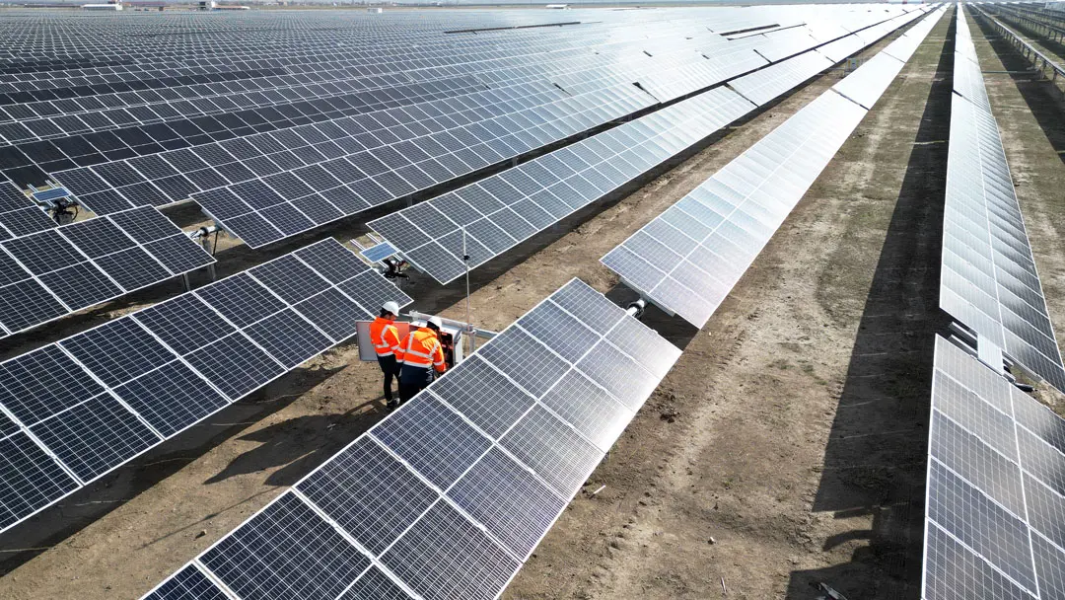
ENVIRONMENTAL AND SOCIAL MANAGEMENT PLAN

APRIL 2026
ANKARA

KEMERHİSAR SOLAR POWER PLANT PROJECT
ENVIRONMENTAL AND SOCIAL MANAGEMENT PLAN (ESMP)

Version | Revision | Date | Prepared By |  |  | Quality Management By | Checked By | Approved By
Draft | A.0 | July 2025 | Şevval Kurt  Biologist  B.Sc. | Deniz Dirier  Sociologist  B.Sc. | İrem Yılmaz  Sociologist  B.Sc. | Esra Okumuşoğlu  Geological Engineer, B.Sc. | D. Emre Kaya  Environmental Engineer, M.Sc. | Günal Özenirler  Environmental Engineer, M.Sc.
Draft | A.1 | November 2025 | Şevval Kurt  Biologist  B.Sc. | Deniz Dirier  Sociologist  B.Sc. | İrem Yılmaz  Sociologist  B.Sc. | Esra Okumuşoğlu  Geological Engineer, B.Sc. | D. Emre Kaya  Environmental Engineer, M.Sc. | Günal Özenirler  Environmental Engineer, M.Sc.
Final | C.0 | January 2026 | Şevval Kurt  Biologist  B.Sc. | Deniz Dirier  Sociologist  B.Sc. | İrem Yılmaz  Sociologist  B.Sc. | Esra Okumuşoğlu  Geological Engineer, B.Sc. | D. Emre Kaya  Environmental Engineer, M.Sc. | Günal Özenirler  Environmental Engineer, M.Sc.
Final | C.1 | April 2026
Revision Codes: A: Draft, B: Final Draft, C: Final
Project No: 25 / 12
APRIL 2026

CLIENT: | CONSULTANT:
 | 
Han Mh, Nihat Timur Blv. No:48, 51730 Kemerhisar/Bor/Niğde  ( +90 388 329 2063  7: +90 388 329 3286 | Tepe Prime İş ve Yaşam Merkezi  Mustafa Kemal Mahallesi Dumlupınar  Bulvarı No: 266 B Blok Kat: 2 Daire: 38  Çankaya - Ankara / Türkiye  : +90 (312) 287 25 07-08  7: +90 (312) 287 25 09

TABLE OF CONTENTS
Page
1 INTRODUCTION 1
2 SUBPROJECT DESCRIPTION AND ACTIVITIES 5
2.1 Project Description 5
2.2 National Legislation 8
2.3 International Standards 10
2.4 E & S Screening 11
3 ENVIRONMENTAL AND SOCIAL IMPACTS RELATED TO PROJECT ACTIVITIES 14
3.1 Land Use, Soil, and Geology 14
3.2 Air Quality and Noise 14
3.3 Water Resources and Wastewater 15
3.4 Waste and Chemical Management 16
3.5 Flora and Fauna 17
3.6 Cultural Heritage 18
3.7 Community Health and Safety / Social Impacts 18
3.8 Labor Management 19
3.9 OHS Risks And Precautions Of Sub-Project Activities 20
3.10 Resource Efficiency 22
4 BASELINE 24
4.1 Methodology 24
4.2 Project Area 25
4.2.1 Area of Influence 27
4.3 Location and Topography 30
4.4 Geography 30
4.5 Climate 31
4.6 Flora and Fauna 31
4.6.1 Flora 31
4.6.2 Fauna 37
4.6.3 Critical Habitat Assessment 41
4.6.4 Limitations 55
4.7 Earthquake Risks 55
4.8 Hydrology and Flood Risk 56
4.9 Project Land Use Rights 56
4.10 Socioeconomic Situation 58
4.10.1 Niğde Province 58
4.10.2 Bor District 59
4.10.3 Kemerhisar Municipality 60
4.10.4 Seslikaya Village 61
5 ENVIRONMENTAL AND SOCIAL MANAGEMENT PLAN 62
5.1 Mitigation Plan for the Project 63
5.2 Monitoring Plan for the Project 73
6 CAPACITY BUILDING AND TRAINING 77
7 STAKEHOLDER ENGAGEMENT 82
7.1 Stakeholder Analysis 82
7.1.1 Previous Stakeholder Engagement Activities 82
7.1.2 Stakeholder Identification and Analysis 83
7.1.3 Stakeholder Engagement Plan 85
7.1.4 Roles and Responsibilities 91
7.1.5 Grievance Mechanism 91
7.1.6 Monitoring and Reporting 94
8 CONCLUSION 97
9 REFERENCES 98
10 APPENDICES 100
10.1 Appendix-1 Title Deed Information For The Project 100
10.2 Appendix-2 Environmental and Social Screening Checklist for the Project 117
10.3 Appendix-3 Botaş Opinion Letter 122
10.4 Appendix-4 Call Letter 123
10.5 Appendix-5 Photos Taken from the Site Visit 124
10.6 Appendix-6 Chance Find Procedure 127
10.7 Appendix-7 Grievance Submission Form 131
10.8 Appendix-8 Grievance Closure Form 132
10.9 Appendix-9 Sample Key Informant Interview Form (For Single Stakeholder Interviews) 133
10.10 Appendix-10 Sample Consultation Form (For Stakeholder Participation Meeting(s) 134
10.11 Appendix-11 EIA Scope Out Certificate 135
10.12 Appendix-12 Project Layout 136

LIST OF TABLES
Page
Table 2-1. Technical Information of the SPPs 4
Table 2-2. National Environmental and Social Legal and Policy Framework 6
Table 4-1. Flora Species in Project Area 28
Table 4-2 Endemic Plant Species 30
Table 4-3. Fauna Species in Project Area 34
Table 4-4. Assessmnet of Criterion 1 (Unknown Population) 44
Table 4-5. Extent of Occurrence (EOO) of Endemic Plant Species Identified through Literature Review 45
Table 4-6. All Parcels Affected by the Project 52
Table 4-7. Main Labour Force Indicators of Türkiye and TR71 Region 54
Table 4-8. Vulnerable/Disadvantaged Individuals/Groups in the Project Area 56
Table 6-1. Proposed Training Topics 74
Table 7-1. Comprehensive List of the Stakeholder Identified for the Project 78
Table 7-2. The Potential Impacts of Project Activities on Social Components 79
Table 7-3. Potential Vulnerable/Disadvantaged Groups and their needs 80
Table 7-4. Stakeholder Engagement Program During the Construction and Operation Phase 82
Table 7-5. Responsibilities of Key Actors/Stakeholders in SEP Implementation 86
Table 7-6. Grievance Mechanism Flowchart 88
Table 7-7. SEP Monitoring Framework 90
Table 10-1. Key Performance Indicators (KPIs) 120

LIST OF FIGURES
Page
Figure 1-1. Project Location 2
Figure 2-1. Project Area 5
Figure 4-1. Corine Habitat and Land Use 22
Figure 4-2. Nationally Protected and/or Internationally Recognized Areas (KBAs) close to the Project Area 23
Figure 4-3. Area of Influence 24
Figure 4-4. Topography of Project Area 25
Figure 4-5. Area of Analysis 39
Figure 6-1. Organizational chart 73
Figure 10-1. Title Deed Information for the Project Area and ETL 107

LIST OF ABBREVIATIONS
Abbr. | Definition
AC | Alternating Current
AoI | Area of Influence
AFAD | Disaster and Emergency Management Directorate
CA | Contracting Authority
CAPEX | Fixed Investment Cost (Capital Expenditures)
CLO | Community Liaison Officer
DC | Direct Current
DMI | State Meteorological Affairs
EIA | Environmental Impact Assessment
EIRR | Economic Internal Rate of Return
EMRA | Republic of Türkiye Energy Market Regulatory Authority
ENPV | Economic Net Present Value
ESMP | Environmental and Social Management Plan
EU | European Union
EUR | Euro
FIRR | Financial Internal Rate of Return
FNPV | Financial Net Present Value
FTE | Full-time equivalents
GDP | Gross Domestic Product
GIS | Geographic Information System
GRM | Grievance Redress Mechanism
ILBANK | The General Directorate of Bank of Provinces
kWe | Kilo Watt Electric
kWh | Kilo Watt Hour
kWp | Kilo Watt Peak
LCOE | Levelized cost of energy
MGM | General Directorate of Meteorological Affairs
MoENR | Ministry of Energy and Natural Resources
MW | Mega Watt
MWe | Mega Watt Electric
MWh | Mega Watt Hour
MWp | Mega Watt Peak
Nbhd | Neighbourhood
O&M | Operation and Maintenance
OP | Operational Program
PIU | Project Implementation Unit
PMU | Project Management Unit of ILBANK
PPP | Public-Private Partnership
PPM | Parts Per Million
PV | Photovoltaic
QA | Quality Assurance
SCP | Sustainable Cities Program
SEGE | Socioeconomic Development Index
SEP | Stakeholder Engagement Plan
SPP | Solar Power Plant
TA | Technical Assistance
ToR | Terms of Reference
TEDAŞ | Turkey Electricity Distribution Inc.
TEİAŞ | Turkey Electricity Transmission Inc.
TTK | Türkiye Hard Coal Cooperation
TUBITAK | Scientific and Technological Research Council of Turkey
TURKSTAT | Turkish Statistical Institute
TUIK | Turkish Statistical Institute
WB | World Bank

INTRODUCTION
The Kemerhisar Solar Power Plant Project is located within the administrative boundaries of Bor district, Niğde province, Türkiye. The project comprises two photovoltaic (PV) power generation units within installed capacities of 190 kWe and 830 kWe, respectively, both located on registered parcels owned by Kemerhisar Municipality. Based on these installed capacities, the Project is expected to generate 1,570,393 kWh/year and 357,913 kWh/year of electricity. An associated Energy Transmission Line (ETL) of approximately 8.6 km in length will connect the power plants to the local distribution network via transformer stations located near the Organized Industrial Zone (OIZ). Of this, 7.6 km will be constructed as an overhead line, while the remaining 1 km will be installed underground.
The Project is being developed by Kemerhisar Municipality under the Sustainable Cities Project – II (Additional Financing), supported by İller Bankası A.Ş. (ILBANK) and financed by the World Bank . The environmental and social documentation including this Environmental and Social Management Plan (ESMP) and Land Acquisition and Resettlement Action Plan (LARAP), has been prepared by 2U1K Engineering and Consulting Inc. in accordance with Türkiye’s Environmental Law and alignment with international standards, particularly Operational Policies (OP) of the World Bank.

The purpose of this ESMP is to identify, assess, and manage potential environmental and social impacts associated with the construction and operation phases of the Project and its associated ETL. The document defines mitigation measures, monitoring requirements, institutional responsibilities, and stakeholder engagement processes to ensure compliance with national legislation and international good practice.
The location of the Project location is presented in Figure 1-1 and Figure 1-2 below.

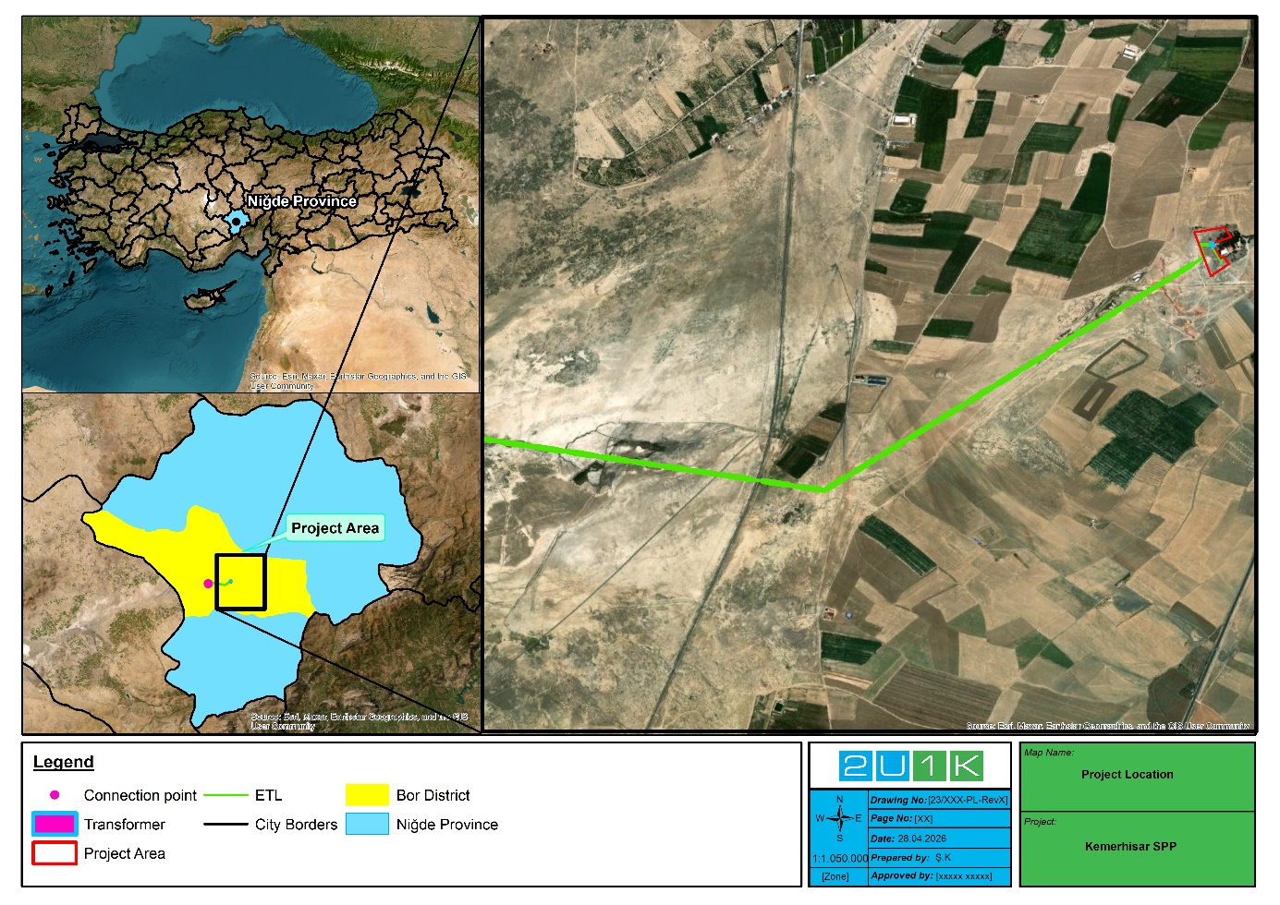
Figure 1-1. Project Location-1
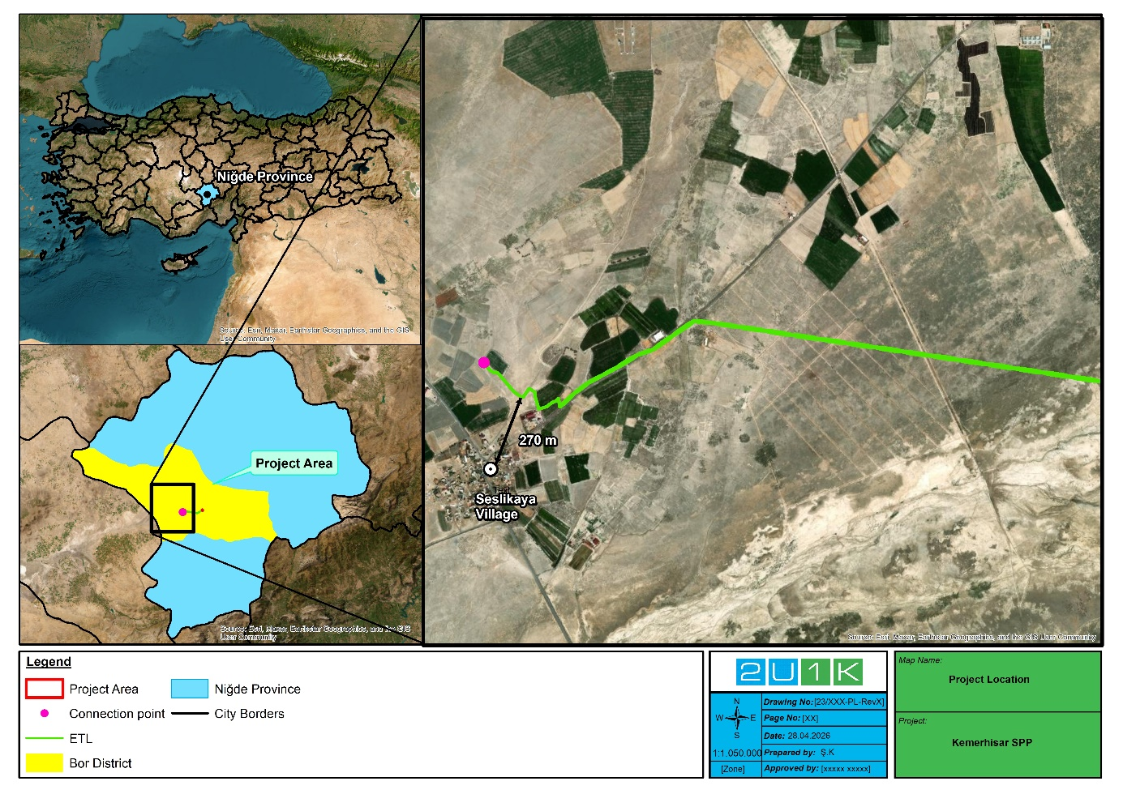
Figure 1-2. Project Location-2

SUBPROJECT DESCRIPTION AND ACTIVITIES

Project Description
Kemerhisar Solar Power Project comprises two distinct solar generation units:
- Kemerhisar SPP-1 with a capacity of 190 kWe and
- Kemerhisar SPP-2 with a capacity of 830 kWe.
The Project was initially defined under Parcel 515/386. In line with TEDAŞ requirements, a cadastral subdivision has been carried out to separate the transformer location. Accordingly, the Project remains in the same location; however, the parcel boundaries have been refined, resulting in a slight reduction in the defined project area. Both SPP units are located on Parcel 515/441, while the associated transformer is situated on the adjacent Parcel 515/442. The project area covers approximately 21,436.39 m2, and the ETL route transverses multiple parcels owned by different private landholders. The transmission line is planned as an above-ground line and will connect to the distribution infrastructure at the Organized Industrial Zone. Connection agreements and permissions, including those from the Turkish Electricity Transmission Corporation (TEİAŞ) and BOTAŞ, have been obtained. The Call Letters issued for both solar units confirm technical feasibility and grid connection compatibility.
The electricity generated by both units will be transferred to the local distribution network through a dedicated ETL. The ETL alignment extends across predominantly agricultural and pasture lands within the Project Area of Influence and traverses a total of 23 parcels, comprising 16 publicly owned and 7 privately owned parcels, as detailed in the LARAP. Required right-of-way permissions for privately owned parcels have been obtained through formal easement arrangements with the relevant landowners.
The power evacuation point is located within the Niğde OIZ and the energy produced by Kemerhisar SPP will be transferred to the OIZ’s internal distribution network. The connection has been approved through a call letter issued by TEİAŞ, and connection agreements have been signed accordingly. Although the OIZ grid is not directly operated by TEİAŞ, it is integrated into the national energy system and complies with TEİAŞ’s technical and regulatory standards.
Along its route, the ETL also crosses existing infrastructure, including the Seslikaya flood protection channel. This crossing will be implemented as an overhead line with a minimum clearance of 8 meters; therefore, no physical structures will be installed within the channel and no direct physical impact on the channel is anticipated. Further details on land ownership, land use types, and parcel-level impacts are provided in Section 4.9 (Project Land Use Rights) and the LARAP.
Additionally, no separate transmission line is required for Kemerhisar SPP-2, as it will be connected to the grid through Kemerhisar SPP-1. Within the project area, photovoltaic panels will be installed covering a total area of 3,600 m².
Planned Solar Power Plant 1 and 2 have capacities of 986.0 kWp DC / 830 kWe AC and 225.0 kWp DC / 190.0 kWe AC, respectively, and are equipped with 550 Wp MonoPerc Half-Cut modules installed at a tilt of 30° and an azimuth angle of 25°. The inclination of 30 degrees has been determined as the optimum tilt for Türkiye, ensuring that the panels harness maximum benefit from the varying solar elevations throughout the year, even when fixed at a constant angle. The project area has an estimated direct normal irradiation (DNI) of approximately 2000 kWh/m².
The plant has an estimated operational lifetime of 30 years, after which it will be decommissioned. Decommissioning costs have been included in the financial analysis at approximately €32,000 per MWp, corresponding to about €31,552 for Kemerhisar-1 and €7,216 for Kemerhisar-2. In addition to the economic planning, the project is expected to avoid the release of more than 76 tons of CO₂ annually, contributing significantly to climate change mitigation.
The technical details of SPP-1 and SPP-2 are shown in Table 2-1 below.
Table 2-1. Technical Information of the SPPs
Technical Information | SPP-1 | SPP-2
FV Panel Type | Monocrystalline MONOPERC | Monocrystalline MONOPERC
FV Panel Power Output | 550 Wp | 550 Wp
FV Panel Count | 1793 | 410
Annual Degradation | %0.5 | %1
Inverter Power Output | 100 kW- 50 kW | 100 kW
Inverter Count | 8-1 | 2
Total DC Power | 986 kWp | 225,0 kWp
Total AC Power | 830 kWe | 190,0 kWe
Estimated Annual Energy Production | 1.570.393,00 kWh | 357.913,00 kWh
Annual Energy Consumption | 1.570.393,00 kWh | 357.913,00 kWh
Production/Consumption | %100 | %100
Decommissioning Cost | EU 31.552,00 | EU 7.216,00

Figure 2-1 illustrates the spatial layout of the Project and its associated infrastructure. The Project Area is shown in red, indicating the location where the solar power plant units will be installed. The transformer location is marked with a blue square, while the connection point is indicated by a pink marker. The ETL alignment is represented by the green line, extending from the Project Area to the connection point.
The ETL has an approximate length of 8.2 km and traverses predominantly rural land characterized by agricultural fields, pasture areas, and sparsely vegetated steppe. The surrounding landscape exhibits a mosaic pattern typical of the Bor–Kemerhisar region, where cultivated agricultural plots are interspersed with non-irrigated and irrigated lands and open steppe areas.

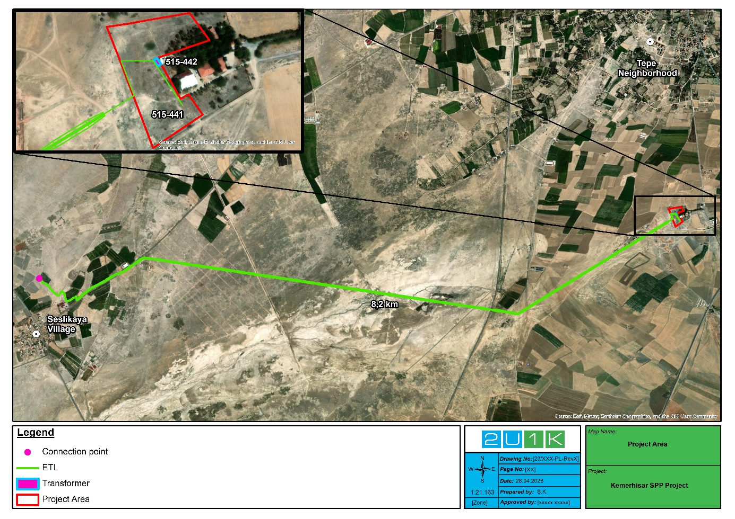
Figure 2-1. Project Area
All energy generation, transmission and connection procedures are being implemented in compliance with Türkiye’s legal framework for unlicensed renewable energy projects, in accordance with Law No. 6446 on Electricity Market and its secondary legislation.
Construction of the solar units and associated infrastructure is expected to be completed within 6 months, contingent on seasonal and logistical factors. Once operational, the project is anticipated to contribute approximately, 1.02 Mwe of clean, renewable electricity to the regional network-supporting local sustainability goals and Türkiye’s commitments under National Energy Efficiency Action Plan and National Climate Strategy.

National Legislation
Table 1-2 presents the summary of national laws and regulations aiming to minimize the potential environmental and social impacts that may arise during the construction and operation activities of the Project.

Table 2-2. National Environmental and Social Legal and Policy Framework
National Environmental, Legal and Political Framework
Environmental Impact Assessment
Environmental Law | Law No: 2872; Date of Ratification: 1983
Regulation on Environmental Impact Assessment | Official Gazette No. 31907 dated 29 July, 2022
Environmental Permit and License Regulation | Official Gazette No. 29115 dated 10 September 2014
Water
Groundwater Law | Law No: 167, Date of Ratification: 1960
Water Pollution Control Regulation | Official Gazette No. 25687 dated 31 December 2004
Regulation on the Monitoring of Surface and Groundwater | Official Gazette No. 28910 dated 29 December 2012
Regulation on Water Intended for Human Consumption | Official Gazette No. 25730 dated 17 January 2005
Air
Regulation on Air Quality Assessment and Management | Official Gazette No. 26898 dated 06 June 2008
Exhaust Gas Emission Control Regulation | Official Gazette No. 30004 dated 11 March 2017
Regulation on Control of Exhaust Gas | Official Gazette No. 30004 dated 11 March 2017
Soil
Soil Conservation and Land Use Law and Applicable Regulation | Official Gazette No. 25880 dated 03 July 2005
Regulation on Control of Soil Pollution and Point Source Contaminated Lands | Official Gazette No. 27605 dated 08 June 2010
Noise
Regulation on the Ambient Noise Emission Caused by Equipment Used Outdoors | Official Gazette No. 26392 dated 30 December 2006
Regulation on Assessment and Management of Environmental Noise | Official Gazette No. 27601 dated 04 June 2010
Energy Efficiency
Energy Efficiency Law | Official Gazette No. 5627 dated 2 May 2007
Waste
Waste Management Regulation | Official Gazette No. 29314 dated 02 April 2015
Regulation on the Control of Waste Electrical and Electronic Equipment | Official Gazette No. 28300 dated 22 May 2012
Regulation on the Control of Excavation Soil, Construction and Demolition Wastes | Official Gazette No. 25406 dated 18 March 2004
Packaging Waste Control Regulation | Official Gazette No. 30283 dated 27 December 2017
Medical Waste Control Regulation | Official Gazette No. 29959 dated 25 January 2017
Regulation on the Control of Waste Batteries and Accumulators | Official Gazette No. 25569 dated 31 August 2004
Medical Waste Control Regulation | Official Gazette No. 29959 dated 25 January 2017
Regulation on the Management of Waste Oils | Official Gazette No. 30985 dated 21 December 2019
Waste Vegetable Oil Control Regulation | Official Gazette No. 29378 dated 06 June 2015
Regulation on the Control of End-of-life Tires | Official Gazette No. 26357 dated 25 November 2006
Communiqué on the Transport of Wastes by Road | Official Gazette No. 29301 dated 20 March 2015
Zero Waste Regulation | Official Gazette No. 30829 dated 12 July 2019
Nature Conservation
Forestry Law | Official Gazette No:6831 dated 05 June 1986
National Social Legal and Policy Framework
Community Health and Safety
Public Health Law | Law No: 1593, Date of Ratification: 1930
Health and Safety Signs Regulation | Official Gazette No. 28762 dated 11 September 2013
Highway Traffic Regulations | Official Gazette No 23053 dated 18 August 1997
Labor and Working Conditions
Occupational Health and Safety Law | Law No: 6331, Date of Ratification: 2012
Regulation on Contractors and Sub-contractors, | Official Gazette No. 27010 dated 27 September 2008
Labor Law (No. 4857) | Official Gazette No. 25134 dated 10 June 2003
Law on Trade Unions and Collective Bargaining Agreements | Official Gazette No. 28460 dated 7 November 2012
First Aid Regulation | Official Gazette No. 29429 dated 29 July 2015
Regulation on Health and Safety Requirements for the Use of Work Equipment | Official Gazette No. 28628 dated 25 April 2013
Regulation on Procedures and Principles of Occupational Health and Safety Training of Employees | Official Gazette No. 28648 dated 15 May 2013
Stakeholder Engagement
Laws on Right to Information (No. 4982) | Official Gazette No. 29186 dated November 25, 2014

International Standards
WB governs projects and activities by the Safeguard Policies to assure that they are conducted in an environmentally, financially and socially sound manner. Safeguard Policies include Environmental and Social Assessments and other instruments that address adverse environmental and social effects of projects as well as their prevention, reduction and mitigation. These policies are expanded in the “World Bank Operations Manual” that provides further guidance on the Operational Policies (OP) and compilation.
The World Bank Group's (WBG) General Environmental, Health and Safety (EHS) Guidelines should be adopted for this project. For this reason, this project will meet the relevant requirements of EHS Guidelines. If national regulations differ from the levels and measures presented in EHS Guidelines, the more stringent one will apply.
Türkiye is a signatory to many international agreements, including the:
- Stockholm Convention on Organic Pollutants,
- Convention on Long-range Trans-Boundary Air Pollution (CRLTAP),
- Rotterdam Convention on the Prior Informed Consent Procedure for Certain Hazardous Chemicals and Pesticides in International Trade,
- Basel Convention on the Control of Transboundary Movements of Hazardous Wastes and their Disposal,
- Kyoto Protocol regarding to the United Nations Framework Convention on Climate Change,
- Montreal Protocol on Substances that Deplete the Ozone Layer,
- Barcelona Convention for the Protection of Marine Environment and the Coastal Region of the Mediterranean,
- Vienna Convention for the Protection of the Ozone Layer,
- Protocol on Environmental Protection to the Antarctic Treaty,
- ILO Conventions;
  - ILO Convention on Forced Labor,
  - ILO Convention on Freedom of Association and Protection of the Right to Organize,
  - ILO Convention on Right to Organize and Collective Bargaining,
  - ILO Convention on Equal Remuneration,
  - ILO Convention on Abolition of Forced Labor,
  - ILO Convention on Discrimination (Employment and Occupation),
  - ILO Convention on Minimum Age,
  - ILO Convention on Worst Forms of Child Labor,
- Paris Agreement.

E&S Screening
In accordance with the Environmental Impact Assessment Regulation (29.07.2022/31907) and World Bank Operational Policies (WB OP's), the proposed solar power plant project on Kemerhisar Municipality land will be evaluated for its environmental and social impacts.
The Kemerhisar Solar Power Project falls under the category of solar power plants listed in Annex-1 and Annex-2 of the Environmental Impact Assessment Regulation. However, since the total installed capacity (190 kWe for Kemerhisar SPP-1 and 830 kWe for Kemerhisar SPP-2) is below 1 MWm per unit, the Project is considered to be outside the scope of the Environmental Impact Assessment Regulation.
In order to comprehensively address potential environmental and social risks and impacts associated with the Project, an Environmental and Social Management Plan (ESMP) is being developed, aligned with the World Bank Environmental and Social Safeguard Policies, within the scope of the İller Bankası Sustainable Cities-2 Additional Financing Project. The ESMP will be implemented to ensure that the Project is carried out in compliance with Türkiye’s Environmental Law, World Bank Operational Policies, and the World Bank’s Environmental, Health, and Safety Guidelines.
The World Bank’s Safeguard Policies are designed to ensure that projects are implemented in an environmentally, socially, and financially responsible manner. These policies require Environmental and Social Assessments and other instruments to prevent, reduce, or mitigate potential adverse impacts. The relevant Operational Policies (OPs) triggered for this Project have been considered within the framework of this environmental and social assessment.
Environmental Assessment Policy (OP 4.01)
The purpose of this policy is;
- To ensure the projects proposed for Bank financing are environmentally and socially sound and sustainable,
- To inform decision-makers about the nature of environmental and social risks, and
- To increase transparency and involvement of decision-makers in the decision-making process.
For the purposes of the WB O.P. 4.01, projects are classified in categories A, B or C depending on the severity of their potential impacts on the environment:
Category A projects; projects with impacts which could potentially result in significant and diverse environmental and/or social impacts and issues in the future and which could not be easily identified at the time of classification.
Category B projects; projects with environmental and/or social impacts that are specific to the location of the facility and/or with impacts that could be easily identified and prevented.
Category C projects; projects resulting in minimum or no environmental and social issues.
FI projects; financial intermediation activities.
This Environmental and Social Management Plan has been prepared by the Project Owner for the investments defined and outlined within the scope of the Project as required by the WB OPs.
The operational policies listed above were determined considering the scope of the project as well as the geographical, natural and demographic structure of the region. Upon the assessment, the project category was regarded as Category C.
Natural Habitats (OP 4.04)
- If the potential impact of a subproject on natural habitats is significant or if the impact is on critical natural habitats, the top priority will be to tackle the problem by identifying a new location. If this is not possible, appropriate mitigation measures will be adopted for the relevant circumstances.
- The construction works under the project will not affect critical habitats as there is no critical habitat in its immediate vicinity. The project area is a natural habitat, construction works may affect natural habitats.
Physical Cultural Resources (OP 4.11)
- Buried properties (e.g. tombs or mounds) can be identified during project-related studies during land preparation.
Involuntary Resettlement (OP 4.12)
- Involuntary resettlement may cause severe long-term hardship, impoverishment, and environmental damage unless appropriate measures are carefully planned and carried out.
- For these reasons, the overall objectives of the Bank's policy on involuntary resettlement are the following:
  - Involuntary resettlement should be avoided where feasible, or minimized, exploring all viable alternative project designs.
  - Where it is not feasible to avoid resettlement, resettlement activities should be conceived and executed as sustainable development programs, providing sufficient investment resources to enable the persons displaced by the project to share in project benefits. Displaced persons should be meaningfully consulted and should have opportunities to participate in planning and implementing resettlement programs.
The Project has been evaluated according to the Involuntary Resettlement Policy and no land acquisition is required under the Project.
The World Bank Group's (WBG) General Environmental, Health and Safety (EHS) Guidelines should be adopted for this project. For this reason, this project will meet the relevant requirements of EHS Guidelines. If national regulations differ from the levels and measures presented in EHS Guidelines, the more stringent one will apply.

ENVIRONMENTAL AND SOCIAL IMPACTS RELATED TO PROJECT ACTIVITIES

Land Use, Soil, and Geology
The area designated for the construction of the solar power plant and the route of the 8.6-km energy transmission line predominantly consist of agricultural lands and pastures that have been previously altered by human activity. During the construction phase, excavation, filling, grading, and topsoil stripping works may temporarily disturb the existing land surface and soil structure. Potential fuel or oil leaks from construction machinery, improper waste handling, or equipment malfunctions could lead to localized soil contamination. If stockpiled soil remains exposed for extended periods, wind and water erosion, as well as sediment transport, may occur.
The geotechnical assessments indicate that the project site is geologically stable, with no active fault lines, landslide hazards, or significant geotechnical risks identified within the project boundaries. Along the approximately 1-km underground section of the transmission line, surface soil will be temporarily removed during excavation and reinstated following the completion of works to restore the original topographic conditions. No permanent alteration of the landform, soil degradation, or loss of agricultural productivity is anticipated during the operation phase of the Project.
Considering the limited spatial extent of excavation works, the temporary nature of soil disturbance, and the stable geological characteristics of the area, the overall impact of the Project on land use, soil, and geology is assessed as low to medium in line with WB ESS-1 and ESS-3.

Air Quality and Noise
This section assesses the impacts of the predicted emissions from the Project on air quality. The related measures for air quality to prevent, minimize, or mitigate the relevant potential risks and consequential impacts are presented in Mitigation Plan for the Project Section. During the implementation of the Project, short-term air quality impacts are anticipated mainly during land preparation, excavation, and construction activities of the solar power plant and the 8.6-km transmission line. The anticipated emissions are expected to originate from construction machinery, transport vehicles, and soil-disturbing works such as grading and backfilling. Dust (particulate matter—PM₁₀ and PM₂.₅) generation during dry and windy periods may temporarily affect the surrounding settlements and vegetation by visible dust dispersion and deposition on nearby surfaces.
Exhaust gas emissions (CO, NOₓ, SO₂) from fuel combustion in machinery and vehicles will also occur, though at levels within the limits of the Regulation on Control of Exhaust Gas Emission. To minimize such risks, all project vehicles and machinery will be subject to regular maintenance, and exhaust emission measurements will be recorded by authorized institutions throughout the project. Although the baseline air quality in the region remains below the national threshold limits, localized dust emissions during the construction period may cause short-term deterioration in air quality, especially near unpaved roads and material storage areas. In the operational phase, the Project will not involve fuel combustion or industrial processes that could cause atmospheric emissions. The solar power plant itself does not generate any air pollutants, and the use of backup generators will be limited to emergencies only.
Routine panel cleaning will not create any gaseous emissions, and no odor-forming gases such as methane are expected. Overall, considering the limited spatial extent and duration of construction works, the impact of the Project on air quality is assessed as low, while temporary increases in particulate matter concentration may occur locally during construction in line with WB ESS-1 and ESS-3.

Water Resources and Wastewater
This section assesses the potential impacts of the Project on water resources and wastewater generation within the Project’s Area of Influence (AoI). During the construction phase, water will be required to meet personnel needs and to suppress dust emissions within the Project area. Drinking water demand of construction workers will be met through bottled water supplied by licensed companies authorized by the Ministry of Health, while domestic water needs will be provided by water tankers. The daily domestic water demand is calculated as 1.86 m³/day for 10 personnel, based on an average per capita water consumption of 186 L/person·day (TÜİK, 2022). This value represents the potable and sanitary water needs during the construction phase of the Project. Additional water required for dust suppression will be supplied separately by municipal water trucks.
$$Daily Water Demand=10 person×\frac{186 L}{person×day}=1.86\frac{m^{3}}{day}$$
Wastewater from these activities will be collected in a sealed septic tank located within the construction site to prevent any infiltration into the soil or groundwater. Water required for dust suppression and cleaning will be delivered to the site by municipal water trucks. The quality of supplied water will comply with both the WB Environmental and Social Standards (ESS) and the Turkish Regulation on Water Intended for Human Consumption.
Short-term and minor adverse effects may occur due to surface runoff, muddy water accumulation in excavation pits, and accidental spills of fuels, lubricants, or hydraulic fluids during equipment maintenance. However, no groundwater resources were encountered during field studies, and no direct abstraction from surface or groundwater sources is foreseen.
In the operation phase, there will be no irrigation requirement or continuous water use. Routine panel cleaning will be conducted twice a year, consuming approximately 4 m³/day of water for several days. The cleaning water will evaporate on the panel surfaces; therefore, no wastewater generation is expected. In the long term, the Project is expected to contribute positively to water resource efficiency by reducing treated wastewater discharges through renewable energy generation. Overall, the potential impact of the Project on water resources and wastewater is assessed as low to medium, temporary in nature, and fully manageable in accordance with WB ESS-1 and ESS-3.

Waste and Chemical Management
The Project’s construction phase will generate various types of waste associated with site preparation, levelling, construction, and installation activities for the solar power plant and the 8.6-km transmission line. Expected waste streams include municipal solid waste, packaging materials (e.g., wood, cardboard, plastic), construction and excavation waste (e.g., soil, concrete, metal scraps), and hazardous and special wastes such as lubricants, oils, filters, contaminated rags, paint residues, and solvents. All waste will be managed in line with the waste hierarchy principles of reduction, reuse, recycling, recovery, and safe disposal.
During construction, an estimated 10 personnel will generate domestic solid waste mainly consisting of organic material and packaging waste. The daily solid waste generation is calculated as approximately 10 kg/day based on TÜİK (2020) data. These wastes will be collected in closed containers and removed by the district municipality to licensed disposal facilities. Excavated soil from the underground ETL section (~1 km) and construction debris will be transported by licensed haulers to the Niğde Municipality’s permitted landfill in accordance with the Regulation on the Control of Excavation Soil, Construction and Demolition Wastes.
Hazardous wastes such as oil-contaminated materials, solvent containers, and chemical residues will be stored temporarily in designated impermeable areas, properly labeled, and collected by licensed companies for recycling or disposal. No asbestos-containing material was identified within the project area; however, if encountered, it will be handled in accordance with the Regulation on Health and Safety Measures in Working with Asbestos (2013). Medical waste generated from first-aid activities will be minimal and will be stored in special containers and delivered to licensed medical waste disposal facilities.
During the operation phase, limited waste will be generated from maintenance and repair activities. These include packaging materials from spare parts, defective or end-of-life electrical components, small quantities of oily rags, filters, and used PPE. Any photovoltaic (PV) panel waste will be stored temporarily under cover and transferred to licensed recycling or disposal facilities. Used oils, accumulators, and batteries will be managed in accordance with the relevant national regulations.
Overall, the waste-related impacts of the Project are assessed as medium before mitigation due to the variety of waste streams and potential risks of mismanagement, and as low after the implementation of the Waste Management Plan and other mitigation measures, in accordance with WB ESS-1 and ESS-3. The impacts are local, short-term, and fully manageable.

Flora and Fauna
The Project area and the 8.6 km transmission line (ETL) route are located in the steppe ecosystem of the Bor District, Niğde Province, at an elevation of approximately 1000–1100 m a.s.l. The area represents a semi-arid, human-modified ecosystem dominated by agricultural and pasture lands. According to the CORINE Land Cover classification, the area includes non-irrigated arable land, pastures, and permanently irrigated land, while no natural forests or maquis formations occur within the Project’s footprint.
Flora and Vegetation
Vegetation within the Project area is characterized by annual herbaceous and ruderal species commonly associated with farmland margins, rural roads, and degraded steppe habitats. While field surveys conducted in July 2025 confirmed the absence of critical or high-conservation-value habitats, several widespread endemic taxa have been reported in the broader Niğde region and are likely to occur sporadically within the Project’s AoI. These include Phlomis armeniaca, Phlomis capitata, Salvia cryptantha, Salvia dichroantha, Saponaria prostrata subsp. prostrata, and Wiedemannia orientalis. These species are not point endemics and exhibit a wide Anatolian distribution, often thriving in disturbed, rocky, or semi-arid steppe environments. Therefore, the construction-related vegetation clearance and soil disturbance may temporarily affect some individuals but will not cause population-level impacts.
During construction, topsoil stripping, grading, and excavation (especially along the 1 km underground ETL section) may result in localized loss of herbaceous vegetation and temporary habitat degradation. However, given the dominance of ruderal and resilient steppe flora, natural regeneration is expected to occur rapidly after construction. No tree felling or large-scale shrub removal will be necessary. Consequently, the direct impacts on flora, including endemic plant species, are assessed as medium before mitigation and low after mitigation, being localized, reversible, and short-term in nature.
Fauna
The faunal community reflects the characteristics of the open agricultural landscape. A total of 24 species were recorded or are likely to occur in the AoI, including 2 amphibians, 6 reptiles, 9 birds, and 7 mammals. All recorded species are classified as Least Concern (LC) according to the IUCN Red List, except Testudo graeca (Common Tortoise), which is Vulnerable (VU). No endemic or critically endangered fauna were identified. The project area is not located along any major migratory bird flyway, and no critical nesting or breeding areas were detected. The 7.6 km overhead ETL segment could pose a minor risk of collision or electrocution for raptors and large birds (e.g., Falco tinnunculus, Ciconia ciconia), though this risk remains low due to the absence of migration corridors and the planned use of bird diverters and insulated conductors.
Overall Impact Evaluation
The primary biodiversity impacts of the Project are linked to temporary habitat loss, soil compaction, and localized species disturbance during construction activities. No irreversible fragmentation or long-term ecosystem alteration is anticipated. The operation phase will involve minimal human activity and no pesticide or herbicide use, with vegetation maintenance limited to erosion control.
Considering the absence of critical habitats, the low ecological sensitivity of the Project footprint, and the limited distribution of recorded endemic species, the Project’s overall impact on biodiversity is assessed as medium before mitigation and low after mitigation, in accordance with WB ESS-6. The impacts are expected to be site-specific, temporary, and reversible, while the Project’s renewable energy contribution will have an indirect positive effect on biodiversity conservation by reducing regional air pollution and greenhouse gas emissions.

Cultural Heritage
No tangible or intangible cultural heritage assets have been identified within the SPP site or along the ETL. If any archaeological artifacts or remains are encountered during earthworks, the Chance Find Procedure will be implemented in coordination with Niğde Museum Directorate, as per Law No. 2863 on the Protection of Cultural and Natural Assets. The impact of the project on cultural heritage has been assessed as local, short-term, and fully manageable.

Community Health and Safety / Social Impacts
Construction activities may temporarily affect nearby residents through dust, noise, and traffic. However, the project area is located over 270m from the nearest settlement (Seslikaya village), ensuring impacts remain minimal.
All construction sites will be fenced and equipped with warning signs. Traffic management measures will be applied to ensure safe movement of vehicles and machinery.
No physical or economic displacement beyond the previously compensated parcels is foreseen. Employment opportunities will be locally advertised, and priority will be given to residents of Kemerhisar Municipality and neighbouring villages, particularly vulnerable groups and women. The assessment conducted on public health and safety/social impacts specific to the project concluded that the impact is local, short-term, and fully manageable.

Labor Management
Workforce Structure
During the construction phase, approximately 40 workers (including skilled, unskilled, and technical staff) will be employed. The operation phase will require around 6 permanent personnel for maintenance, security, and monitoring activities. The majority of the workforce will be hired locally from Kemerhisar and Bor districts, minimizing external labor influx.
Worker Accommodation and Welfare
If required, external workers will be accommodated in local guesthouses or municipal facilities in Bor District, approximately 6 km from the site. Daily transportation will be arranged by the contractor, ensuring a maximum commuting time of 30 minutes. Accommodation and site facilities (canteen, sanitation, rest areas) will comply with the World Bank EHS Guidelines and Turkish Occupational Health and Safety Law No. 6331.
Occupational Health and Safety (OHS)
A site-specific OHS Management Plan will be prepared and submitted to ILBANK before mobilization. The plan will include:
- Emergency Preparedness and Response Plan,
- Community Health and Safety Management Plan,
- Traffic Management Plan,
- Incident Reporting Procedure,
- Risk Assessment and Job Safety Analyses,
- Use of Personal Protective Equipment (PPE),
- Fire Safety and First Aid Measures.
All workers will receive OHS induction and task-specific training according to relevant regulation. The project will ensure that construction contractors maintain records of safety performance and provide first-aid kits and firefighting equipment at the site.
Labor Conditions and Worker Rights
All employment practices will comply with Labor Law No. 4857 and Occupational Health and Safety Law No. 6331, as well as the principles of World Bank ESS2. Workers will be provided with written contracts, fair wages, and working hours in line with Turkish legislation.
The project prohibits:
- Child labor (under 18 years),
- Forced or bonded labor,
- Discrimination on the basis of gender, ethnicity, or religion.
Worker Grievance Mechanism
A dedicated worker grievance mechanism (WGM) will be established to enable workers to raise concerns anonymously and without retaliation. Complaints can be made verbally or in writing and will be recorded and resolved within 15 working days. The mechanism will be aligned with ILBANK’s Corporate Grievance Policy and the project’s Community Grievance Mechanism (GM).
Primary Supply Workers
Primary suppliers (e.g., PV panel, cable, inverter, and construction material providers) will be required through contracts to adhere to the same labor and OHS standards. Procurement contracts will include clauses prohibiting child or forced labor and mandating compliance with national OHS regulations.
Monitoring and Reporting
The contractor will maintain monthly reports on workforce numbers, gender composition, working hours, incidents, and grievances. ILBANK and Kemerhisar Municipality will supervise compliance through periodic audits. Corrective actions will be documented and followed up during construction and operation.

OHS Risks And Precautions Of Sub-Project Activities
The construction and operation of the Kemerhisar Solar Power Plant (SPP) and its associated Electricity Transmission Line (ETL) involve a range of occupational health and safety (OHS) risks arising from heavy machinery operations, manual handling of photovoltaic (PV) components, electrical systems, outdoor working conditions, and logistical activities.
Given the project’s location in Bor District, Niğde Province, characterized by a semi-arid continental climate, with hot summers and cold winters, climatic factors further intensify some of these risks such as heat stress, dehydration, and cold exposure.
During the construction phase, workers will be exposed to mechanical, electrical, ergonomic, chemical, and environmental hazards. The operation of heavy machinery and equipment (excavators, cranes, loaders, and trucks) within confined working areas poses collision and run-over risks, particularly where machinery and workers operate simultaneously. Excavation and trenching activities for the underground portion of the ETL (approximately 1 km) may cause collapse risks and accidental falls into open trenches. Manual handling of heavy PV modules, steel frames, and electrical components could lead to musculoskeletal injuries and fatigue due to repetitive lifting or improper posture. In addition, welding, cutting, and grinding operations during mounting and connection of support structures will expose workers to heat, sparks, and noise, potentially causing burns, eye damage, or hearing impairment if improperly managed.
Electrical hazards are significant throughout both the construction and operation stages. Workers may encounter electrical shock, arc flash, or grounding-related risks during the installation of inverters, switchgear, and cables. As the project will operate with high-voltage systems, even minor negligence could result in severe injury or fatality.
Moreover, the handling of fuels, lubricants, and cleaning chemicals introduces the potential for fire, explosion, or chemical exposure. Spillage during refueling or improper storage of flammable substances may increase both fire and soil contamination risks.
Environmental conditions in Niğde also pose notable safety challenges. The region’s high summer temperatures (exceeding 35°C) and low humidity increase the likelihood of heat stress, dehydration, and fatigue among outdoor workers, while winter frost and slippery surfaces can lead to falls and cold-related injuries.
The project’s rural setting means that medical and emergency response times may be delayed; thus, incidents such as falls, cuts, or electrical accidents could have more severe consequences if first aid is not immediately available.
The transportation and logistics activities associated with the project—especially the movement of heavy vehicles and machinery along local access roads connecting Bor and Kemerhisar—pose additional risks to both workers and local communities. Traffic-related accidents, particularly involving pedestrians or local road users, are among the most significant OHS concerns for the area.
Noise and vibration from equipment, coupled with dust generation from excavation and material transport, may result in temporary discomfort, respiratory irritation, or hearing strain for workers operating close to active zones.
Working at height is another critical hazard during both the construction of ETL poles and the installation of solar panels on mounting structures. Falls from height, slips from scaffolding, and mechanical failure of lifting systems represent some of the most serious occupational hazards of the project. Likewise, certain confined-space tasks—such as entering manholes or foundation pits for underground cabling—can create risks of oxygen depletion, gas accumulation, or entrapment if not properly managed.
Psychosocial and communicable disease risks are also relevant, as the project will employ a limited workforce working in close quarters under potentially stressful environmental conditions. The possibility of contagious diseases spreading in shared worker accommodations or transport vehicles remains a minor but notable risk, particularly during seasonal flu or pandemic outbreaks.
During the operation phase, the overall risk level will decrease, but several OHS hazards will persist. Electrical hazards remain the most significant, especially during inspection and maintenance of energized components, inverters, and transformers. Workers conducting periodic panel cleaning face fall risks, as well as exposure to high surface temperatures and intense solar radiation. Long-term outdoor work can cause fatigue, dehydration, and heat exhaustion. Additionally, the use of cleaning agents and lubricants may lead to mild chemical irritation if handled without caution.
Ergonomic issues such as repetitive strain, poor posture during maintenance, or prolonged static positions could also lead to musculoskeletal discomfort over time.
In conclusion, the key occupational risks for the Kemerhisar Solar Power Plant and ETL project arise mainly from heavy equipment operation, working at height, electrical systems, traffic and transport activities, extreme weather, manual handling, and chemical exposure.
Although these risks are manageable through appropriate control measures, their presence during construction and operation phases underscores the need for continuous supervision, professional OHS management, and regular performance monitoring to safeguard workers’ health and safety across all project stages.

Resource Efficiency
Resource efficiency principles have been incorporated into the design and implementation of the Kemerhisar Solar Power Plant Project located in Bor District, Niğde Province. The Project, including its 8.6 km transmission line has been developed to ensure the efficient use of land, materials, energy, and water, while minimizing environmental impacts and operational costs throughout its lifecycle.
The Project area was selected within low-productivity agricultural and pasture lands, avoiding ecologically sensitive zones and permanent natural habitats. The solar panel layout was optimized according to topography, slope orientation, and solar radiation data to maximize energy generation efficiency while minimizing land disturbance and grading requirements.
During construction, material use will be optimized through accurate planning of cable routes, foundations, and mounting systems. Surplus excavation soil will be reused on site for backfilling and land rehabilitation, reducing external material needs. Packaging materials (metal, plastic, cardboard) will be separated at source and transferred to licensed recycling facilities. Preference will be given to locally sourced and recyclable construction materials to reduce transport-related emissions and resource depletion.
Construction machinery and transport vehicles will be regularly maintained to ensure fuel efficiency and lower greenhouse gas emissions. The project’s energy demand during operation will be minimal and primarily limited to the monitoring and security systems. The internal energy consumption will be supplied directly from the photovoltaic (PV) system itself, ensuring net-zero operational energy use.
Given the semi-arid climatic conditions of Niğde, water use efficiency is a priority. During construction, water will be used mainly for dust suppression and will be supplied by municipal water trucks. During operation, water consumption will be limited to periodic panel cleaning conducted twice a year, requiring approximately 4 m³/day for several days. The cleaning process will use potable water from licensed suppliers, and the water will evaporate without generating wastewater.
A Recycling and Waste Recovery Plan will be implemented to extend material life cycles. Damaged or end-of-life PV modules and auxiliary components (e.g., cables, frames, inverters) will be collected and transferred to licensed recycling facilities for material recovery. Construction and maintenance waste will be minimized through reuse and recycling wherever feasible.
Efficient project management will ensure reduced working hours, minimized transport, and optimized logistics. Collaboration with local suppliers and hiring local workforce will reduce transportation emissions and strengthen socio-economic benefits in Kemerhisar and nearby settlements.
Overall, the Kemerhisar Solar Power Plant has been designed to maximize renewable energy yield per unit of land, minimize natural resource consumption, and align with the World Bank ESS-3 (Resource Efficiency and Pollution Prevention). The project’s efficient use of resources contributes to long-term environmental sustainability and regional climate resilience.

BASELINE

Methodology
The Environmental and Social Assessment (ESA) was conducted through a combination of desk-based analysis and field surveys to establish baseline conditions and identify potential environmental and social sensitivities within the Project Area and its Area of Influence (AoI).
During the desk-based phase, existing environmental and social data, topographic and geological maps, and spatial datasets were reviewed. Land use and land cover were mapped using the CORINE (Coordination of Information on the Environment) Land Cover dataset, which provides a standardized and comparable classification system across Europe. These data were cross-checked with high-resolution satellite imagery (Google Earth Pro, 2024) and official spatial datasets obtained from MTA and Doğa Derneği (2023) to verify site characteristics, water features, and conservation boundaries. Socio-economic and demographic information was compiled from TÜİK statistics and consultations with local authorities.
Field surveys were conducted in July 2025 to verify desk-based findings and assess on-site environmental and social conditions. The surveys covered soil and land use characteristics, noise and air quality observations, as well as local flora and fauna. Social data were collected through site observations, interviews with local stakeholders (village headmen, residents, and municipal representatives), and focus group discussions, particularly addressing community perceptions and project expectations.
A comprehensive field study was carried out on July 29, 2025 within the scope of the Project. During the visit, meetings were held with the headman of Seslikaya Village—the nearest settlement to the Project Area—followed by a focus group discussion with women from the community. Consultations were also conducted with Kemerhisar Municipality officials and the Mayor to obtain information on the current status of the Project. Subsequently, the project site and transmission line route were visited, and environmental and ecological observations were undertaken to assess baseline conditions. Photographs taken during these studies are provided in Appendix-5.
The field study was conducted by the following team members:
- Günal Özenirler – Senior Environmental Engineer
- Deniz Dirier – Sociologist
- İrem Yılmaz – Sociologist
- Şevval Kurt – Biologist

Project Area
Kemerhisar is a town in Bor District of Niğde Province, located in the Central Anatolia region of Türkiye. Niğde is bordered by Aksaray to the northwest, Nevşehir to the north, Kayseri to the northeast, Adana to the south and Konya to the west. The Kemerhisar Municipality plans to establish two solar power plant project areas within Tepe Neighborhood. The project sites are owned by the Kemerhisar Municipality, with a combined area of approximately 21,436.39 m^{2.} The project sites are located approximately 2,5 kilometers from the city center of Kemerhisar Municipality.
According to sunshine duration and radiation data measured by TSMS (Turkish State Meteorological Service) from 1971 to 2000, Türkiye’s annual mean total sunshine hours are 2573 (daily mean is 7 h) and mean total radiation is 1474 KWh/m²-year (daily 4 KWh/m²).
Niğde’s annual mean total sunshine hours are 2737 (daily mean is 7,5 h) and mean total radiation is 1550-1800 KWh/m² (daily 4.5 kWh/m²).
According to the Corine Land Cover Data, the project area, which consists of two parcels, consists of non-irrigated arable land. Constantly irrigated lands and pastures are seen in the immediate vicinity of the project area. The map showing land use and habitats in the project area and its surrounding is given in Figure 4-1 below.
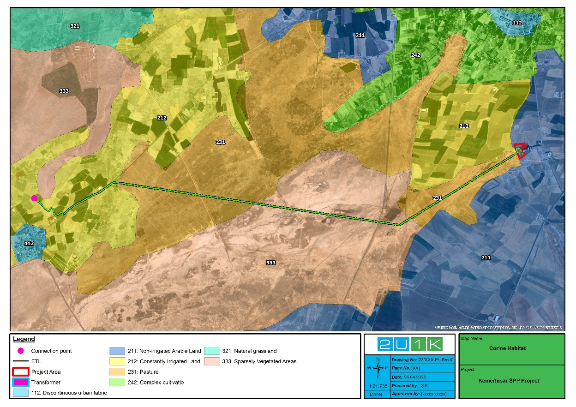
Figure 4-1. Corine Habitat and Land Use
According to the results of the population registration system, the population in Tepe neighborhood is 1.628 in 2023 and 1.602 in 2024.
There are no schools, places of worship, recreation areas or national protected areas in or near the project area.
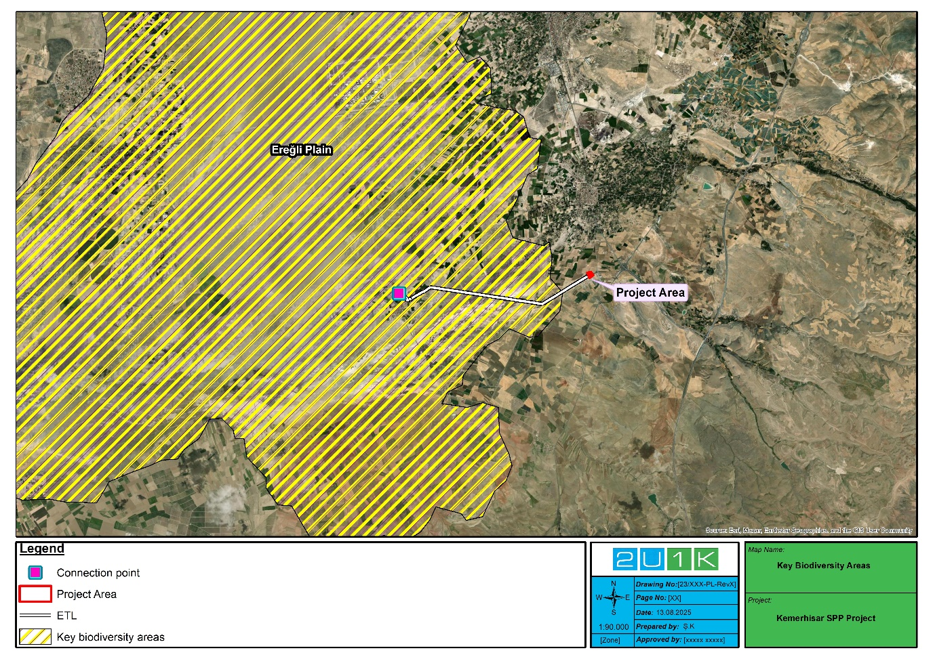
Figure 4-2. Nationally Protected and/or Internationally Recognized Areas (KBAs) close to the Project Area
Natural and Cultural Resources
Although there are no significant cultural resources in the immediate vicinity of the project area, a large part of the transmission line is located within the Ereğli Plain, which has the status of internationally recognized areas.

Area of Influence
The Project Area of Influence (AoI) has been defined to ensure that all potential environmental and social impacts associated with the subproject are appropriately assessed.
For the subproject site, the AoI extends 500 meters from the project boundary in all directions. This buffer zone has been determined to encompass potential indirect impacts that may arise during both the construction and operational phases.
For the project’s transmission line, the AoI is defined as a corridor of 50 meters on each side of the line, resulting in a total width of 100 meters. This corridor accounts for potential impacts such as dust generation, noise emissions, and other disturbances expected during construction activities.
The AoI primarily comprises agricultural lands and pastures, reflecting the dominant land use characteristics in the surrounding environment. Area of influence of Project area is given below.
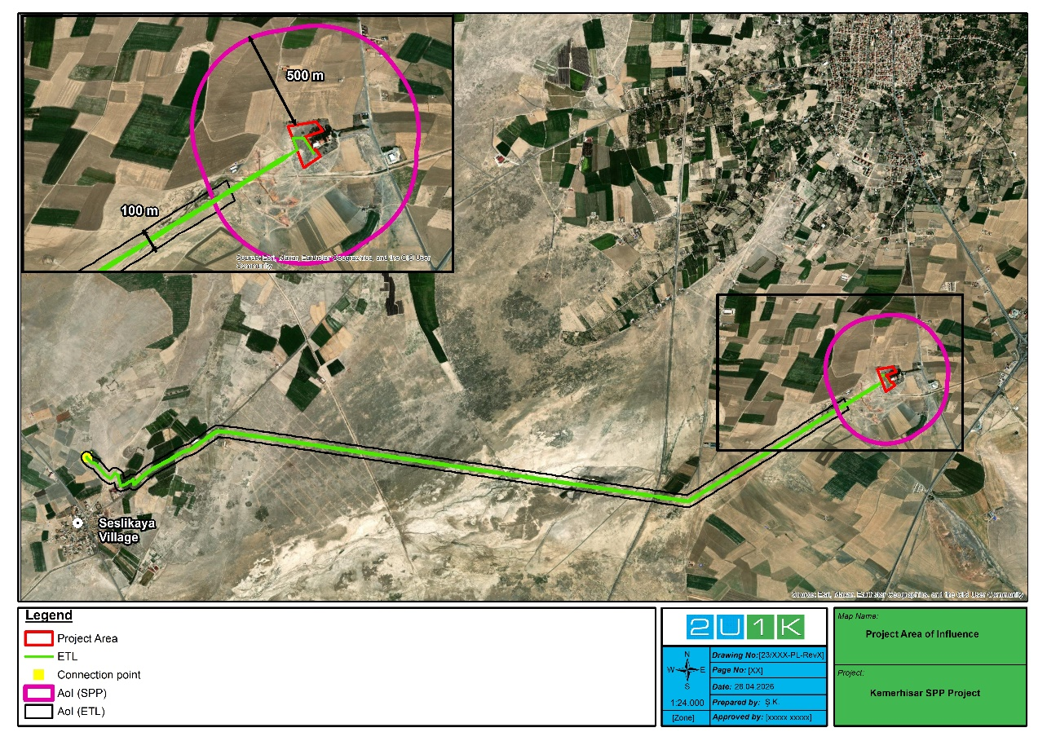
Figure 4-3. Area of Influence

Location and Topography
Kemerhisar Solar Power Plant (SPP) Project is located within the administrative boundaries of Niğde Province, in the southern section of Central Anatolia. The province lies close to the transition zone between the continental interior of Anatolia and the Mediterranean climatic belt. Although Niğde is an inland province without direct coastal access, its southern parts still experience the moderating effects of the Mediterranean climate. Summers are characteristically hot and arid, while winters remain relatively mild and moist. Seasonal temperatures may exceed 35°C during the summer months, whereas winter conditions are generally temperate, with limited frost and snowfall restricted to higher elevations.
The general topography of Niğde is diverse, consisting of broad plains and gently undulating lands that gradually rise toward the Taurus Mountains in the south. This variation creates a mosaic of valleys, uplands, and foothill areas, many of which are utilized for agriculture and greenhouse cultivation. The region benefits from fertile soils, numerous groundwater resources, and a high rate of solar irradiation throughout the year.
These environmental and morphological characteristics make Niğde suitable for solar-based renewable energy investments. The flat or slightly inclined terrain of the Kemerhisar Project Area, combined with its favorable climatic conditions and accessibility, provides an appropriate setting for the efficient operation of photovoltaic systems. The map showing the topography of Project area is given below.
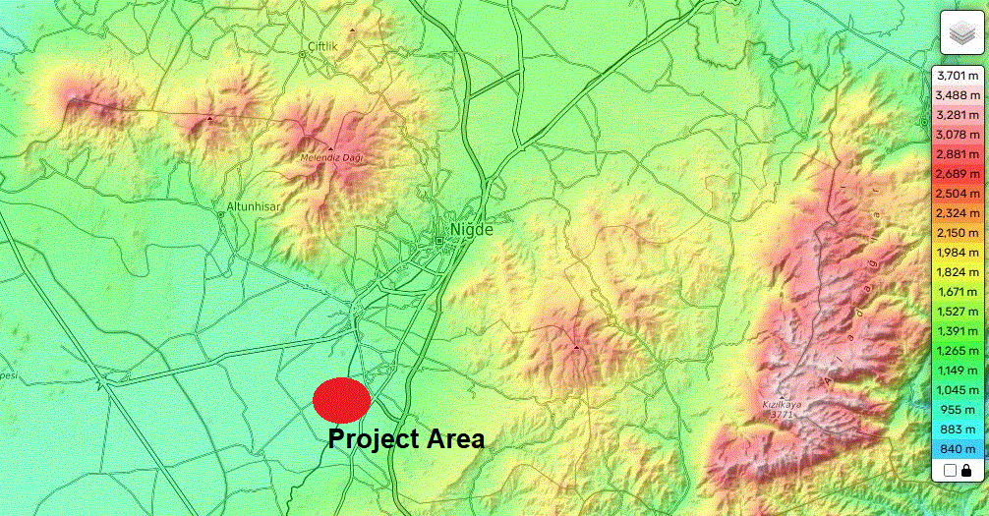
Figure 4-4. Topography of Project Area

Geography
The Kemerhisar SPP Project is situated within the Obruk Plateau, a characteristic geomorphological unit of Central Anatolia. This plateau forms part of a closed basin system, surrounded by mountainous areas to the north (Hasan and Melendiz Mountains) and east (Aladağlar), resulting in a bowl-shaped topography that channels surface water toward the central plains. The sub-project area lies approximately 25 km south of Niğde and 6 km south of Bor District, in Tepe rural neighborhood, at an elevation of around 1100 m above sea level. According to the Geotechnical and Foundation Survey Report, the foundation soil consists mainly of clay units and is suitable for construction. Based on the examinations and calculations conducted in the project area, no settlement or swelling is anticipated.

Climate
Niğde Province is located within the continental climatic zone of Central Anatolia, influenced to a limited extent by the Mediterranean climate in its southern parts. The region exhibits hot and dry summers and cold and wet winters, with a marked temperature difference between seasons. Snowfall is regularly observed during winter months, and this climatic regime directly influences agricultural and livestock activities in the area (Niğde Provincial Directorate of Agriculture and Forestry; NİTSO Report).
According to long-term records from the Turkish State Meteorological Service (MGM):
- Average annual temperature: 12.0 °C
- Average annual precipitation: 334 mm
- Average annual number of precipitation days: 89
- Absolute maximum temperature: 39.7 °C (August)
- Absolute minimum temperature: –25.6 °C (January)
- Monthly precipitation: highest in May (48.2 mm); lowest in July (5.5 mm)
- Monthly temperature range: –0.2 °C (January) to 22.9 °C (July)
Snowfall occurs on approximately 15 days per year, and the average snow cover thickness is around 30 cm, remaining on the ground for about one month during winter. In the Kemerhisar area, typical daily temperatures range between –4 °C and 30 °C throughout the year, with cold, snowy winters and dry, clear summers.

Flora and Fauna

Flora
The project area and transmission line route are located in the vicinity of Kemerhisar, Bor District, Niğde Province, at an altitude of approximately 1000–1100 meters above sea level. According to the Corine Land Cover (CLC) classification, the area falls within “Non-irrigated Arable Land,” “Pastures,” and “Permanently Irrigated Land” units. It represents an anthropogenic ecosystem heavily influenced by agricultural activities, and the natural vegetation has been largely degraded.
The existing vegetation is predominantly composed of annual herbs, ruderal taxa, field margin flora, and, in some locations, steppe species. Steppe flora elements and ruderal species associated with agricultural production (such as those along field margins and rural roads) are commonly observed, while forested or maquis-type formations are absent. Although literature studies have identified 9 endemic plant species that are or may be found in the project area, no endemic species were found in the field studies. The endemic species listed in Table 4-1 are not point endemics but are classified as widespread endemic species.
Within the scope of the Critical Habitat Assessment, these endemic species were evaluated against the relevant criteria and thresholds. Due to their wide distribution ranges and lack of restriction to specific or irreplaceable habitats, they do not meet the requirements for designation as Species of Conservation Concern (SCC). Accordingly, despite the endemic status of these species, their presence does not trigger Critical Habitat classification, and the project area is not considered to support flora species of elevated conservation sensitivity under IFC PS6. The floristic assessment identified, or anticipates the presence of, the plant species listed in Table 4-1 in the project area.

Table 4-1. Flora Species in Project Area
No | Species | Family | Common Name | Endemism | IUCN | BERN | CITES | Source
1 | Consolida glandulosa | Ranunculaceae | Larkspur | Endemic | - | - | - | *L
2 | Consolida raveyi | Ranunculaceae | Larkspur | Endemic | - | - | - | L
3 | Ceratocephala testiculatus | Ranunculaceae | Bur buttercup | Not endemic | - | - | - | L
4 | Roemeria hybrida subsp. hybrida | Ranunculaceae | Poppy | Not endemic | - | - | - | L
5 | Eruca sativa | Brassicaceae | Arugula | Not endemic | - | - | - | L
6 | Crambe orientalis vary. Orientalis | Brassicaceae | Oriental seakale | Not endemic | - | - | - | L
7 | Conringia orientalis | Brassicaceae | Hare’’s-ear mustard | Not endemic | - | - | - | L
8 | Capsella bursa-pastoris | Brassicaceae | Shephard’s purse | Not endemic | - | - | - | L
9 | Boreava orientalis | Brassicaceae | - | Not endemic | - | - | - | L
10 | Saponaria prostrata subsp. prostrata | Caryophyllaceae | Prostrate soapwort | Endemic | - | - | - | L
11 | Scandix stellata | Apiaceae | Starry shepherd’s needle | Not endemic | - | - | - | L
12 | Valerianella coronata | Caprifoliaceae | Crowned corn-salad | Not endemic | - | - | - | L
13 | Anthemis coelopoda varyete bourgaei | Asteraceae | Chamomile | Not endemic | - | - | - | L
14 | Anthemis austriaca | Asteraceae | Austrian chamomile | Not endemic | - | - | - | L
15 | Centaurea depressa | Asteraceae | Iranian knapweed | Not endemic | - | - | - | L
16 | Scariola viminea | Asteraceae | Pliant lettuce | Not endemic | - | - | - | L
17 | Nonea caspica | Boraginaceae | - | Not endemic | - | - | - | L
18 | Phlomis armeniaca | Lamiaceae | Jerusalem sage | Endemic | - | - | - | L
19 | Phlomis capitata | Lamiaceae | - | Endemic | - | - | - | L
20 | Phlomis nissolii | Lamiaceae | - | Endemic | - | - | - | L
21 | Wiedemannia orientalis | Lamiaceae | Dead-nettle | Endemic | - | - | - | L
22 | Molucella laevis | Lamiaceae | Shellflower | Not endemic | - | - | - | L
23 | Nepeta stricta varyete curvidens | Lamiaceae | Catmint | Not endemic | - | - | - | L
24 | Salvia suffruticosa | Lamiaceae | Greek sage | Not endemic | - | - | - | L
25 | Salvia cryptantha | Lamiaceae | - | Endemic | - | - | - | L
26 | Salvia dichroantha | Lamiaceae | West Anatolian sage | Endemic | - | - | - | L
27 | Secale cereale varyete cerale | Poaceae | Rye | Not endemic | - | - | - | L
28 | Leymus cappadocicus | Poaceae | Wild rye | Not endemic | - | - | - | L
39 | Hordeum vulgare | Poaceae | Barley | Not endemic | - | - | - | L
30 | Henrardia persica vary. glaberrima | Poaceae | Persian grass | Not endemic | - | - | - | L
31 | Juncus acutus | Juncaceae | Spiny rush | Not endemic | LC | - | - | *O
32 | Camphorosma monspeliaca | Amaranthaceae | Montpellier camphorosma | Not endemic | - | - | - | O
33 | Polypogon monspeliensis | Poaceae | Annual beard grass | Not endemic | - | - | - | O
34 | Alhagi maurorum | Fabaceae | Camelthorn | Not endemic | - | - | - | O
35 | Salix babylonica | Salicaceae | Weeping willow | Not endemic | - | - | - | O
36 | Centaurea solstitialis | Asteraceae | Yellow star thistle | Not endemic | - | - | - | O
37 | Morus alba | Moraceae | White mulberry | Not endemic | - | - | - | O
38 | Elaeagnus angustifolia | Elaeagnaceae | Russian olive | Not endemic | - | - | - | O
*L: Literature, **O: Observation

Table 4-2 Endemic Plant Species
Species Name | Figure
Consolida raveyi | 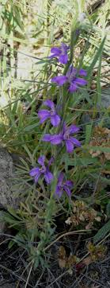  (Source: yabanicicekler.com)
Consolida glandulosa | No photographs of the species were found.
Saponaria prostrata subsp prostrata | 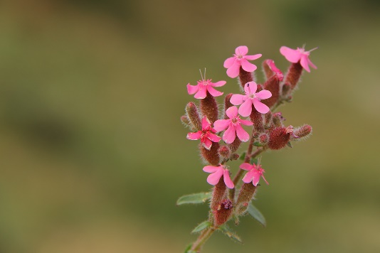  (Source: sekerali.com)
Phlomis armeniaca | 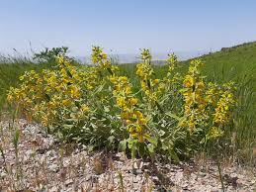  (Source: floranatolica.com).
Phlomis capitata | 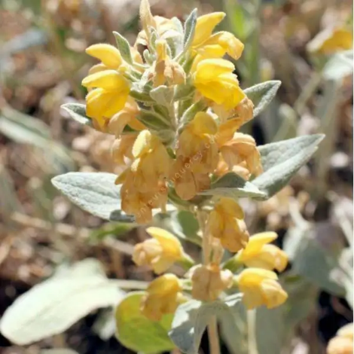  (Source: senteursduquercy.com)
Phlomis nissolii | 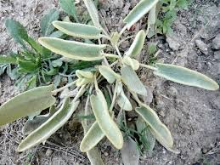  (Source: gerard-weiner.fr).
Wiedemannia orientalis | 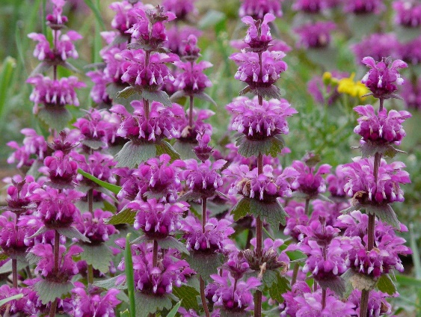  (Source: yabanicicekler.com).
Salvia cryptantha | 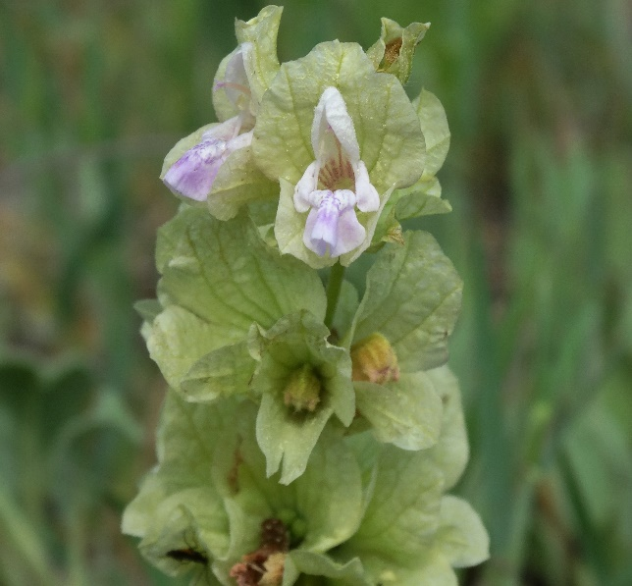(Source: yabanicicekler.com).
Salvia dichroantha | 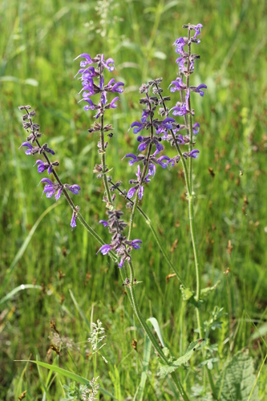  (Source: inaturalist.org).

Fauna
The project area mainly consists of agricultural lands and pasture habitats, and therefore, the faunal diversity is limited, though it reflects a structure typical of the region. While no forest habitats are present within the project boundaries, the surrounding open areas, farmlands, and rural settlements provide shelter, feeding, and breeding opportunities for certain mammal, reptile, and bird species.
Based on field observations and literature records, a total of 24 species have been identified in the Project area and its vicinity, including 2 amphibians, 6 reptiles, 9 birds, and 7 mammals.
According to the IUCN Red List, all recorded species are classified as Least Concern (LC), except Testudo graeca (Common Tortoise), which is listed as Vulnerable (VU).
All identified species are listed under the Bern Convention Annex II–III and are not globally threatened. Testudo graeca and Falco tinnunculus are further protected under CITES Appendix II. Given the ecological characteristics of the site, no endemic or critically endangered species were identified. Fauna species found or likely to be found in the Project area are given in Table 4-3 below.

Table 4-3. Fauna Species in Project Area
Species | Common Name | IUCN | BERN | CITES | Source
Amphibians
Ranidae
Pelophylax ridibundus | Marsh Frog | LC | Ann-III | - | L
Bufonidae
Bufo viridis | Green Toad | LC | Ann-II | - | L
Reptiles
Testudinidae
Testudo graeca | Common Tortoise | VU | Ann-II | App-II | L
Lacertidae
Lacerta trilineata |  | LC | Ann-II | - | L
Eremias strauchi | Strauch's Racerunner | LC | Ann-III |  | L
Colubridae
Dolichophis caspius | Large Whip Snake | LC | Ann-III | - | L
Eirenis modestus | Ring Headed Dwarf Snake | LC | Ann-III | - | L
Natrix tessellata | Dice Snake | LC | Ann-II | - | L
Birds
Passeridae
Passer domesticus | House Sparrow | LC |  |  | L
Emberizidae
Miliaria calandra | Corn Bunting | LC | Ann-III |  | L
Muscicapidae
Oenanthe oenanthe | Northern Wheatear | LC | Ann-II |  | L
Sturnidae
Sturnus vulgaris | Common Starling | LC |  |  | L
Hirundinidae
Hirundo rustica | Barn Swallow | LC | Ann-III |  | L
Ciconiidae
Ciconia ciconia | White Stork | LC | Ann-III |  | L
Corvidae
Pica pica | Eurasian Magpie | LC |  |  | L
Oriolidae
Oriolus oriolus | Eurasian Golden Oriole | LC | Ann-II |  | L
Falconidae
Falco tinnunculus | Common Kestrel | LC | Ann-III | App-II | L
Mammals
Erinaceidae
Erinaceus concolor | Southern white-breasted hedgehog | LC | - | - | L
Hemiechinus auritus | Long-eared hedgehog | LC | - | - | L
Cricetidae
Microtus guentheri | Guenther’s vole | LC | - | - | L
Muridae
Mus domesticus | House mouse | LC | - | - | L
Canidae
Vulpes vulpes | Red Fox | LC | - | - | L
Leporidae
Lepus europaeus | European hare | LC | - | - | L
Vespertilionidae
Pipistrellus kuhlii | Kuhl’s pipistrelle | LC | Ann-II | - | L

Critical Habitat Assessment
This section includes the Critical Habitat Assessment (CHA) conducted for the Project to identify areas considered critical habitat in line with IFC Performance Standard (PS) 6 and the associated Guidance Note (GN).
PS6 makes several stipulations for Critical Habitat, including achievement of a net gain for Critical Habitat-qualifying biodiversity. A net gain is required for all Critical Habitat features potentially affected by the Project. Where significant residual adverse effects are not predicted, additional conservation actions supported by qualitative evidence and expert opinion may be sufficient to substantiate a net gain. If, however, after the application of feasible preventive and restorative actions in the first steps of the mitigation hierarchy (avoid, mitigate, restore), there is a potentially significant residual impact on a Critical Habitat qualifying feature then ecological compensation (offset) is required with measurable conservation outcomes at an appropriate geographical scale. In Natural Habitat, no net loss, where possible, is required.
Critical Habitats will be identified using the critical habitat assessment criteria defined in IFC PS6. Critical habitats are defined as areas of high importance or value for biodiversity: (i) habitats of high importance for Critically Endangered and/or Endangered species; (ii) habitats of high importance for endemic and/or restricted-range species; (iii) habitats where globally migratory species are found and/or where species congregate in dense concentrations; (iv) highly threatened and/or globally unique ecosystems; and/or (v) areas associated with key evolutionary processes and/or ecological functions or features required to sustain the viability of the biodiversity values identified above.
PS6 guides how to best identify three classes of area based on vegetation condition (‘quality’ or ‘state’), and significance for biodiversity. PS6 uses the term ‘habitat’ to refer to these areas, rather than the actual vegetation within them. These three-area classed are (i) Modified Habitat; (ii) Natural Habitat; and (iii) Critical Habitat (with Critical Habitat a subset of Modified and Natural Habitat).
Habitat condition is classified as either Natural or Modified based on the extent of human modification of the ecosystem. Monoculture plantations, agricultural areas and urban areas are usually classed as Modified. Both Natural and Modified Habitats may contain globally important biodiversity values, thereby qualifying as Critical Habitat.
Areas Identified in PS6 |  | Condition of the Area
 |  | Natural | Modified
High Biodiversity Values | Present | Critical Habitat | Critical Habitat
High Biodiversity Values | Absent | Natural Habitat | Modified Habitat

Since habitat destruction is recognized as a major threat to the maintenance of biodiversity and to assess likely significance of impacts, IFC PS6 requires the following depending on habitat status:
Modified habitats are areas that may contain a large proportion of plant and/or animal species of non-native origin, and/or where human activity has substantially modified an area’s primary ecological functions and species composition.
Modified habitats may include areas managed for agriculture, forest plantations, reclaimed6 coastal zones, and reclaimed wetlands.
Performance Standard 6 applies to those areas of modified habitat that include significant biodiversity value, as determined by the risks and impacts identification process required in Performance Standard 1. The Municipality and the Contractor should minimize impacts on such biodiversity and implement mitigation measures as appropriate.
Natural habitats are areas composed of viable assemblages of plant and/or animal species of largely native origin, and/or where human activity has not essentially modified an area’s primary ecological functions and species composition.
The Municipality and the Contractor will not significantly convert or degrade natural habitats, unless all of the following are demonstrated:
- No other viable alternatives within the region exist for development of the project on modified habitat;
- Consultation has established the views of stakeholders, including Affected Communities, with respect to the extent of conversion and degradation; 8 and
- Any conversion or degradation is mitigated according to the mitigation hierarchy.
In areas of natural habitat, mitigation measures will be designed to achieve no net loss of biodiversity where feasible. Appropriate actions include:
- Avoiding impacts on biodiversity through the identification and protection of set-asides,
- Implementing measures to minimize habitat fragmentation, such as biological corridors,
- Restoring habitats during operations and/or after operations, and
- Implementing biodiversity offsets.
Critical habitats are areas with high biodiversity value, including (i) habitat of significant importance to Critically Endangered and/or Endangered species; (ii) habitat of significant importance to endemic and/or restricted-range species; (iii) habitat supporting globally significant concentrations of migratory species and/or congregatory species; (iv) highly threatened and/or unique ecosystems; and/or (v) areas associated with key evolutionary processes.
In areas of critical habitat, the Municipality and the Contractor will not implement any project activities unless all the following are demonstrated.
- No other viable alternatives within the region exist for development of the project on modified or natural habitats that are not critical;
- The project does not lead to measurable adverse impacts on those biodiversity values for which the critical habitat was designated, and on the ecological processes supporting those biodiversity values;
- The project does not lead to a net reduction in the global and/or national/regional population of any Critically Endangered or Endangered species over a reasonable period of time; and
- A robust, appropriately designed, and long-term biodiversity monitoring and evaluation program is integrated into the Municipality and the Contractor’s management program.
Identification of the Analysis Area
The information on the region’s ecology was carried out to define an ecologically appropriate Area of Analysis (AoA), to determine the presence of features that may qualify for Critical Habitat. The AoA is identified at a scale larger than the project site or impact area itself, considering large-scale ecological processes where appropriate. This approach ensures that all potential risks within the project footprint and surrounding vicinity are taken into consideration.
The AoA (1387 km2) was defined using a combination of topographic information and legally protected areas and/or internationally recognized areas of high biodiversity value. In this assessment, since a part of the ETL is located within the Ereğli Plain (KBA) and the habitats within the KBA are generally homogeneous, it was determined as the area that would represent the AoA. As a precaution, it will be assumed that all of the identified species are distributed in suitable habitats within this area.
The map showing the defined AoA is given Figure 4-5.
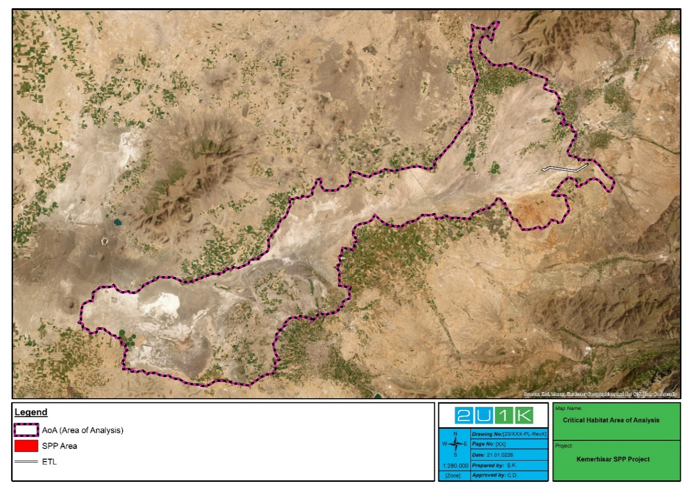
Figure 4-5. Area of Analysis
Assessment Criteria
Critical habitats are areas of high biodiversity value that include at least one or more of the five values specified in IFC-PS6 and/or other recognized high biodiversity values. Each criterion has the same importance for making critical habitat designations or for determining compliance with PS6. Criteria for defining critical habitats were set out in the IFC PS6 in 2012 and the World Bank's ESS6 (2017).
- Criterion 1: Critically Endangered (CR) and/or Endangered (EN) species
- Criterion 2: Endemic and/or restricted range species
- Criterion 3: Habitat supporting migratory and/or concentrating species
- Criterion 4: Highly threatened and/or unique ecosystems
- Criterion 5: Key evolutionary processes and applicable ecological functions.
Projects that are located within internationally and/or nationally recognized areas of high biodiversity value may require a critical habitat assessment:
- Areas that meet the criteria of the IUCN’s Protected Area Categories Ia, Ib and II.
- Key Biodiversity Areas (KBAs), which encompass Important Bird and Biodiversity Areas (IBAs).
- Biosphere Reserves and Ramsar Wetlands of International Importance
Criterion 1: Critically Endangered (CR) and/or Endangered (EN) Species
Species threatened with global extinction and listed as CR and EN on the IUCN Red List of Threatened Species shall be considered as part of Criterion 1. Critically Endangered species face an extremely high risk of extinction in the wild. Endangered species face a very high risk of extinction in the wild.
Thresholds for Criterion 1 are the following:
- Areas that support globally important concentrations of an IUCN Red-listed EN or CR species (≥0.5% of the global population and ≥5 reproductive units of a CR or EN species).
- Areas that support globally important concentrations of an IUCN Red-listed Vulnerable (VU) species, the loss of which would result in the change of the IUCN Red List status to EN or CR.
- As appropriate, areas containing important concentrations of a nationally or regionally listed EN or CR species.
Criterion 2: Endemic and/or Restricted-Range Species
For purposes of Criterion 2, the term endemic is defined as restricted-range. Restricted range refers to a limited extent of occurrence (EOO).
- For terrestrial vertebrates and plants, restricted-range species are defined as those species that have an EOO less than 50,000 square kilometers (km²).
- For marine systems, restricted-range species are provisionally being considered those with an EOO of less than 100,000 km².
- For coastal, riverine, and other aquatic species in habitats that do not exceed 200 km width at any point (for example, rivers), restricted range is defined as having a global range of less than or equal to 500 km linear geographic span (i.e., the distance between occupied locations furthest apart).
The threshold for Criterion 2 is the following:
- Areas that regularly hold ≥10% of the global population size and ≥10 reproductive units of a species.
Criterion 3: Habitat Supporting Migratory and/or Congregatory Species
Migratory species are defined as any species of which a significant proportion of its members cyclically and predictably move from one geographical area to another (including within the same ecosystem). Congregatory species are defined as species whose individuals gather in large groups on a cyclical or otherwise regular and/or predictable basis. Examples include the following:
- Species that form colonies.
- Species that form colonies for breeding purposes and/or where large numbers of individuals of a species gather at the same time for non-breeding purposes (for example, foraging and roosting).
- Species that utilize a bottleneck site where significant numbers of individuals of a species occur in a concentrated period of time (for example, for migration).
- Species with large but clumped distributions where a large number of individuals may be concentrated in a single or a few sites while the rest of the species is largely dispersed (for example, wildebeest distributions).
- Source populations where certain sites hold populations of species that make an inordinate contribution to recruitment of the species elsewhere (especially important for marine species).
Thresholds for Criterion 3 are the following:
- Areas known to sustain, on a cyclical or otherwise regular basis, ≥ 1 percent of the global population of a migratory or congregatory species at any point of the species’ lifecycle.
- Areas that predictably support ≥10 percent of the global population of a species during periods of environmental stress.
Criterion 4: Highly Threatened or Unique Ecosystems
The IUCN is developing a Red List of Ecosystems, following an approach similar to the Red List for Threatened Species. The Municipality and the Contractor should use the Red List of Ecosystems where formal IUCN assessments have been performed. Where formal IUCN assessments have not been performed, the Municipality and the Contractor may use assessments using systematic methods at the national/regional level, carried out by governmental bodies, recognized academic institutions and/or other relevant qualified organizations (including internationally recognized NGOs).
The thresholds for Criterion 4 are the following:
- Areas representing ≥5% of the global extent of an ecosystem type meeting the criteria for IUCN status of CR or EN.
- Other areas not yet assessed by IUCN but determined to be of high priority for conservation by regional or national systematic conservation planning.
Criterion 5: Key Evolutionary Processes and Applicable Ecological Functions
The structural attributes of a region, such as its topography, geology, soil, temperature, and vegetation, and combinations of these variables, can influence the evolutionary processes that give rise to regional configurations of species and ecological properties. In some cases, spatial features that are unique or idiosyncratic of the landscape have been associated with genetically unique populations or subpopulations of plant and animal species. Physical or spatial features have been described as surrogates or spatial catalysts for evolutionary and ecological processes, and such features are often associated with species diversification. Maintaining these key evolutionary processes inherent in a landscape as well as the resulting species (or subpopulations of species) has become a major focus of biodiversity conservation in recent decades, particularly the conservation of genetic diversity. By conserving species diversity within a landscape, the processes that drive speciation, as well as the genetic diversity within species, ensures the evolutionary flexibility in a system, which is especially important in a rapidly changing climate.
For illustrative purposes, some potential examples of spatial features associated with evolutionary processes are as follows:
- Landscapes with high spatial heterogeneity are a driving force in speciation, as species are naturally selected based on their ability to adapt and diversify.
- Environmental gradients, also known as ecotones, produce transitional habitat, which has been associated with the process of speciation and high species and genetic diversity.
- Edaphic interfaces are specific juxtapositions of soil types (for example, serpentine outcrops, limestone, and gypsum deposits), which have led to the formation of unique plant communities characterized by both rarity and endemism.
- Connectivity between habitats (for example, biological corridors) ensures species migration and gene flow, which is especially important in fragmented habitats and for the conservation of metapopulations. This also includes biological corridors across altitudinal and climatic gradients and from “crest to coast.”
- Sites of demonstrated importance to climate change adaptation for either species or ecosystems are also included within this criterion.
The significance of structural attributes in a landscape that may influence evolutionary processes will be determined on a case-by-case basis, and the determination of critical habitat will be heavily reliant on scientific knowledge. In the majority of cases, this criterion will apply in areas that have been previously investigated and that are already known or suspected to be associated with unique evolutionary processes. While systematic methods to measure and prioritize evolutionary processes in a landscape do exist, they are typically beyond a reasonable expectation of assessments conducted by the private sector.
Findings
As mentioned in the Limitations section above, due to the absence of population data for the species, the distribution ranges of species recorded in the project area and its vicinity were determined by comparing their widths within the Area of Analysis (AoA) to their global Extent of Occurrence (EOO).
Evaluation against each criterion is carried out in table format which includes potential triggering species, their IUCN status, relation to the Project AoA, observation status in the AoA and summary of finding. Potential species were selected in line with the Critical Habitat Criteria in comparison to literature information and survey findings.
For Criteria 1 to 3, the assessment relied on expert opinion due to the limited information available for estimating the number of individuals of potentially qualifying species within the Area of Analysis (AoA). This expert assessment aimed to evaluate the significance of the identified potential Critical Habitat in relation to the species’ global populations. To address the lack of local population data, the Extent of Occurrence (EOO) of each species was used as a proxy. This approach reflects a precautionary stance in evaluating the habitats against the PS6 thresholds. The global EOO information was sourced from the IUCN Red List Database, which encompasses all species that could potentially trigger Critical Habitat criteria.
In some cases, the presence of species in the AoA has been inferred based on habitat suitability. Suitable Habitat refers to habitat featuring ecological characteristics that may support the breeding, feeding, resting, or sheltering of species. Regardless of whether these habitats are modified or natural, they are identified as suitable if they meet these criteria. In cases where presence of a suitable habitat has been confirmed, the distribution within the species range and project AoA has been assumed.
It should be noted that population and range data of assessed species were gathered from the IUCN Red List Data Base.
Criterion 1: Critically Endangered (CR) and/or Endangered (EN) Species
To assess whether the Project triggers a CH under Criterion 1, a comprehensive list of CR, EN and VU species (VU species which are likely to trigger Criterion 1b) of the AoA has been developed based on baseline data. The assessment of unknown populations is given in
Table 4-4.

Table 4-4. Assessmnet of Criterion 1 (Unknown Population)
Species | IUCN | Extent of Occurrence (EOO) (km²) | EOO within AoA (km²) | % of Global Range in AoA  (≥0.5% for EN and CR) | Evaluation / Notes
Reptile
Testudo graeca | VU | 3167528 | 1030 | <0.05 | - This species ranges from the Mediterranean basin eastward to Iran, with populations found in North Africa, southern Europe and western Asia. It is widespread in Türkiye (except northeast).  - This proportion is not large enough to cause the Red List status of their loss to change to EN or CR.  - The AoA is therefore not considered to be of sufficient value to qualify as a Critical Habitat under Criterion 1b..

Criterion 2: Endemic and/or Restricted-Range Species
To assess whether the Project triggers Critical Habitat (CH) under Criterion 2, the assessment of Criterion 2 based on baseline survey counts is presented in Table 4-5.
Phlomis capitata, Consolida glandulosa, Consolida raveyi, Saponaria prostrata subsp. prostrata, Phlomis armeniaca, Phlomis nissolii, Wiedemannia orientalis, Salvia cryptantha, Salvia dichroantha were excluded from the assessment as they do not meet the PS6 definition that species with an EOO of less than 50,000 square kilometers (km²) are considered narrowly distributed. Therefore, these species were not included within the scope of Species of Conservation Concern.
Table 4-5 shows the information on endemic species, which were evaluated according to criterion 2.

Table 4-5. Extent of Occurrence (EOO) of Endemic Plant Species Identified through Literature Review
No | Species | Endemism | Estimated EOO (km²) | Restricted-range Assessment* | Distribution Map
1 | Phlomis capitata | Endemic | ~470,000 | Not restricted-range | 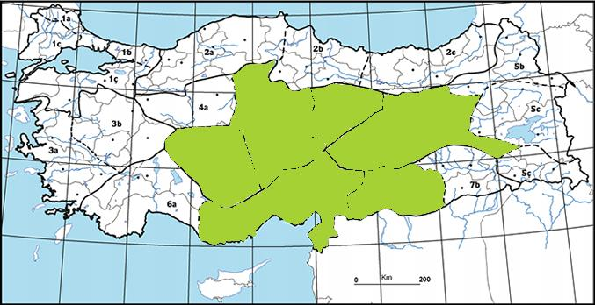
2 | Consolida glandulosa | Endemic | ~980,000 | Not restricted-range | 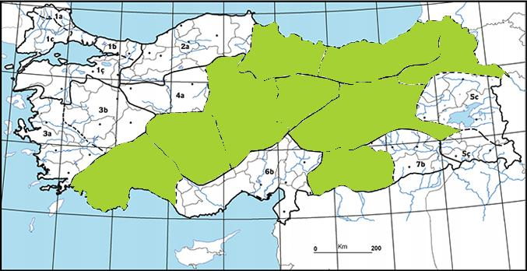
3 | Consolida raveyi | Endemic | ~630,000 | Not restricted-range | 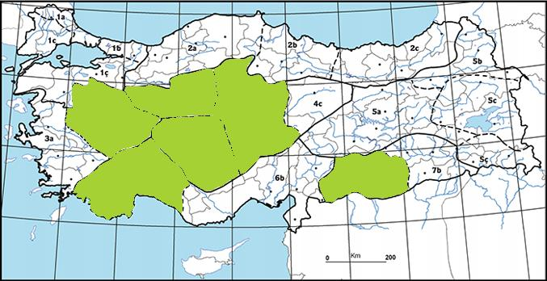
4 | Saponaria prostrata subsp. prostrata | Endemic | ~725,000 | Not restricted-range | 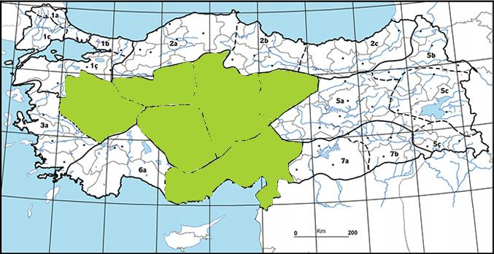
5 | Phlomis armeniaca | Endemic | ~1,100,000 | Not restricted-range | 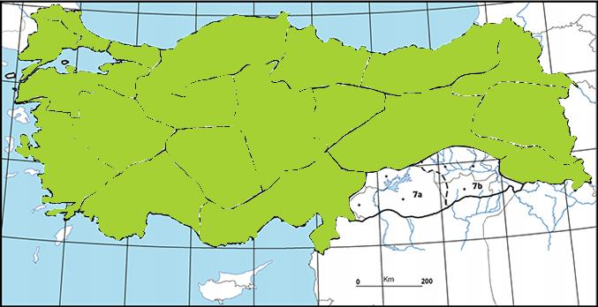
6 | Phlomis nissolii | Endemic | ~830,000 | Not restricted-range | 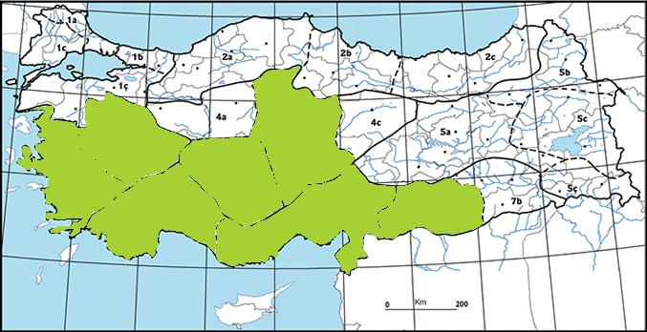
7 | Wiedemannia orientalis | Endemic | ~1,100,000 | Not restricted-range | 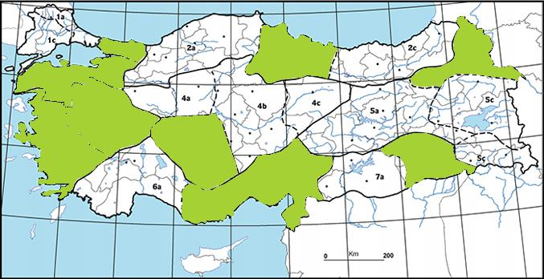
8 | Salvia cryptantha | Endemic | ~1,100,000 | Not restricted-range | 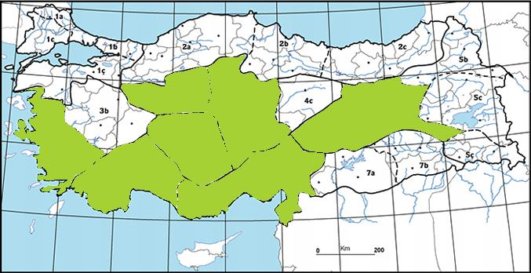
9 | Salvia dichroantha | Endemic | ~600,000 | Not restricted-range | 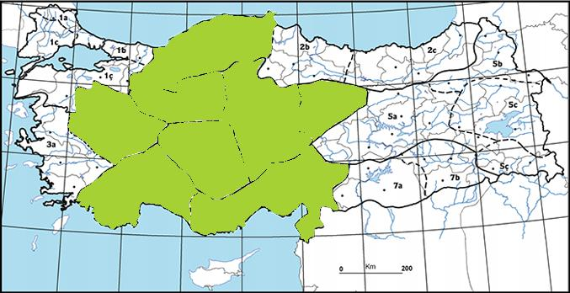

Criterion 3: Habitat Supporting Migratory and/or Congregatory Species
Although migration movements are observed in the Project site and its immediate vicinity, it is not a main migration route that is intensively used in terms of migration routes. Field observations and findings from previous studies, including data from eBird and Türkiye’s bird migration route map, further support the hypothesis that the area does not lie along a significant migratory pathway. The Project site and its immediate vicinity is not a habitat that migratory species can use for feeding and breeding purposes, and species use the airspace of the Project. The project site is subjected to intense grazing pressure, which is prevalent throughout the entire area and extends to sections outside the project habitat. This grazing activity significantly impacts the local ecosystem. Although water quality values do not appear to be detrimental to the continuity of aquatic life, it is evident that there is a high organic pollution load resulting from pollutants from various sources (anthropogenic activities) in the upstream part of the project area. Additionally, the habitat has been highly modified due to the anthropogenic land use, which negatively affects the ecological conditions in the area.
Counts of all bird species identified in terrestrial fauna studies are not available in the referenced sources. Therefore, they were evaluated according to the global distribution (EOO) also used in Criterion 1.
According to Criterion 3, for a migratory or congregatory species to trigger critical habitat, it must host 1% or more of its global population. Accordingly, in the methodology applied, the total area of habitats where the species can disperse within the project AoA must be at least 1% of the EOO of the species. For this condition, the minimum EOO area of a species should be 138,700 km². The EOOs of all bird species identified in the studies are larger than 138,700 km². Therefore, there are no species potentially meeting the threshold and Criterion 3 is not applicable.
Criterion 4: Highly Threatened or Unique Ecosystems
None of the ecosystems in Türkiye have been assessed according to the IUCN Red List of Ecosystems. Therefore, there are no quantitative thresholds available to assess the Project under CH criterion 4.
Based on the analysis of habitat types within the Area of Analysis (AoA), the Project area does not contain ecosystems that qualify as highly threatened or unique under Criterion 4 of the Critical Habitat definition. According to the CORINE Land Cover classification, the dominant land cover types within the AoA comprise non-irrigated arable land, permanently irrigated arable land, pastures, natural grasslands, and sclerophyllous vegetation. These habitat types are widely distributed at both national and regional scales and are characteristic of modified or semi-natural landscapes shaped by long-term agricultural activities. None of the identified habitats represent rare, irreplaceable, or globally significant ecosystems, nor are they recognized as being under imminent risk of collapse. Consequently, the Project area does not support highly threatened or unique habitats as defined under Criterion 4, and therefore does not trigger Critical Habitat designation under this criterion.
Criterion 5: Key Evolutionary Processes and Applicable Ecological Functions
The Project area does not exhibit distinctive geological, topographical, ecological, or evolutionary characteristics that would indicate the presence of key evolutionary processes or unique ecological functions. The area is not substantially different from the surrounding landscape in terms of elevation, moisture gradients, habitat heterogeneity, or environmental gradients that typically support evolutionary diversification or ecological specialization.
The Project area does not function as an isolated system, nor does it display spatial heterogeneity or environmental complexity sufficient to sustain unique or irreplaceable evolutionary processes. Field surveys and review of secondary data confirm that the habitats present within the Area of Analysis are representative of the broader regional landscape and have been shaped predominantly by long-term anthropogenic influences, including agricultural activities and grazing.
Accordingly, the Project does not meet the thresholds for Criterion 5 under the Critical Habitat definition, and therefore does not trigger Critical Habitat designation based on key evolutionary processes or applicable ecological functions.
It is important to implement action plans such as the mitigation measures and the Biodiversity monitoring programme to minimize the potential impacts of the project and protect the ecological values in the region. This will limit the environmental impacts of the project area and contribute to the long-term conservation of Ereğli Plain KBA.Although the Project is unlikely to be located within Critical Habitat, the Project will need to meet IFC PS6 expectations for the management of impacts on Modified and Natural Habitat. The requirements of PS6 paragraphs 12, 14 and 15 for projects located within Modified and Natural Habitat are provided below.
PS6 paragraph 12; ‘This Performance Standard applies to those areas of Modified Habitat that include significant biodiversity value, as determined by the risks and impacts identification process required in Performance Standard 1. The client should minimize impacts on such biodiversity and implement mitigation measures as appropriate.’
PS6 paragraph 14; ‘The client will not significantly convert or degrade natural habitats, unless all of the following are demonstrated: No other viable alternatives within the region exist for development of the project on modified habitat; Consultation has established the views of stakeholders, including Affected Communities, with respect to the extent of conversion and degradation; and Any conversion or degradation is mitigated according to the mitigation hierarchy.’
PS6 paragraph 15; ‘In areas of Natural Habitat, mitigation measures will be designed to achieve no net loss of biodiversity where feasible.’
PS6 footnote 9; ‘No net loss is defined as the point at which project-related impacts on biodiversity are balanced by measures taken to avoid and minimize the project’s impacts, to undertake on-site restoration and finally to offset significant residual impacts, if any, on an appropriate geographic scale (e.g. local, landscape-level, national, regional).
Accordingly, the species covered in this assessment will be considered as "Species of Conservation Concern (SCC)".

Limitations
Although field surveys aimed at identifying flora species are ideally conducted during flowering periods, the fieldwork for this Project was carried out during the summer months, after the main flowering season, due to project scheduling constraints. As a result, certain plant species—particularly those identifiable primarily through floral characteristics—may not have been detected during the surveys.
However, the data obtained and evaluated within the scope of this report are not solely based on field observations. The assessment also incorporates information derived from a comprehensive review of relevant literature and secondary data sources, which were used to supplement and support the field survey findings.

Earthquake Risks
According to regional geological assessments and disaster management data, Niğde Province is situated within an area affected by several active tectonic zones. The province occasionally experiences low to moderate seismic activity, mainly influenced by fault systems extending through Central Anatolia and its surrounding basins.
The primary fault structures controlling the seismic behavior of the region include the Tuz Gölü Fault Zone, Ecemiş Fault Zone, and Konya Fault Zone, accompanied by secondary discontinuities such as the Karaaömerler, Divanlar–Altınekin, and Göçü Faults. Among these, the Tuz Gölü Fault Zone represents the nearest active structure to both the Kemerhisar settlement and the solar project site.
According to the Türkiye Earthquake Hazard Map issued by the Disaster and Emergency Management Authority (AFAD, 2019), Niğde Province is categorized within a low-to-moderate seismic hazard region, with peak ground acceleration (PGA) values ranging between 0.2 and 0.4 g. Under national seismic zoning, this corresponds to a third-degree earthquake risk classification.
Geotechnical evaluations completed for the project site identified clay-dominant foundation soils exhibiting no evidence of deformation, settlement, or swelling, confirming that the ground conditions are suitable for structural development.
Field surveys and geological mapping did not reveal any active surface ruptures or fault traces within or adjacent to the project boundary. The closest mapped fault segment—part of the Tuz Gölü Fault Zone—lies outside the project area and does not intersect with any of the planned facilities or linear infrastructure.

Hydrology and Flood Risk
The hydrological characteristics of the project region are shaped by the closed basin structure of Central Anatolia, which limits surface drainage and creates locally confined catchments. The area surrounding Kemerhisar forms part of the Bor–Emen plain, where seasonal streams and man-made irrigation channels represent the main surface water features. There are no permanent rivers or natural lakes within or immediately adjacent to the project boundary.
The closest hydrological structure to the project site is the Seslikaya flood protection channel, which runs near the energy transmission line route. The power line passes above the channel with a minimum clearance of 8 meters, in accordance with technical permits granted by the State Hydraulic Works (DSİ). Excavation will be limited to the 1,000-meter underground cable section, while no works will be conducted within the channel area; hence, surface water flow will not be directly affected.Groundwater in the region is generally found at shallow to moderate depths, depending on local alluvial deposits. The Bor plain aquifer system is the principal groundwater body supplying both municipal and agricultural uses. Monitoring records from DSİ indicate that groundwater levels exhibit seasonal fluctuations in response to irrigation demands and precipitation cycles, but remain stable within normal limits for the area.
Based on the National Water Information System (USBS) flood risk mapping, the Kemerhisar settlement and surrounding areas are exposed to low to moderate flood probability, primarily related to intense rainfall events that can temporarily increase surface runoff within the drainage network. The project parcel itself, located on elevated terrain with gentle slope and agricultural surroundings, is outside the designated Q500 flood hazard zones defined by DSİ and USBS mapping.
Given these hydrological conditions, the project area does not contain sensitive or protected surface water bodies, and no flood-prone zones intersect with the planned solar plant site or transmission corridor. Routine inspections and preventive drainage maintenance are recommended during both construction and operational phases to sustain current site stability.

Project Land Use Rights
Within the scope of the Kemerhisar Solar Power Plant (SPP) Project, a total of 23 land parcels are located along the planned electricity transmission line route, of which 16 are publicly owned and 7 are privately owned. All of these parcels — including those under public ownership — will be subject to land acquisition or easement procedures in order to allocate them for project use. At the same time, the area where the solar panels will be installed belongs to Kemerhisar Municipality, and the land covers approximately 25 decares. The land is classified as “building plot (arsa)” in the land registry.
The land acquisition processes will be carried out in accordance with the applicable legal framework.
Information on all parcels to be used for the Project is presented in the table below.
Table 4-6. All Parcels Affected by the Project
No | Purpose of Expropriation | Parcel no | Province/District/Village | # of Shareholders | Type of Land | Landowner | Total Area of Land (m²) | Expropriated Area (m²) | Easement Area (m²)
1 | ETL | 114/186 | NİĞDE/BOR/SESLİKAYA KÖYÜ | 1 | Field | Candan Yanık | 5395,16 | 0 | 291,9
2 | Tower + ETL | 113/8 | NİĞDE/BOR/SESLİKAYA KÖYÜ | 1 | Field | Yasin Kaya | 6000,00 | 19,24 | 971,10
3 | Tower + ETL | 113/6 | NİĞDE/BOR/SESLİKAYA KÖYÜ | 1 | Field | Yasin Kaya | 20400,00 | 16,84 | 1.900,92
4 | ETL | 113/7 | NİĞDE/BOR/SESLİKAYA KÖYÜ | 1 | Field | İsmail Altay | 20700,00 | 0 | 355,01
5 | Tower + ETL | 115/18 | NİĞDE/BOR/SESLİKAYA KÖYÜ | 1 | Field | Ahmet Sume | 6800,00 | 10,89 | 1.011,52
6 | Tower + ETL | 109/2 | NİĞDE/BOR/SESLİKAYA KÖYÜ | 1 | Field | Osman Ölmez | 9500,00 | 19,30 | 1.525,15
7 | ETL | 108/1 | NİĞDE/BOR/SESLİKAYA KÖYÜ | 1 | Field | Osman Akköseler | 10600,00 | 0 | 1.359,29
8 | Tower | 117/2 | NİĞDE/BOR/SESLİKAYA KÖYÜ | 1 | Pasture land | Public Common Property | 17.000,00 | 12,85 | 0,00
9 | Tower | 117/1 | NİĞDE/BOR/SESLİKAYA KÖYÜ | 1 | Pasture land | Public Common Property | 41.300,00 | 3,24 | 0,00
10 | Tower | 118/1 | NİĞDE/BOR/SESLİKAYA KÖYÜ | 1 | Pasture land | Public Common Property | 38.440,00 | 3,24 | 0,00
11 | Tower | 127/1 | NİĞDE/BOR/SESLİKAYA KÖYÜ | 1 | Pasture land | Public Common Property | 22.600,00 | 3,24 | 0,00
12 | Tower | 126/1 | NİĞDE/BOR/SESLİKAYA KÖYÜ | 1 | Pasture land | Public Common Property | 23.000,00 | 3,24 | 0,00
13 | Tower | 134/1 | NİĞDE/BOR/SESLİKAYA KÖYÜ | 1 | Pasture land | Public Common Property | 89.000,00 | 3,24 | 0,00
14 | Tower | 133/1 | NİĞDE/BOR/SESLİKAYA KÖYÜ | 1 | Pasture land | Public Common Property | 85.100,00 | 3,24 | 0,00
15 | Tower | 132/1 | NİĞDE/BOR/SESLİKAYA KÖYÜ | 1 | Pasture land | Public Common Property | 120.500,00 | 3,24 | 0,00
16 | Tower | 470/200 | NİĞDE/BOR/SESLİKAYA KÖYÜ | 1 | Pasture land | Public Common Property | 7.962.668,93 | 42,12 | 0,00
17 | Tower | 559/2 | NİĞDE/BOR/SESLİKAYA KÖYÜ | 1 | Pasture land | Public Common Property | 1.882.533,89 | 23,85 | 0,00
18 | ETL | 476/1 | NİĞDE/BOR/SESLİKAYA KÖYÜ | 1 | Railway line | Republic of Turkey State Railways (TCDD) | 417.373,43 | 0,00 | 111,02
19 | Tower | 491/6 | NİĞDE/BOR/SESLİKAYA KÖYÜ | 1 | Pasture land | Public Common Property | 490.621,69 | 23,13 | 0,00
20 | Tower | 489/138 | NİĞDE/BOR/SESLİKAYA KÖYÜ | 1 | Pasture land | Public Common Property | 443.122,94 | 29,16 | 0,00
21 | Tower | 515/329 | NİĞDE/BOR/SESLİKAYA KÖYÜ | 1 | Pasture land | Public Common Property | 227.217,56 | 21,21 | 0,00
22 | ETL | 515/243 | NİĞDE/BOR/SESLİKAYA KÖYÜ | 1 | Bare land | Treasury of Finance | 8.900,00 | 0,00 | 338,94
23 | Tower and Solar Panel Site | 515-441 | NİĞDE/BOR/SESLİKAYA KÖYÜ | 1 | Plot | Kemerhisar Municipality | 21.436,39 | 91,00 | 654,20

Socioeconomic Situation
Considering the project area, socio-economic information about Niğde Province, Bor District, Kemerhisar Municipality and Seslikaya Village is given in this section, respectively.
According to TÜİK's 2024 data, Niğde Province has a population of 372,708, of whom 186,509 are female (50.04%) and 186,199 are male (49.96%). Niğde Province's population growth rate is -1.16%. Furthermore, the average household size in Niğde Province is 3.00.
According to data from the same year, Bor District has a population of 62,346, of whom 31,479 are female (50.46%) and 30,867 are male (49.51%). Bor District's population growth rate is -0.33%.
According to TÜİK's 2022 data, Kemerhisar Municipality has a population of 5,463. In addition, during the interview with the village headman, it was learned that the population of Seslikaya Village was 100 people.

Niğde Province
According to the 2022 Niğde Province Economic Indicators data, Niğde's economy is based on agriculture. 70% of the working population earns a living from agriculture. Industrialization has begun to develop in recent years. Apples, legumes, sunflowers, potatoes, wheat, barley, rye, beans, chickpeas, garlic, and sugar beets are the most commonly grown products. In addition, viticulture is also among the main sources of livelihood in Niğde Province.The share of the labor force employed in the manufacturing and construction sectors is relatively low. Although the province hosts Organized Industrial Zones and small- to medium-sized enterprises, large-scale industrial facilities are limited. In recent years, investments in solar energy have increased, and Türkiye’s second-largest solar power plant is located within the boundaries of Niğde.

Socioeconomic Development
According to the 2017 Socio-Economic Development Index (SEGE) study prepared by the General Directorate of Development Agencies under the Republic of Türkiye, Niğde ranks 57th among the 81 provinces and is classified as a lower-middle developed province. This ranking also corresponds to the regional average within the TR71 Region (comprising Niğde, Kayseri, Sivas, and Yozgat).

Main Labour Force Indicators
In the TR71 Region, where Niğde is located, the labour force participation rate is below the national average. According to 2023 data from the Turkish Statistical Institute (TURKSTAT), the labour force participation rate across Türkiye is approximately 53.3%, while the TR71 Region falls slightly below this average. Unemployment rates in the region are observed to be close to or slightly below the national average. Information about main labour force indicators is given in Table 4-7 below.
Table 4-7. Main Labour Force Indicators of Türkiye and TR71 Region
Main Labour Force Indicators | Labour force participation rate (%) | Employment Rate | Unemployment Rate
Main Labour Force Indicators | 2021 2022 | 2021 2022 | 2021 2022
TR71 (Niğde, Kayseri, Sivas, Yozgat) | %50,2 %49,9 | %43,7 %45,2 | %13 %9,4
Türkiye in General | %51,4 %53,1 | %45,2 %47,5 | %12 %10,4
Source: TURKSTAT

Bor District
The economy of Bor District is predominantly based on agriculture, livestock, textile handicrafts, and leather processing. Although the land in the district is generally suitable for agriculture, its limited extent and progressive urbanization have led to a decline in agricultural activity over time, prompting migration to education, public employment, and overseas work. Agriculture remains a significant source of income for many households. Major crop outputs include cereals, chickpeas, potatoes, onions, beans, sugar beet, and widespread vegetable and fruit cultivation. Notably, the famous Niğde apple is also produced around Bor in valley zones. Livestock farming, particularly small ruminants, is important economically, with bovine numbers on the rise.
Bor is especially renowned for its leather industry, which dates back to the 16th century and today accounts for an estimated ~60 % of the district’s economy. The district supplies approximately 20 % of Turkey’s leather. Production is carried out by numerous traditional tanneries, many operating under challenging conditions. While larger industrial-scale processing remains limited, Bor hosts industrial facilities such as a sugar factory, an military factory, the BİRKO (Koyunlu) carpet factory, and tanning workshops—despite lacking downstream industries that could utilize processed hides.
Bor District has also been identified as highly suitable for solar energy investments, owing to its high solar radiation levels and the availability of lands unsuitable for conventional agriculture but ideal for photovoltaic development. In 2015, an Energy Specialized Industrial Zone covering approximately 2,539 hectares across Emen, Seslikaya, and Badak villages was officially designated, later recognized as a Renewable Energy Resource Area (YEKA) in 2018.
The presence of Niğde Ömer Halisdemir University’s vocational schools—specifically Bor Vocational School and Bor Halil Zöhre Ataman Vocational School—has contributed to local employment and skills development, especially in fields such as computer science, electronics, and animal husbandry.
The district's population, according to 2021 Address-Based Register System data, stands at approximately 59,919 individuals, nearly equally divided between male and female residents. Bor remains categorized among underdeveloped regions, with per-capita income levels well below the national average. While older traditional economic activities such as rug weaving, leatherwork, and apple cultivation have declined, recent developments - most notably the growth of the tanning sector and educational infrastructure - have partly revitalized the local economy.

Kemerhisar Municipality
Kemerhisar is a town in Bor District of Niğde Province, located about 8 km from Bor and 22 km from Niğde city center. As of 2022, its population stands at 5,463 (TurkStat).
The economy is mainly agricultural, with production focused on apples, grapes, potatoes, onions, and vegetables. Some residents work in the nearby Bor sugar factory, and small-scale livestock farming is also common.
Historically, Kemerhisar sits on the ancient Roman city of Tyana. It is home to a 1.5 km-long Roman aqueduct and other archaeological remains, including a recently uncovered early Christian church.
With socio-economic indicators below the national average, the town faces outmigration, particularly among youth seeking better opportunities. Still, Kemerhisar holds potential for growth in agriculture and cultural tourism, supported by its historical significance and strategic location.

Seslikaya Village
On July 29, 2025, a headman meeting and household interviews were held to examine the socioeconomic situation of Seslikaya Village, which is within the project impact area, and a focus group interview was also held with the female residents of the village.
During an interview with the village headman, it was learned that the majority of the villagers are between the ages of 36 and 65. It was also noted that the village population has decreased due to deaths from old age in the last five years. The village's primary source of income is livestock, with a total of approximately 230 head of cattle and 2,000 head of small cattle. The village's secondary source of income is agriculture, where crops such as beets, barley, and wheat (irrigated agriculture) are cultivated.
The village has electricity, internet, and telephone lines. The nearest health center is 9 km away in Kemerhisar Municipality, and the nearest school is 16 km away in Bor District.
During an interview with the village headman, it was learned that the drinking water network in the village is inadequate and that residents need a water tank. It was also stated that although the village has a sewer system, it is quite inadequate and suffers from constant blockages.
There are multiple solar power plants within the lands of Seslikaya Village. The village headman and residents stated that these solar power plants encroach on fertile land, harming livestock production. In a focus group interview with the women, it was stated that many different companies conduct interviews with the villagers before implementing their solar power plant projects, just as we did. These companies reportedly made numerous promises regarding services and employment, but they never fulfilled any of them. Consequently, the villagers reluctantly participated in our social work, believing that the information they provided would be useless.
In addition, during the interview with the headman, it was learned that there were elderly individuals in need of care, physically / mentally disabled people, female household heads, and refugees in the village. The numbers of the vulnerable groups listed are presented in
Table 4-8.
Table 4-8. Vulnerable/Disadvantaged Individuals/Groups in the Project Area
Settlement | Elderly individuals in need of care | Physically / Mentally disabled | Female Household Head | Refugees
Seslikaya Village | 1 | 1 | 15 | 20
Source: Survey study with the headmen, 2025
During the interview with the headman, it was learned that there were no historical buildings or monuments within the village borders and on the lands close to the village.

ENVIRONMENTAL AND SOCIAL MANAGEMENT PLAN
The activities to be performed in the scope of the Project are presented in Mitigation Plan for the Project and considered for the assessment of the best practice mitigation measures defined for the Project.
The activities to be carried out within the scope of the Project will be in compliance with the most up-to-date national legislation and WB standards. Where Turkish legislation differs from WB Policies, the stricter one will be applied for the implementation of the Project.
The monitoring, review and audit program detailed in Monitoring Plan for the Project will be implemented during construction and operation phases to monitor the implementation of the environmental and social commitments of the ESMP requirements. Monitoring for the implementation of mitigation measures and commitments provided in the ESMP will be carried out continuously by the contractor and Project Owner in line with Monitoring Plan starting from the Construction Project. Project Owner will audit the Project every six (6) months during the construction period and once a year during the operation period. The Project Owner will be responsible for ensuring that the Contractor and its subcontractors comply with applicable national/international regulations and lenders' requirements.

Mitigation Plan for the Project
No. | Topic | Definition of Potential Impact | Type of Impact | Impact Significance Before Mitigation | Cost | Measures to be Taken | Responsibility | Key Performance Indicators
C1 | Disclosure | Insufficient information | Adverse | Low | Included in construction costs | - Before the start of construction works, the local people and all relevant stakeholders will be informed of the works to be performed and the measures to be taken.  - The information on the start and finish dates of construction and working periods and the permits obtained from the provincial/district municipality will be shown by the operations owner in a signboard that is easily visible to all personnel at the construction site. | Contractor  Project Owner | - Number of grievances  - Percentage of closed grievances within the target timeframe
C2 | Occupational Health and Safety (OHS) | Inadequate workers health and safety conditions | Adverse | High | Included in construction costs | - The Project management unit to be formed by the Project owner and the contractor's project team will include staff(s) (at least one environmental and one social expert and one full time Class A OHS expert) who will take part in full-time and effectively control the implementation of the Project and, Project Owner will make sure that the measures provided below are taken by the contractor, and enforce necessary actions/sanctions in case lack of these measures on site.  - To control the cases (fire, earthquake, etc.) which may occur during the construction activities under the Project, and which require urgent action, an EPRP and an OHS Management Plan will be prepared and shared with all employees.  - The Project Owner will require all employees and contractors to adhere to local and international health and safety legislation and guidelines. Workers will be provided with all suitable personal protective equipment (PPE) (hard hats, safety harnesses, protective coveralls, glasses, gloves, armor-clad steel-toed shoes, etc.).  - Appropriate hand and face washing facilities will be provided to the employees, and also shower facilities for dusty works.  - Technical and OHS legal basic training, orientation, tool box trainings and on the job training including the code of conduct indicating the possible risks regarding the work site and works to be carried will be given to workers by the contractor. Training will also be given on risks that may arise due to changes in workplace or job, change of work equipment, application of new technology. Information and training activities will be carried out not only for the employees, but also about the measures to be taken for community health and safety.  - All employees will be informed about working conditions, job definitions, responsibilities, relations with the local community and potential work risks and precautions.  - Workers will be required to comply with all OHS regulations and necessary inspections will be made additionally workers also should have professional competency certificates for the specific tasks.  - The contractor formally agrees that all work will be carried out in a safe and disciplined manner and is designed to minimize risks on neighboring residents and environment.  - All activities will be implemented in line with both the Law on Occupational Health and Safety and its relevant regulations, and also the WBG EHS Guidelines.  - The contractor will assign full-time personnel with Class A certification and experience in charge of OHS and she/he shall monitor the site OHS implementations.  - Before the construction works start, a Risk Assessment study will be implemented for all works to be carried out and legal OHS training for the team should be completed. EPRP will be prepared and put into practice. Both the Risk assessment and EPRP will take into consider communicable disease risks.  - Emergency teams will be formed, and drills and training programs will be carried out in line with emergency scenarios.  - Employees will have a good command of emergency plans, and the grievance will be reported to the authorized teams and resolved, if they require urgent action.  - Appropriate signposting of the sites will be provided in accordance with the Health and Safety Signs Regulation, and then workers will be informed about the meaning of the signs and the key rules and regulations to follow.  - OHS trainings and toolbox talks will be provided to the employees including the code of conduct indicating the possible risks regarding the work site and works to be carried out. These will include regular trainings to workers on COVID-19 and other infectious diseases symptoms, how to be protected and what to do when symptoms appear.  - First aid kit will be kept available at the construction site, taking into account that first aid response may be required before the casualty is referred to the nearest healthcare provider. In accordance with the First Aid Regulation, an adequate number of trained first aiders will be assigned at the construction site.  - Both trainings and incidents (fatalities, near misses, lost time incidents, any significant events including spills, fire, outbreak of pandemic or communicable diseases, social unrest, etc.) will be recorded.  - In the event of any significant incident (e.g. environmental, social, labor or lost-time incidents) the Contractor shall immediately notify Kemerhisar municipality shall inform ILBANK and WB within 24 hours. Then, within 15 days, a report on the root causes of the incident and the corrective actions to be taken will be presented to ILBANK and WB.  - Guidance, directives and recommendations of Ministry of Health, Ministry of Family and Social Services, WHO and the WB shall be followed and all relevant necessary measures shall be taken, both for occupational health and safety of employees and for workplaces, in case of an outbreak of any other pandemic/communicable disease including COVID-19.  - Since the works will be performed at areas close to the public, the public access to these areas shall be restricted by any means. If a trench needed to be left open for night, the sufficient illumination of the area shall be ensured by the Contractor and necessary signs shall be placed, and the area shall be enclosed with physical robust barriers without leaving any space between them.  - Installation of concrete molds, concreting, installation of water tank etc. may require working at height, working in confined space etc. Therefore relevant procedures such as Confined Space Entry Procedure, Working at Height Procedure, etc. will be prepared in accordance with applicable national requirements and internationally accepted standards.  - Adequate and appropriate training in confined space hazard control, atmospheric testing, use of required PPE as well as the serviceability and integrity of PPE shall be verified before workers are required to enter a permitting confined space. In addition, adequate and appropriate rescue and/or rescue plans and equipment shall be in place before the worker enters the confined space. In the event of an accident, coordination will be established with the emergency response teams to ensure that the most accurate first aid is given. The Emergency Action Plan will be revised in accordance with the operational period and necessary training will be given to all personnel. A work permit system will be implemented for work at heights and confined space entries.  - Only personnel holding the height work permit will work at height, and safeguarding measures (guardrails, fall arrest) will be in place.  - The construction areas will be surrounded and necessary security measures will be taken, no one will be allowed to enter except for the staff.  - The WBG General Environment, Health and Safety Guidelines will apply.  - Equipment that meets international standards in terms of performance and safety will be used.  - All equipment used during the construction phase will be kept in good working condition.  - In accordance with the regulation, the contractor will designate a full-time OHS responsible person with the requisite certification and experience, along with an workplace physician and a nurse, to monitor field practices.  - Manual handling of PV modules and structural elements will be supported with mechanical aids (e.g., panel lifters, carts, cranes) to reduce musculoskeletal strain and lifting-related injuries.  - Work–rest schedules will be arranged in accordance with ambient temperature and humidity conditions in Niğde; during extreme heat (>35°C), outdoor works will be limited to early morning and late evening hours.  - Workers will be instructed to maintain hydration, and shaded resting areas will be provided across the site.  - Noise exposure from generators, vehicles, and mechanical tools will be controlled through scheduled maintenance and the use of hearing protection.  - A Weather Monitoring Procedure will be applied to suspend works during lightning, strong winds, or storms, particularly along the ETL route and open field areas.  - Periodic ergonomic assessments will be conducted to evaluate postural risks and adjust working methods, especially during PV module installation and maintenance.  - Cleaning agents and lubricants used during maintenance will be handled according to Material Safety Data Sheets (MSDS), and workers will receive training on chemical handling.  - Lightning protection systems and earthing controls will be inspected before any outdoor maintenance or electrical intervention works.  - All vehicles and heavy machinery entering the site will undergo routine inspection for safety compliance and fuel leakage prevention.  - Fatigue management practices will be introduced, including rotation of high-risk tasks and monitoring of working hours, especially during the peak construction season.  - Insect and wildlife encounters (e.g., snakes, scorpions) will be recorded and managed by the OHS team through awareness training and safe relocation procedures.  - Regular psychological well-being checks will be performed by the workplace physician to reduce stress and fatigue among workers operating under harsh climatic conditions.  - Panel cleaning operations will be conducted under supervision, using safety harnesses and non-slip footwear to prevent falls.  - Lightning-prone work areas will be equipped with grounding rods and warning signage to prohibit entry during storm alerts. | Contractor  Project Owner | - % of scheduled HSE Inspection  - % of attendance at HSE meetings  - % of closing of Non Compliance Reports (NCRs)  - Reporting safe observations  - Reporting unsafe observations  - Reporting near misses  - % of Toolbox attending  - % of Risk Assessment compliance  - % of Legal Requirements compliance  - Results of scheduled audits  - HSE training carried out to training matrix  - > 90% of all training to matrix  - % of attendance at scheduled trainings  - Engagement in HSE program by individual managers and supervisors  - Engagement in HSE program by contractor’s  - # of accidents/incidents  - # of drills  - # of toolbox trainings  - % of workers trained on heat stress, ergonomics, and weather safety procedures  - # of weather-related work suspensions (due to lightning, strong wind, or extreme heat)  # of ergonomic assessments conducted / corrective actions implemented  - # of chemical handling and MSDS training sessions conducted  - # of fatigue and psychosocial well-being evaluations conducted by occupational physician
C3 | Employment / Economy | Child labour, forced labour and unregistered employment  Contribution to economy | Adverse | Low | Included in construction costs | - Care will be taken to contributing to the local economy through the use of local materials and to procuring various goods and services from local resources.  - Priority should be given to the local labor where possible and practical.  - Efforts will be exercised to allocate employment opportunities to the local parties and the settlements within the AoI.  - The work permits of the employees will be controlled within the scope of the Project, prohibiting child labor, forced labor, and child labor under the age of 18.  - Discrimination in the workplace will be eliminated.  - Necessary measures will be taken by contractor to make sure that workers coming from outside the city will be given a training program on dialogue and communication with local communities, and that there are no social or cultural issues between host communities and external workers. It is the Project Owner's responsibility to ensure that the contractor complies with the determined criteria. | Contractor  Project Owner | - Number of grievances  - Percentage of closed grievances within the target timeframe
C4 | Institutional Arrangements and Capacity Development | Insufficient institutional capacity or lack of awareness among project personnel regarding ESMP and E&S standards may lead to non-compliance or ineffective implementation. | Adverse | Medium | Included in construction costs | - Establish a Project Management Unit (PMU) including at least one Environmental Specialist, one Social Specialist, and one full-time Class A OHS Expert.  - Prepare a site-specific Contractor ESMP (C-ESMP) before mobilization and obtain approval from Project | Project Owner / Contractor | - Number of trainings; % of staff trained; % of non-compliances corrected through capacity measures.
C5 | Resource Efficiency and Pollution Prevention | Excessive water use, improper waste handling, or inefficient energy consumption during construction and operation may increase environmental footprint. | Adverse | Medium | Included in construction costs | - Optimize water use (closed-loop system, reuse). Use closed-loop or semi-closed water circulation systems for panel cleaning and dust suppression, minimizing fresh water abstraction. Collect, filter, and reuse washing water where technically feasible; prevent discharge of turbid water to soil or surface drainage.  - Recycle construction materials. Segregate construction waste at source (metal, wood, glass, packaging, soil, concrete) and ensure recovery and reuse on site where possible. Ensure that recyclable waste (e.g. cable reels, metal parts, packaging) is delivered only to licensed recycling facilities.  - Ensure fuel-efficient machinery and regular maintenance. Use modern machinery and vehicles meeting Euro 5 emission standards (or equivalent). Implement a preventive maintenance schedule for all machinery and vehicles to reduce fuel consumption and emissions. Idle running of machinery longer than 5 minutes will be prohibited. Record fuel consumption per activity and cross-check against benchmarks in the ESMR to identify improvement opportunities.  - Track waste quantities and recycling ratios. Calculate and report monthly recycling ratios (%) and total waste generation per MW installed. Maintain waste transfer manifests signed by licensed transporters and final disposal facilities.  - Promote energy efficiency and low-carbon operations. Use energy-efficient lighting, inverters, and transformers with low standby losses. Prefer local suppliers to reduce transportation-related emissions. Record electricity use during operation and identify opportunities for carbon footprint reduction. | Contractor / Project Owner | Water/fuel use per MW; % of waste recycled; number of pollution incidents.
C6 | Social Life | Potential Community Disturbance | Adverse | Low | Included in construction costs | - The Contractor will provide training to the site personnel on environmental and social issues. It is the Project owner's responsibility to ensure that the contractor complies with the determined criteria.  - The operations to be carried out during construction works will be performed not to restrict / hinder the social and economic life of local people.  - To avoid any impact on the safety and daily life of communities, safety and information signs will be placed on site before the work.  - The public, and nearby institutions and organizations, and hospitals and schools will be informed at least two days before starting repair / maintenance works that may cause disturbance temporarily.  - The construction activities to be performed around or in front of hospitals and/or healthcare providers will be planned not to hinder the public access to these services and the opinions of the relevant stakeholders will be sought in order to determine the common working strategy in this regard  - The Project Owner will ensure that contractors establish the code of conduct and will check that workers will be given training especially on communication with local people of foreign nationality public before starting work, so that local people of foreign nationality will not be adversely affected by external workers. | Contractor  Project Owner | - Number of grievances  - Percentage of closed grievances within the target timeframe
C7 | Labor Conditions | Improper Working Conditions,  Child labor, forced labor and unregistered employment | Adverse | Low | Included in construction costs | - Workers will be allowed to have access to the Grievance Redress Mechanism and will be required to be aware about this Mechanism.  - All workers will be given training on discrimination and codes of conduct. The trainings given to the employees will be explanatory about the concepts of sexual harassment and abuse, gender-based violence, abuse and intervention with harassment. At the same time, through the trainings, it will be ensured that workers learn the Grievance Redress Mechanism of the Project (explained in detail in the Project's SEP document) and the steps to be followed in exercising their legal rights. Access to the Grievance Redress Mechanism will be easy and effective. The grievance redress mechanism officer designated for the Project will be announced to all employees during the trainings to be given before starting work. There will be brochures and posters containing the grievance redress mechanism and the contact information of the authorized person in places such as the cafeteria, canteen and service areas used by the employees.  - Minimum legal labor standards will be met (child/forced labor, anti-discrimination, working hours, minimum wages) as per International Labor Organization (ILO) regulations.  - At the same time, the Operational Policies of the World Bank and the national legislation will be complied with in terms of the working conditions.  - Workers will be provided hygienic and adequate facilities.  - Workers will be allowed to have access to primary healthcare on site, enabling the provision of prescriptions.  - Discrimination based on language, race, gender, political thought, philosophical belief and religion will be avoided in business relations. | Contractor  Project Owner | - Number of grievances  - Percentage of closed grievances within the target timeframe
C8 | Community Health and Safety | Community health and safety risks | Adverse | High | Included in construction costs | - To minimize the impact of the traffic activities that are expected to intensify during the construction phase, the working hours will be adjusted according to the peak hours of transportation.  - Special crossings will be created by taking additional measures for the elderly, pregnant women, people with small children and the disabled.  - The project area will be fenced to avoid physical hazards to the communities associated with the project.  - Contractors will take necessary health and safety measures, such as using appropriate warning signs and signboards, arranging time schedule of noisy works (mostly after 9:00 AM before 6 PM), making the regular maintenance of the machinery, replacement or repair of part which cause noise and performing watering in dry seasons, under the management of the Project Owner during site preparation and construction activities so that the public is informed of the construction plan and locations in a timely manner and the construction sites are determined.  - Care will be taken to ensure that warning signs are visible and illuminated at night and in bad weather conditions.  - According to relevant regulation; the adequate number of appropriate firefighting equipment will be kept available at construction sites at all times.  - An emergency action plan will be prepared and implemented in order to be able to take and manage measures to protect public health and safety. Project employees, local people and response teams will be informed about this plan.  - Local people will be informed about possible dangers and precautions to be taken with brochures that will be placed on signs and notice boards to be hung in various areas in the neighborhood.  - Detailed information on the use of the Grievance Redress Mechanism and contact information on the grievance redress mechanism officer will be made available to the public. (via the project website, information brochures left at the Mukhtars offices, posters and hand brochures in places such as schools, health centers, hospitals, mosques, which are the common areas used by the community intensively).  - Damages that may occur on the road surfaces due to traffic caused by heavy construction machinery during construction works on existing roads will be repaired by the contractor. In case of any damage to infrastructure elements on private lands due to construction activities, mitigation measures will be taken by the contractor. | Contractor  Project Owner | - Number of communicable and non-communicable diseases and injuries experienced.  - Number of community health safety & security complaints from local communities as recorded in the grievance register.  - Number of reported community health & safety incidents  - Number of reported noise incidents
C9 | Land Use | Damages to adjacent lands and structures | Adverse | Low | Included in construction costs | - Any unintended damages caused to adjacent land and structures during construction will be compensated and repaired by Project Owner/Contractor.  - If grievances are received regarding unauthorized use of privately-owned lands, damage to neighboring lands, etc. through the Grievance Redress Mechanism to be established, assessments / investigations will be performed on a case-by-case basis, and corrective actions will be planned and implemented, where necessary.  - Materials will be stored in closed and protected areas.  - If it is required to provide an additional space for closed and protected areas, the contractor will fulfill temporary rental formalities or obtain relevant permits. Additionally, if the project requires additional land, a LARAP shall be prepared. | Contractor  Project Owner | - Number of grievances  - Percentage of closed grievances within the target timeframe
C10 | Stakeholder Engagement | Communication issues with the stakeholders | Adverse | Low | Included in construction costs | - An adequate timing will be planned for interaction / communication with communities and for engagement.  - Regular consultations will be carried out with the authorities and communities regarding the project management. | Contractor  Project Owner | - Number of grievances  - Percentage of closed grievances within the target timeframe  - Records of stakeholder engagement activities
C11 | Grievance Redress Mechanism | Grievance Issues | Adverse | Low | Included in construction costs | - An efficient Grievance Redress Mechanism will be initiated to allow potentially affected individuals to voice their concerns on the Project. | Contractor  Project Owner | - Number of grievances  - Percentage of closed grievances within the target timeframe
C12 | Documentation | Missing documentation | Adverse | Low | Included in construction costs | - All activities, information meetings, opinions/suggestions, grievances, etc. provided during the construction period will be documented continuously | Contractor  Project Owner | N/A
C13 | Sustainable Development Goals | Failure to set sustainable goals | Adverse | Low | Included in construction costs | - Throughout the life of the project, workers will be recruited from the region as much as possible.  - Throughout the life of the project, priority will be given to working with local suppliers and procuring services from the local employees in the service industry, as much as possible (fuel supply, vehicle maintenance/food, beverage and spare parts supply, etc.). | Contractor  Project Owner | N/A
C14 | Traffic and Pedestrian Safety | Direct and indirect threats posed by construction activities against traffic and pedestrians | Adverse | High | Included in construction costs | - Actions will be taken to ensure that any vehicles operating during the construction period obey the set speed limit (30 km/hr).  - Traffic and warning signs will be placed around and near the project area.  - The project area will be made visible.  - Local people will be informed about potential hazards and risks through brochures and posters left in common areas frequently used by local people such as headman's offices, hospital, health center, mosque, coffee house and marketplace.  - The activities affecting the local traffic will be planned considering the rush hours of the traffic as much as possible.  - All drivers involved in the project will be informed about road safety, speed limits, and traffic rules to be followed during the project, and requirements to be observed.  - The weight of all vehicles will not exceed the legal limits according To Highway Traffic Regulation.  - In case of hazardous chemical or waste storage on site, the transfer of these wastes will be performed out by licensed carriers not to pose a threat to community health.  - The routes developed in agreement with the competent authorities will be used for special cargos. The designated routes will be programmed to prevent traffic congestion on the roads, and will be published in advance to prevent possible disturbance.  - The arrangements in traffic will be discussed with the Municipality and planned jointly.  - To prevent unauthorized access to the construction site, the construction site will be surrounded by fence/curtain/protection tape, and uncontrolled entrances will be prevented. | Contractor  Project Owner | - Number of non-compliances against the mitigation controls identified in Traffic Management Plan  - Number of drivers found to be exceeding speed limits or driving unsafely  - Number of road traffic accidents involving:  - Accidental injuries and deaths,  - Spillages (such as cargo or fuel),  - Wildlife-vehicle collisions.  - Number of traffic-related grievances
C15 | Air Quality | Air pollution from Construction Works | Adverse | Low | Included in construction costs | - Dust from outdoor sources will be minimized by employing control measures such as covering the piles and increasing the moisture content.  - Dust suppression techniques such as the application of water or non-toxic chemicals will be used to minimize dust from vehicle movements.  - Truck loading and unloading operations will be carried out with due care, and materials will be prevented from scattering around.  - Modern equipment and vehicles that can meet the applicable emission standards will be selected for construction works.  - All vehicles will have exhaust emission permits and all vehicles will be regularly maintained.  - Exhaust systems and emission levels of machinery and vehicles will be checked by the contractor.  - Project Grievance Redress Mechanism will be implemented.  - In case of any complaints, air quality measurement will be carried out at the nearest sensitive receptors in accordance with international standards, and the results will be recorded.  - Speed limits will be set for construction equipment, and actions will be taken to ensure that such limits are complied with.  - Any damage caused by inadequate dust suppression measures (i.e. pollution of the surrounding area, transport to a residential area by wind, dust deposits by the wind, etc.) will be compensated by the contractor. | Contractor  Project Owner | - Number of air quality events recorded (e.g., visible dust emissions, odor complaints, measurement exceedances, etc.) Records of Non-Compliance with air quality standards  - Community complaints
C16 | Noise | Noise from Construction Works | Adverse | Low | Included in construction costs | - Residents living near the project area will be informed during the construction phase.  - Construction works will be planned in consultation with local communities, and operations with the highest noise generation potential will be scheduled during the time of the day that will cause minimum disturbance.  - Noise control devices, such as temporary noise barriers and deflectors, will be used for operations causing impact as well as exhaust silencers for combustion engines.  - Use of roads close to the settlements in transportation activities for the project will be avoided or minimized.  - Equipment and vehicles used externally will be regularly maintained.  - "Low noise" equipment will be used as much as possible during the construction phase. Where construction equipment is provided with impermeable acoustic covers or enclosures, covers will be kept closed while equipment is in operation.  - When equipment is not working, they will be turned off or reduced to the minimum level.  - Vibration levels will be monitored in case of complaints, and measures will be taken to reduce vibration if standards are exceeded.  - Noise measurement will be carried out at the nearest noise sensitive receptors in accordance with the international standard, in case of any complaints. | Project Owner  Contractor | - Number of recorded noise and vibration incidents (e.g., exceedance of noise limits, community complaints, or unplanned high-noise activities)Records of Non-Compliance with Project standards  - Number of noise-related community grievances
C17 | Waste Management | Wastes of Construction Works | Adverse | Medium | Included in construction costs | - During the construction period, any waste will be collected separately at source, and stored in the temporary waste storage area.  - Waste disposal records will be kept regularly. To keep these records, a Waste Registry Information Form will be prepared, which will contain information on the waste code, amount, and transfer and disposal method  - Where appropriate, waste can be reused or recycled.  - Temporary storage of medical waste will be performed in accordance with Article 14 of the Medical Waste Control Regulation. In addition, medical waste will be transported to processing facilities in accordance with Article 15 of the same regulation. | Project Owner  Contractor | - Total waste generated  - Ratio of recovered/reused/ recycled waste to total waste generated
C18 | Domestic Waste | Waste management failure, pollution from waste | Adverse | Low | Included in construction costs | - Any domestic waste generated will be sorted at source (plastic, glass, paper, etc.), and reusable waste will be recycled.  - Unrecyclable waste will be collected in closed sanitary trash bins and will be disposed of by the solid waste collection system of Niğde/Kemerhisar Municipalities. | Project Owner  Contractor | - Total waste generated  - Ratio of recovered/reused/ recycled waste to total waste generated
C19 | Waste Oils | Waste management failure, pollution from waste | Adverse | Low | Included in construction costs | - If different categories of oils are generated from the works at the construction site, these oils will be stored separately.  - Containers where waste oils are stored will be kept closed and protected from rainwater.  - Waste oils will only be transported by licensed transportation companies, and will only be delivered to licensed recycling or disposal facilities. | Project Owner  Contractor | - Total waste generated  - Ratio of recycled to total waste generated
C20 | Waste Batteries and Accumulators | Waste management failure, pollution from waste | Adverse | Low | Included in construction costs | - Waste batteries will be collected separately from other wastes, delivered to authorized organizations and recycled.  - Waste batteries and accumulators will be delivered to waste battery and accumulator disposal facilities within the Municipal borders through authorized transportation companies. | Project Owner  Contractor | - Total waste generated  - Ratio of recycled total waste generated
C21 | End-of-life Tires | Waste management failure, pollution from waste | Adverse | Low | Included in construction costs | - In cases when tires of the vehicles to be changed during construction activities; end-of-life tires will be delivered to the companies that distributes and sells tires via the authorized transportation companies. | Project Owner  Contractor | - Total waste generated  - Ratio of recycled waste to total waste generated
C22 | Construction and Demolition Wastes | Waste management failure, pollution from waste, loss of top soil during excavation and construction activities | Adverse | Low | Included in construction costs | - Consideration will be given to recycling of construction wastes and especially to their reuse as infrastructure material.  - For a robust recycling and disposal system, waste will be sorted at source. ,  - Construction and demolition wastes, including inert materials (e.g., soil, stone, brick, and concrete), will be segregated at source to facilitate appropriate handling and disposal.  - Recyclable and reusable materials (e.g., uncontaminated concrete, metal, and wood) will be prioritized for reuse within the project (e.g., as backfilling or infrastructure material).  - Inert but non-reusable materials will be transported to licensed inert waste disposal areas or used for site leveling and rehabilitation, provided that they meet environmental safety standards.  - Non-inert or contaminated wastes (e.g., asphalt, painted concrete, metal scraps with coatings) will be classified as non-hazardous or hazardous according to the Waste Management Regulation and sent to authorized recycling or disposal facilities.  - Temporary waste storage areas will be established on impermeable surfaces, protected from runoff, and clearly labeled to prevent cross-contamination.  - Waste records (quantities, transport documents, disposal certificates) will be kept and regularly reported to the relevant environmental authority.  - Contractors will receive training on waste segregation and management procedures prior to commencement of works.  - Topsoil management will be implemented only in excavation areas, including the 1 km underground cable route and localized pole foundation works along the overhead line.  - The upper 20–30 cm fertile layer will be stripped and stockpiled separately from subsoil in these sections.  - Stockpiled topsoil will be stored in low heaps (<2 m height) and protected against erosion and compaction by drainage channels and vegetation cover, and additionally covered with plastic sheets to prevent weed growth and the introduction of invasive species.  - The stored topsoil will be reused for site reinstatement and revegetation after construction to preserve soil productivity.  - Drainage channels around the stockpiled areas will be regularly inspected, and any erosion, runoff, or sediment accumulation will be immediately corrected.  - Locations of temporary topsoil storage will be recorded and inspected during construction.  - Bird diverters (spiral or flapper type) will be installed on the 7.6 km overhead section of the ETL, particularly in open habitats, to minimize bird collision risks.  - Conductors and pole tops will be insulated to prevent bird electrocution.  - Construction vehicles will operate only along designated access roads and avoid unnecessary vegetation clearance outside the approved working corridor.  - Lighting within the Project site will be designed to face downward and inward, using low-intensity, motion-sensor fixtures to reduce light pollution and disturbance to nocturnal species.  - Noise and dust suppression measures (e.g., water spraying, speed limits, maintenance of machinery) will be implemented, especially near fauna habitats.  - All workers will receive biodiversity awareness training covering identification of protected species, handling protocols for wildlife encounters, and prohibition of hunting, trapping, or collecting flora/fauna.  - Regular monitoring of flora and fauna will be conducted during construction and operation to evaluate the effectiveness of mitigation measures and ensure compliance with WB ESS-6.  - Post-construction monitoring (minimum two years) will focus on the regeneration of endemic flora, recolonization of fauna, and mortality observations along the ETL route. | Project Owner  Contractor | - Total waste generated  - Ratio of recovered/reused/ recycled waste to total waste generated  - Ratio of inert waste properly disposed of in licensed facilities  - Number of waste transport and disposal records maintained and verified  - • Amount of topsoil stripped, stored, and reused (% of total excavated area)
C23 | Wastewater and Water Management | Wastewater management failure, pollution from wastewater | Adverse | Low | Included in construction costs | - Wastewater generated during the construction works will be integrated into the existing sewerage system, and necessary agreements will be executed with the municipality so that the wastewater sewer system ending with Niğde Wastewater Treatment Plant. | Project Owner  Contractor | - Minimization and continued improvement in the number of the reported water quality related incidents.  - Zero NCRs per year  - Zero grievances per year  - No significant adverse impact  - No infrastructure damage and damage to loads/humans
C24 | Hazardous Materials | Pollution from hazardous materials | Adverse | Low | Included in construction costs | - If hazardous wastes are stored in the project area, those wastes will be stored in containers that are strong, leak-proof, safe and in accordance with internationally recognized standards. The containers will bear "hazardous waste" label, with the amount, content, properties, storage conditions and storage date of the stored material indicated on the containers.  - Containers containing hazardous materials will be placed in sealed vessels to prevent spills and leaks.  - Hazardous wastes will be transported by licensed waste transportation companies and will be disposed of at licensed facilities.  - Toxic paints, solvents or lead-based paints will not be used.  - Hazardous waste management will be fulfilled in consultation with Niğde/Kemerhisar Municipality in accordance with the Hazardous Waste Control Regulation.  - Hazardous chemicals and wastes likely to be generated at the construction site will be stored not to pose a threat to community health.  - The disposal of hazardous chemicals and wastes that may be generated at the construction site will be carried out at licensed facilities under the supervision of authorized companies and experts. | Project Owner  Contractor | - Ratio of hazardous waste generated to total waste (by contamination + by generation)
C25 | Biodiversity | Habitat loss, individual loss, disturbance of fauna&flora species, sccidental or deliberate damage to habitat species, spread of invasive species | Adverse | Medium | Additional cost is not expected. | - If species are encountered in the sub-project area, they will not be disturbed, especially during breeding, feeding, and wintering periods. Their eggs will not be damaged or collected, even if they are empty.  - Operation sites will be fenced to prevent fauna species from entering these areas.  - Prohibit hunting, trapping and intentional killing of wild animals by the sub-project workers and drivers.  - Mitigation measures will be implemented to reduce noise, dust, and air pollution.  - Lighting for security purposes will be directed inward and downward to minimize light pollution in remote areas and to reduce disturbance to nocturnal wildlife and birds.  - Only non-invasive, native species will be used for rehabilitation.  - Avoid clearance of endemic plant populations wherever feasible by micro-siting project components (e.g., shifting alignment, relocating access roads). If avoidance is not possible, implement translocation or seed collection before construction begins, under expert supervision (botanist/ecologist).  - Regular watering of construction areas and access roads to suppress dust, especially during dry and windy conditions.  - Before construction begins, conduct a pre-construction flora survey to mark and map the locations of all endemic species within or near the project footprint.  Clearly delineate and fence sensitive microhabitats where endemic species occur to prevent accidental damage by machinery.  - Conduct pre-construction fauna survey to identify and map sensitive fauna habitats (burrows, nests, dens, breeding sites). Mark and avoid key microhabitats where possible (especially hedgerows, small shrubs, tree clusters, burrow zones). | Project Owner  contractor | - Zero damage to natural habitats, wetlands and sites considered as protected areas  - Zero hunting, foraging, logging

Monitoring Plan for the Project
Issue | Monitoring Location | Timing / Frequency of Monitoring | Parameters Monitored | Monitoring Method | Target/ threshold values | Legal Requirements for monitoring | Key Performance Indicators | Cost | Responsible Party
Disclosure | Settlements near the project area | During Construction  Monthly | Grievances | - On-site inspections  - Minutes of meetings  - Grievance redress mechanism records | Zero grievances closed out within the target timeframe | - Regulation on Assessment and Management of Environmental Noise  - Regulation on Air Quality Assessment and Management  - WB OP 4.01 | - Grievance Records  - Number of grievances  - Percentage of closed grievances within the target timeframe | Brings no additional cost | Project Owner Contractor
Labor Conditions | Project area | Monthly | Grievances | - Internal and external audits  - Grievance records  - Accident records  - Training records  - Sample contracts  - Human Resource Policy  - Number of the local employees  - Legal work permit | Zero grievances closed out within the target timeframe | - Labor Law (No. 4857)  - Law on Trade Unions and Collective Bargaining Agreements  - ILO International Regulations | - Number of worker grievances  - Percentage of closed grievances within the target timeframe | No additional costs | Project Owner  Contractors
Occupational Health and Safety | Project area  Settlements near the project area | Daily | Safe conditions and worker’ behaviors on the construction site  Risk analysis and procedures  Disease  Incidents  Grievenaces  Toolbox talks and trainings  HSE Inspection  Legal Requirements  EPRP  Work Permits  Safely Work Instructions  Project OHS Professional availability (OHS Expert, Workplace Physician, Nurse) | - On-site inspections  - Interviews with employees  - Complaint records  - Training and toolbox records  - Contract examples  - Internal and external audits  - Accident and near miss records  - Drill records  - On site permit records | The targets are expressed numerically in Table 9-1 | - Occupational Health and Safety Law  - Regulation on Health and Safety Requirements for the Use of Work Equipment | - % of scheduled HSE Inspection  - % of attendance at HSE meetings  - % of closing of NCRs  - Reporting safe observations  - Reporting unsafe observations  - Reporting near misses  - % of Toolbox attending  - % of Risk Assessment compliance  - % of Legal Requirements compliance  - Results of scheduled audits  - HSE training carried out to training matrix  - > 90% of all training to matrix  - % of attendance at scheduled trainings  - Engagement in HSE program by individual managers and supervisors  - Engagement in HSE program by contractor’s | No additional costs | Project Owner  Contractors
Community Health & Safety | Project area  Residential areas around project area | Daily | Safety conditions at the site  Fencing of construction site  Warning signs and flashlights  Grievances  Incidents  Accidents | - Records of comments/ suggestions/ grievances  - Site Audits  - Training records | No significant increase in communicable and non-communicable disease and injury rates per 1,000 residents per annum.  Decreasing number/ continuous improvement in number of complaints  Zero incidents per year | - Public Health Law  - Health and Safety Signs Regulation | - Number of communicable and non-communicable diseases and injuries.  - Number of community health safety & security complaints from local communities as recorded in the grievance management system.  - Number of reported community health & safety incidents  - Number of reported noise incidents | No additional costs | Project Owner  Contractors
Documentation | Project area | During the construction period, the contractor will report the ESMRs monthly to the Project owner, the Project Owner to ILBANK every 3 months together with the Grievance Register. Moreover, ILBANK, will compile these ESMRs and report them to WB biannually together with the Project Progress Report. | N/A | - On-site inspection  - Record control | N/A | WB OP 4.01 | N/A | No additional costs | Project Owner  Contractors  ILBANK
Land Use | Project area  Settlements near the project area | Monthly | Grievance Records | - Grievance redress mechanism  - Compensation for unintended damages to land and structures during construction | Zero grievances not closed out within the target timeframe | - WP OP 4.12  - Soil Conservation and Land Use Law No. 5400 | - Grievance Records  - Number of grievances  - Percentage of closed grievances within the target timeframe | No additional costs | Project Owner  Contractors
Grievance Redress Mechanism | Project area  Settlements near the project area | Monthly | Grievance Records | - View/suggestion/ grievance records  - On-site inspection | Zero grievances not closed out within the target timeframe | ILBANK SCP-II ESMF | - Grievance Records  - Number of grievances  - Percentage of closed grievances within the target timeframe | No additional costs | Project Owner  Contractors
Sustainable Development | Settlements near the project area | Monthly | N/A | - View/suggestion/grievance records  - Product supply records  - List of employees  - On-site inspection | N/A | WB OP 4.01 | N/A | No additional costs | Project Owner  Contractors
Air Quality | Project area  Settlements and schools near the project area | Daily (visual observation)  During Construction  In case of grievance  Monthly | Grievance Records | - Visual observation of visible dust emissions  - On-site inspections  - PM2.5 and PM10 Measurements to be performed in case of grievance | - Minimization and continued improvement in the number of the reported air quality related incidents.  - Zero complaints per year  - Minimization and continued improvement in the number of air quality related community complaints. | - Regulation on Air Quality Assessment and Management  - WB OP 4.01 | - Number of air quality events recorded (e.g., visible dust emissions, odor complaints, measurement exceedances, etc.) Records of Non-Compliance with air quality standards  - Community complaints | No additional costs | Contractors
Noise | Project area  Settlements and schools near the project area | During Construction  In case of grievance  Monthly | Grievance Records | - Monitoring conducted at the nearest sensitive receptors using noise measuring devices  - On-site inspections  - Measurements to be performed in case of grievance | - Minimize and continued improvement in number of reported noise and vibration related incidents.  - Zero NCRs per year  - Zero grievances per year | Regulation on Assessment and Management of Environmental Noise | - Number of recorded noise and vibration incidents (e.g., exceedance of noise limits, community complaints, or unplanned high-noise activities)Records of Non-Compliance with Project standards  - Number of noise-related community grievances | No additional costs | Contractors
Waste Management | Project area | During Construction  Daily | - Temporary waste storage area conditions  - Waste amount  - Recovery / reuse / recycle ratio | - Waste records  - On-site inspection | - Minimization of total waste generated  - Minimize the ratio of hazardous waste generated to total waste (by contamination + by generation)  - Increasing the ratio of recovered/reused/recycled waste to total waste generated | - Regulation on Hazardous Waste Control  - Packaging Waste Control Regulation  - Waste Management Regulation | - Total waste generated  - Ratio of hazardous waste generated to total waste (by contamination + by generation)  - Ratio of recovered/ reused/ recycled waste to total waste generated | No additional costs | Contractors
Domestic Waste | Project area | During Construction  Daily | - Waste amount  - Recovery /reuse /recycle ratio | - Waste records  - On-site inspection | - Minimization of total waste generated  - Increase in the ratio of recovered/ reused/ recycled to landfilled | - Packaging Waste Control Regulation  - Waste Management Regulation | - Total waste generated  - Ratio of recovered/ reused/ recycled waste to total waste generated  - Records regarding transportation and disposal. | No additional costs | Contractors
Waste Oils | Project area | During Construction  Weekly | - Waste amount  - Waste storage conditions  - Recovery /reuse/ recycle ratio | Visual observations  Waste records | - Minimization of total waste generated  - Increase in the ratio of recovered/ reused/ recycled waste to total waste generated | Waste Oil Control Regulation | - Total waste generated  - Ratio of recycled waste to total waste generated.  - Records regarding transportation and disposal. | No additional costs | Contractors
Waste Batteries and Accumulators | Project area | During Construction  Monthly | - Waste amount  - Recovery /reuse/ recycle ratio | Waste records | - Minimization of total waste generated  - Increase in the ratio of recovered/ reused/ recycled waste to total waste generated | Waste Battery and Accumulator Regulation | - Total waste generated  - Ratio of recycled waste to total waste generated.  - Records regarding transportation and disposal. | No additional costs | Contractors
Construction and DebrisDemolition Wastes | Project area | During Construction  Daily | Waste amount and storage conditions  Transfer records | On-site inspection | - Minimization of total waste generated  - Increase in the ratio of recovered/ reused/ recycled waste to total waste generated | Regulation on the Control of Excavation Soil, Construction and Demolition Wastes | - Total waste generated  - Records regarding transportation and disposal. | No additional costs | Contractors
Wastewater and Water Management | Project area | During Construction  At the beginning of the project. | Sewer connection permit. | Official Letter regarding permit. | - Permit in place. | - Water Pollution Control Regulation | - Permit | No additional costs | Contractors
Hazardous Waste Management | Project area | During Construction  Daily | Waste amount and storage conditions | - Waste records  - On-site inspection | Increase in the ratio of hazardous waste generated to total hazardous waste (by contamination + by generation) | Waste Management Regulation | - Total waste generated  - Records regarding transportation and disposal. | No additional costs | Contractors
Cultural Heritage | Project area  Settlements near the project area | Daily throughout the construction  Monthly | Existence of a Chance Find | - On-site inspection  - Existence of a Chance Find Procedure | Zero Grievance Records | - Law on the Conservation of Cultural and Natural Properties  - WB OP 4.11 | - Number of chance find records and reports | No additional costs | Contractors
Direct and indirect threats posed by construction activities against traffic and pedestrians | Project area | During Construction  Daily | Grievance  Information gethered through Public Consultation  Information on avaliable padastrien ways  Existance and number of warning signes properly installed at desigred location  Traning records for dirivers  Avaliablity of EPRP | On-site inspection | - Number of non-compliances against the mitigation controls identified in Traffic Management Plan  - Zero number of drivers found to be exceeding speed limits or driving unsafely  - Number of road traffic accidents involving:  - Zero accidental injuries and deaths,  - Zero traffic-related grievances  - Driver training records  - Existence of EPRP  - Installation of warning signs | Occupational Health and Safety Law | - Number of non-compliances against the mitigation controls identified in Traffic Management Plan  - Number of drivers found to be exceeding speed limits or driving unsafely  - Number of road traffic accidents involving:  - Accidental injuries and deaths  - Spillages (such as cargo or fuel)  - Wildlife-vehicle collisions  - Number of traffic-related grievances | No additional costs | Contractors
Access to the Construction Site  Security Fence Protection Tape | Settlements near the project area | During Construction  Daily | Grievance | On-site inspection | Zero Number of unauthorized accesses to the project site | Occupational Health and Safety Law | Number of unauthorized accesses to the project site | No additional costs | Contractors

CAPACITY BUILDING AND TRAINING
The implementation of the Environmental and Social Management Plan (ESMP) for the Kemerhisar 32 MW Solar Power Plant (SPP) and its associated 1 km Electricity Transmission Line (ETL) will require strong institutional coordination, adequate technical capacity, and effective communication among all stakeholders. To ensure full compliance with ILBANK’s Environmental and Social Management System (ÇSYS) and the World Bank’s Environmental and Social Standards (ESSs), targeted capacity building and training programs will be carried out for all relevant institutions and project personnel.
Institutional Framework and Roles
The Project Implementation Unit (PIU) established under Kemerhisar Municipality will be responsible for the coordination, management, and monitoring of ESMP implementation.
The PIU will include at least the following staff members:
- 1 Environmental Specialist
- 1 Social Specialist
- 1 Occupational Health and Safety (OHS) Specialist (Class A certified)
- 1 Energy Engineer
- 1 Community Liaison / External Relations Officer
If needed, the number of specialists will be increased to ensure continuous monitoring and compliance.
The Supervision Consultant will oversee construction and installation activities and ensure the contractor’s compliance with ESMP commitments.
The Contractor will employ dedicated environmental, social, and OHS experts responsible for day-to-day implementation of mitigation measures and site inspections.
The ILBANK Project Management Unit (PMU) will supervise overall ESMP implementation and provide technical guidance on ILBANK-WB procedures, stakeholder consultation, and information disclosure requirements.
All institutions will ensure that reporting is accurate, complete, and timely, maintaining open communication channels across all management levels.
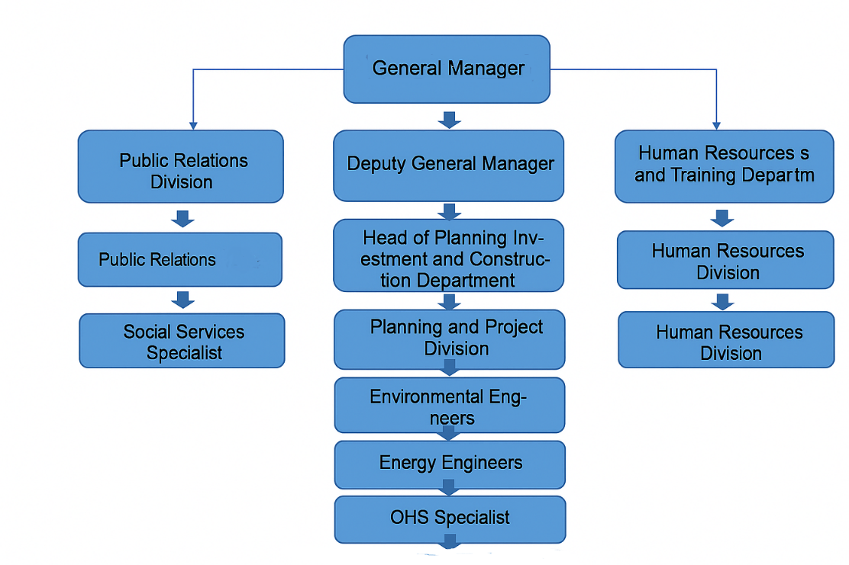
Figure 6-1. Organizational chart
Training Framework and Objectives
Training programs will aim to strengthen institutional capacity, enhance awareness, and ensure compliance with environmental, social, and OHS requirements throughout the construction, operation, and decommissioning phases.
The objectives of the capacity-building program are to:
- Increase understanding of the ESMP’s requirements and commitments.
- Develop the technical competence of contractor and PIU staff.
- Ensure effective implementation, monitoring, and documentation of mitigation measures.
- Strengthen preparedness for emergencies, accidents, and environmental incidents.
- Promote a culture of safety and environmental responsibility at all project levels.
Trainings will be delivered by external experts (if required), the Supervision Consultant, and ILBANK’s E&S specialists. The PIU will oversee the training program and ensure all contractor personnel attend the required sessions.

Table 6-1. Proposed Training Topics
Institution | Roles and Responsibilities
ILBANK | - Ensure implementation of the Project in compliance with ILBANK ESMS requirements and applicable WB OPs.  - Conduct site visits for supervision, monitoring, and auditing when necessary.  - Review and approve the Environmental and Social Management Plan (ESMP) and its disclosure on ILBANK’s official website.  - Oversee preparation and submission of monthly Environmental and Social Monitoring Reports (ESMRs) by the Contractor through the Supervising Consultant and Kemerhisar Municipality.
Kemerhisar Municipality Project Implementation Unit (PIU) | - Provide guidance on preparation of project documentation and stakeholder consultation/disclosure in accordance with ILBANK ESMS and WB ESS requirements.  - Ensure implementation of the ESMP and all associated management plans.  - Provide HSE trainings to all project personnel.• Monitor and report environmental and social mitigation measures during ESMP implementation.  - Oversee contractors’ performance and coordinate ILBANK/WB supervision missions.• Suspend works in case of non-compliance or imminent environmental, social, or OHS risks.  - Report significant incidents to ILBANK and WB within 24 hours and ensure corrective action plans are implemented.  - Coordinate actions in case of design changes, new environmental or social data, or legal revisions.
Contractor | - Implement all requirements of the ESMP and associated management plans.  - Employ qualified environmental, social, and OHS experts (minimum: one Environmental, one Social, and one A Class OHS Specialist).  - Ensure all subcontractors comply with project standards, obtain required permits and licenses.  - Provide environmental, social, and OHS training to all staff.  - Monitor and report environmental and social incidents to Kemerhisar Municipality within 24 hours.  - Prepare and submit monthly and quarterly ESMRs to Kemerhisar Municipality.  - Develop and implement HR Management Procedures including fair treatment, non-discrimination, GBV/SEA/SH prevention, child and forced labor prohibition.
Supervision Consultant | - Supervise construction works and equipment installation.  - Ensure the contractor applies mitigation measures and monitoring requirements as defined in the ESMP.  - Report contractor performance monthly to Kemerhisar Municipality and ILBANK.  - Prepare time-bound Corrective Action Plans in case of non-compliance.  - Maintain sufficient internal capacity to conduct effective E&S supervision.  - Provide guidance to Kemerhisar Municipality on WB requirements, public consultations, and disclosure procedures.  - Assign at least one full-time Environmental, Social, and OHS Specialist to monitor field performance.
Environmental and Social Consultant (MGS) | - Provide technical advisory to the Project Owner.  - Conduct public consultations and disclosure meetings for ESMP and SEP.  - Update ESMP and SEP based on stakeholder feedback.  - Organize and deliver training workshops for the Project Owner on E&S risks, mitigation measures, and monitoring obligations.

Expected Outcomes
- Improved environmental, social, and OHS management performance during construction and operation.
- Strengthened institutional coordination between Kemerhisar Municipality, ILBANK, and the Contractor.
- Increased staff competence in handling environmental and occupational risks.
- Effective response to incidents and better documentation and reporting quality.
- Enhanced community relations and transparency through trained liaison staff.
Monitoring and Evaluation
The PIU will maintain a Training Record Log, indicating training topic, date, trainer, participants, and evaluation results.
Quarterly reports will be submitted to ILBANK summarizing:
- Number of training sessions conducted
- Percentage of workers trained
- Attendance rates
- Training evaluation outcomes
- Identified needs for additional capacity building
Performance indicators related to training will align with the OHS and Environmental KPIs (e.g., > 90 % of all training to matrix, % of attendance at scheduled trainings, and # of toolbox trainings).

STAKEHOLDER ENGAGEMENT

Stakeholder Analysis
This Stakeholder Analysis is based on the relevant Turkish legislation and international regulations by considering the project is exempt from EIA and classified as a Category C Project according to the WB OP 4.01. In conformity, relevant WB OPs (i.e., WB OP 4.01 and WB’s 2010 Policy on Access to Information) and EU Directives. In this regard, the relevant national and international policies considered are given below.

Previous Stakeholder Engagement Activities
On July 29, 2025, Senior Environmental Engineer Günal Özenirler, Biologist Şevval Kurt, Sociologist İrem Yılmaz, and Sociologist Deniz Dirier visited the Kemerhisar Municipality in the Bor District of Niğde Province. Here, they obtained information about the construction and operation phases of the project. Following this, the sociologists traveled to Seslikaya Village, which is within the project's impact area, and conducted individual interviews with the village mayor and four landowners. Additionally, a focus group discussion was held with three women residing in the village.
During the interviews, detailed questions were asked about the participants' lifestyles, economic situations, and land holdings in order to determine how they would be affected by the planned GES project. The following points were noted during the interviews:
- During a meeting with the village headman of Seslikaya Village, it was learned that the village's sewage system frequently clogs and malfunctions. For this reason, it was stated that there are periodic complaints about odors in the village. This situation creates problems both in terms of public health and social life in the village.
- Most of the people in the village meet their drinking water needs through wells they have dug themselves. The village needs a free drinking water source.
- During discussions with the village headman and villagers, it was learned that there are many other GES companies' power plants in the village and its surroundings. The primary source of income for the village is animal husbandry. Currently, the grazing land available to those who make their living from animal husbandry is gradually decreasing. This situation will create problems in the future for the villagers, who are already struggling to make ends meet.
- During the interviews, it was learned that other solar energy companies previously present in the area had visited Seslikaya Village and made numerous promises to the villagers regarding job opportunities for women, distributing shopping cards to everyone, or activities to develop the village. Most of these promises were not fulfilled by the companies. As a result, the individuals interviewed no longer have any confidence that their requests will be fulfilled.

Stakeholder Identification and Analysis
The purpose of a stakeholder identification is to determine and prioritize the project stakeholders for consultation that may be affected (either directly or indirectly in positive or negative way) by the project or that have an interest in the project but are not necessarily directly impacted by it.
Within the scope of this project, a comprehensive list of the internal and external stakeholders is given in Table 7-1.
Table 7-1. Comprehensive List of the Stakeholder Identified for the Project
Stakeholder Groups | Level of Interest | Level of Influence
Direct Stakeholders
Directly Affected Communities
Residents in the project area of influence | High | Moderate
Vulnerable individuals/groups in the project area of influence | High | Moderate
Formal or informal users of lands allocated to the project | High | Moderate
Public Administrations at National Level
The Ministry of Environment, Urbanization and Climate Change. | Moderate | High
Ministry of Energy and Natural Resources | High | High
Turkish Energy Market Regulatory Board | Moderate | Moderate
Ministry of Industry and Technology | Moderate | Moderate
General Directorate of Energy Affairs | High | High
General Directorate of ILBANK | High | Low
Public Administrations/Authorities/Agencies at Provincial Level
Kemerhisar Municipality | High | High
Provincial Directorate of Environment, Urbanization and Climate Change | Moderate | High
Mukhtar of Seslikaya Village | High | Moderate
Contractors/Sub-contractors and Supervision Consultant Companies | High | High
Indirect Stakeholders
Indirectly Affected Communities
Residents outside of the project area of influence | Low | Moderate
Vulnerable individuals/groups outside of the project area of influence | Low | Moderate
Public Administrations at National Level
Ministry of Interior | Low | Low
Ministry of Agriculture and Forestry | Low | Low
Public Administrations/Authorities/Agencies at Provincial Level
Provincial Directorate of Disaster and Emergency | Low | Low
Provincial Directorate of Health | Low | Low
Other Interested Parties
Chamber of Environmental Engineers | Low | Low
International Solar Energy Society (GUNDER) | Moderate | Moderate
The types and causes of exposures and how above-mentioned stakeholder groups are affected (positive/negative) are given in Table 7-2
Table 7-2. The Potential Impacts of Project Activities on Social Components
Social Component | Type of Potential Impact (Positive/Negative) | Potential Impact Definition
Emergency Response | Positive | After the increase in the electricity prices in Turkey, municipalities are having hard times paying them. After the implementation of this project, it is expected to be offset the energy demand and prices.
Local Employment | Positive | Employment opportunities
Transportation/Traffic | Negative | Safety issues due to increase in traffic, damages on roads, generation of greenhouse gas emissions / noise
OHS and Community H&S | Negative | Water pollution, air emissions/noise and visual pollution
As part of the stakeholder identification process, it is also important to identify individuals and groups that may be differentially or disproportionately affected by the Project because of their disadvantaged or vulnerable status. The potential vulnerable/disadvantaged groups can be listed as follows:
- Elderly people in need of care and social assistance
- Mentally/physically disabled individuals
- Women who have lost their spouses/are divorced
- Refugees
The project is situated in an isolated area with no residential settlements nearby, ensuring that during both the construction and operation phases, there are no anticipated adverse social impacts on specific vulnerable groups such as the disabled, the elderly, refugees, and individuals dependent on their livelihoods. The project remains open to making necessary adjustments based on feedback and complaints received from stakeholders Potential vulnerable/disadvantaged groups and their needs in and around the project area are shown in the Table 7-3 below.

Table 7-3. Potential Vulnerable/Disadvantaged Groups and their needs
Community | Stakeholder group | Key characteristics | Language needs | Preferred notification means (e-mail, phone, radio, letter) | Specific needs (accessibility, large print, child care, daytime meetings)
Seslikaya Village | Elderly people in need of care and social assistance | Limited mobility; may rely on family members or caregivers; may have limited access to digital communication; possible health issues | Primarily Turkish; may need clear, slow, and repeated verbal explanations | Face-to-face visits via mukhtar’s office, village meetings, announcements through mosque loudspeakers, phone calls | Accessible meeting locations, transportation assistance, printed materials in large font, inclusion of caregivers in communication
Seslikaya Village | Mentally/physically disabled individuals | Physical access limitations; cognitive or sensory impairments; reliance on family or support services | Turkish; may require simplified language, visual aids, or sign language (if hearing impaired) | Direct caregiver communication, home visits, accessible printed materials, phone calls | Accessible venues (ramps, seating), visual communication materials, extra time for participation, assistance during meetings
Seslikaya Village | Women who have lost their spouses/are divorced | May have limited income and resources; often primary caregivers for children; possible social stigma; limited mobility due to domestic responsibilities | Turkish | Women-focused community meetings, face-to-face via women’s associations or social service units, phone calls, printed flyers | Meeting times compatible with childcare, inclusion in livelihood support programs, access to grievance mechanism in a confidential manner
Seslikaya Village | Refugees | Possible language and cultural barriers; limited integration into village social structures; possible insecure legal or economic situation | Depending on origin (e.g., Arabic, Sari); may need translation into Turkish | Meetings with translation support, liaison through community leaders/NGOs, WhatsApp or SMS messages, visual materials | Translation services, culturally sensitive communication, legal aid information, assurance of non-discrimination in engagement

Stakeholder Engagement Plan
The Stakeholder Engagement Plan (SEP) is a control mechanism that ensures the implementation of key principles during the project. The engagement activities will be scheduled in a manner to ensure maximum involvement of relevant stakeholders. To maximize stakeholder engagement, it prevents disruption of local stakeholders’ daily work and regulates the timing and number of engagement activities. Accordingly, recording the findings and feedback together in accordance with all engagement activities, sharing them with the responsible parties, and following the process are essential. Also, engagement activities need to be culturally appropriate, provided equal access to relevant stakeholders, and enable their feedback. Ultimately, all engagement activities are in accordance with the project-specific SEP schedule.
The SEP will be disclosed by ILBANK, and Kemerhisar Municipality, and Contractor in consultation with the stakeholders on potential benefits of the planned Project and the potential adverse impacts and associated mitigation measures through appropriate methods. The guidance of WB’s OP 4.01 and WB’s 2010 Policy on Access to Information will be followed for all disclosure attempts. Detailed engagement plan for the project is given in Table 7-4.

Table 7-4. Stakeholder Engagement Program During the Construction and Operation Phase
Stakeholder | Purpose of Engagement | Documents/Materials to be Used for Engagement | Engagement Method | Location | Responsible Party | Timetable for Implementation
All stakeholders | - Disclosure of full Project information package | - Full Project information package | - ILBANK Website  - Kemerhisar Municipality website  - Information boards at local mukhtar offices and project site | - Kemerhisar Municipality website  - Information boards at local mukhtar offices and project site | - ILBANK  - Contractor  - Project Implementation Unit (PIU) | - Prior to the commencement of any construction activities  - In case revision throughout construction and operation period
Related central and local governmental agencies | - Up-to-date information for disclosure on the Project  - Consultation on permitting, environmental, occupational issues and  - Community management,  - Emergency preparedness and response collaboration | - Project documentation as required by the authorities | - Face to face meetings  - Email correspondence or other means | - The municipality building and/or relevant stakeholders’ own places | - PIU  - Community Liaison Officer (CLO) (Kemerhisar Municipality & Contractor)  - Supervision Consultant | - Before the start of construction activities (at least 15 days)  - As required throughout the construction and operation phases
Headmen (mukhtars) | - Deliver all aspects of Project-related information to include project timeline and conditions, E&S impacts and mitigations  - Assess complaints and feedback from stakeholders | - Stakeholder engagement meeting announcements  - Project presentation document and Brochures covering information on the communication channels as well as a non-technical summary (NTS) of the Project including E&S issues regarding the Project  - Consultation and grievance forms (Open & Close-Out) | - Periodic and needed face to face meetings  - Grievance Mechanism  - Review of grievances on an appropriate basis. | - Municipality building and/or headmen offices | - Contractor  - PIU  - Supervision Consultant | - At least 15 days before the project start  - The monthly basis for the construction phase  - The quarterly basis for the operation phase  - Grievances will be assessed immediately, and installed grievance boxes will be checked weekly during project phases  - Anytime as needed
Local communities; Land Owners / Users/Renters/Informal Users including vulnerable groups/PAP: | - Deliver all aspects of Project-related information to include project timeline and conditions, E&S impacts and mitigations.  - Assess complaints and feedback from stakeholders | - Project information, E&S  - Expropriation process/issues based on specific stakeholder groups in a suitable and understandable language/format | - Non-technical meetings-disclosure  - Face to face meetings  - Focus group discussions/ separate informative meetings for land issues | - Municipality building and/or relevant stakeholders’ own places | - Contractor  - PIU  - Supervision Consultant | - At least 15 days before the project start  - The monthly basis for the construction phase  - The quarterly basis for the operation phase  - Grievances will be assessed immediately, and installed grievance boxes will be checked weekly during project phases  - Anytime as needed
Local businesses | - Deliver information regarding requirements and opportunities of local procurement and service provision  - Disclose information on Project, E&S aspects and associated impacts of which related to construction / operation activities | - Particular information on required goods and services  - Project information, E&S, construction / operation impacts and associated mitigation measures.  - Grievance Management | - Face to face meetings  - Email correspondence  - Phone calls | - Municipality building and/or at the relevant stakeholders’ own places | - Contractor  - PIU  - Supervision Consultant | - At least 15 days before the project start  - As required for construction impacts issues and operation period
Local NGOs | - Inform on updated current Project status, associated project activities, potential E&S impacts of which depending on Project phase, Project E&S Management System (ESMS) including community HS management and emergency preparedness issues | - E&S issues  - Particularly prepared documentation/materials as a response to concerns on the Project | - Face to face meetings  - Email correspondence  - Phone calls | - Municipality building and/or at the relevant stakeholders’ own places | - PIU  - Contractor  - Supervision Consultant | - The quarterly basis for the construction and operation phase  - Anytime as needed
Media | - Deliver Project-related information to further parties in interest in an appropriate manner | - Visual materials/advertisements on Project-related information (may be particularly prepared in consideration to any public concern on the Project)  - Video/audio records | - Visual materials/advertisements to be published by local / national media agencies | - Media | - PIU | Anytime as needed
Internal stakeholders (including own workers and indirect (contracted) employees) | - Deliver information on the Project, working conditions and worker management including worker rights and OHS management addressed in the Project-specific E&S policy and other relevant ESMS documentation  - Ensure that SEP covering GRM is efficiently implemented | - Employment contracts  - Through selected worker representatives  - H&S-related announcements  - GRM forms and guidance  - Training documents/materials (i.e., presentations) | - Communicating relevant written documentation with the Project employees  - Induction and orientation trainings | - Project site | - PIU  - Contractor | At the time of recruitment
 |  |  | - Toolbox trainings | - Project site | - PIU  - Contractor | Daily before start of each shift during the construction / operation phases
 |  |  | - H&S Committee Meetings | - Project site | - PIU  - Contractor | Monthly as periodically and anytime as needed

Roles and Responsibilities
Kemerhisar Municipality and Contractor will implement the SEP activities during the construction and operation phases of the Project. The planned organizational structure of the Team is presented in Table 7-5.
Table 7-5. Responsibilities of Key Actors/Stakeholders in SEP Implementation
Actor/Stakeholders | Responsibilities
Kemerhisar Municipality | SEP Management  Stakeholder engagement activities;  Establishment of Grievance Redress Mechanism  Management or resolution of Grievances resolution;  Consultation on specific SEP activities;
ILBANK | Monitoring and supervising the process of SEP implementation;  Reporting the progress of SEP implementation to WB on regular periods
Contractor/Subcontractor(s) | Taking part of in SEP activities;  Reporting of issues to Kemerhisar Municipality related to stakeholder engagement;  Grievance management and resolution;  Resolution of grievances issues resulting from construction activities with collaboration and under the direction of Kemerhisar Municipality;  Informing Kemerhisar Municipality on construction activities (such as road closures and service interruptions);  Internal Reporting to Kemerhisar Municipality on SEP implementation
Supervision Consultant | Guide public participation and announcement requirements;  Provide necessary information to Kemerhisar Municipality  Review GRM and complaints to Kemerhisar Municipality.
WB | Audit the Kemerhisar Municipality's compliance with the provisions set out in the SEP managed by the Municipality during the construction and operation phase via the Project Progress Reports  Visit project sites to conduct its own monitoring at certain intervals or when necessary.

Grievance Mechanism
Kemerhisar Municipality will establish a Grievance Redress Mechanism (GRM) to receive, resolve, and follow the concerns and complaints of the Project affected communities. All grievances will be effectively received, recorded, and responded to within a predetermined timeline and based on their contents.
At the earliest convenience, the stakeholders will have access to Kemerhisar Municipality PIU and Contractor dedicated CLOs for responses to responses to grievance. Stakeholders will be informed on the Satisfactory responses to the grievances and corrective activities. The GM for the stakeholders will be operated according to the following procedure;
- Following tools will be used so that all stakeholders can be informed regarding the Project’s GRM process:
- Web page
- Email address
- Public meetings
- Telephone
- Frequently Asked Questions (Brochure, web page, bulletin, etc.)
- Grievances can be submitted by the channels outlined below:
- Telephone (Call Center and units): +90 388 329 2063
- Personal visit to Kemerhisar Municipality and Contractor head office/branches
- Grievance boxes (installed at the Kemerhisar Municipality Units / Contractor)
- Relevant public administrations (district governorship, municipality, headmen)
- Email: yaziisleri@kemerhisar.bel.tr
- Meetings
- Staff and local communication desk of Kemerhisar Municipality / Contractor
- By written petition to Kemerhisar Municipality / Contractor
- During site visits and miscellaneous
- All the submitted grievances are collected at the GRM Section of PIU Department.
- The submitted grievances are recorded in databases by CLOs of PIU and Contractor.
- PIU and Contractor CLOs or any contact person who received the grievance confirm the grievance reception via phone and/or email within 2 days.
- The response to the relevant grievance will be drafted by CLOs of PIU / Contractor and approved by Project Managements.
- After responding to the relevant grievance, necessary revisions will be made on the Grievance Form with respect to the result of GM process which will be communicated with relevant Complainant within 10 working days. The required actions for valid grievances will be taken within 15 working days. If applicant accepts the resolution within 30 days, the submitted grievance is marked as closed. If the applicant does not sign-off Complaint Close-Out Form due to insufficient satisfaction, a meeting will be organized by the PIU management on relevant complaint and if necessary, with the participation of Contractor. The compliant can participate this meeting to submit his/her Project-related concern face to face to the management. The aim of this meeting is to find alternative solutions of which both parties agree with.
- All the grievances will be monitored by recording them via the monitoring and evaluation system which will be established within the scope of GM.
- Regarding grievances received by Contractor; the grievances which are within the scope of Contractor responsibility will be handled by itself and reporting to the PIU during monitoring activities. The grievances within the scope of Kemerhisar Municipality responsibility will be immediately communicated with PIU by Contractor and handled by the PIU accordingly. Contractor CLO is responsible for recording and tracking grievances.
- If the complaint cannot be resolved with the existing process, applicants can always apply to relevant legal institutions. Such institutions can be summarized as follow:
- Civil Courts of First Instance
- Administrative Courts
- Commercial Courts of First Instance
- Labor Courts, and Ombudsman (https://ebasvuru.ombudsman.gov.tr/)
During construction and operational activities, the GRM described above shall continue to be driven by stakeholders' views, making this procedure accessible to all affected stakeholders. Requests that require urgent remedy and/or support shall be responded to and given support within the same day. All outstanding grievances/requests shall be recorded within two business days, reviewed and assessed within ten business days, and concluded not later than 15 business days. Corrective actions shall be taken to resolve the grievance. GM Flow Chart is given in Table 7-6.
Table 7-6. Grievance Mechanism Flowchart
Stage of GM | Required Action
Grievance submission | Receiving the grievance by any above-mentioned communication channel.  (Following to receive more sensitive grievances i.e. SEA/SH, child abuse or abuse, necessary action will be taken within 48 hours. For such cases at the workplaces, the complaint will be directed by the GM focal point (based in ILBANK headquarter) to relevant legal authorities/service providers such as Ministry of Family and Social Services and Prosecutors Office.)
Grievance registration | Grievance Form and Grievance Register Table are used during registration process. After grievance registration, feedback will be sent to the Complainant for the purpose of confirmation within two (2) days.  Anonymous registration will be conducted if a Complainant requests that complaint of whom is handled anonymously.
Grievance assessment | Grievances are assessed within 10 working days with the clarification of the fact that relevant grievance is compliance with admissibility criteria. The Complainant will be informed appropriately in case of invalid grievances.
Responses to the grievances | According to the grievance type, consultation with stakeholders in question can be conducted on site.  After grievance assessment, grievance will be responded appropriately via previously-mentioned communication channels.  Application to ILBANK or Court of First Instance is also available for Complainants if a resolution cannot be figured out for whose grievances.
Grievance closure | As long as alternative agreement is not conducted, grievance of Complainant is closed within fifteen (15) Business Days as of submission date and the Grievance Close Out Form is filled accordingly.  In the case of grievances cannot be closed within fifteen (15) Business Days, it is ensured that well documented mitigatory circumstances related to which are reported.  Regarding the anonymous grievances, outcome of GMGRM process and associated taken actions should be declared on Kemerhisar Municipality website for the purpose of informing relevant Complainants.
In the case of unresolved grievances | ILBANK monitors GM process according to following outline:  -Confirmation of grievance submission  -Assessment of grievance by the Kemerhisar Municipality and information to ILBANK accordingly  -Communication of grievance response to Complainant by the Kemerhisar Municipality which is monitored by ILBANK (The timeframe for response at this level is thirty (30) days.)  -Application to Court of First Instance by Complainants in case of unresolved grievances
Reporting | The grievances will be analyzed quarterly by Kemerhisar Municipality PIU considering the frequencies, types and resolution methods of which. By doing this, for instance, complaints submitted by majority of Contractor/Subcontractor(s) and/or those originated from certain works can be determined in a better way.  The outcomes are reported to the PIU management by CLOs
Right to Appeal | If the complaint cannot be resolved with the existing process, applicants can always apply to relevant legal institutions. Such institutions can be summarized as follow:  - Civil Courts of First Instance  - Administrative Courts  - Commercial Courts of First Instance  - Labour Courts, and  Ombudsman (https://ebasvuru.ombudsman.gov.tr/)

Samples of grievance submission form and grievance closure form are presented in Appendix-7 and Appendix-8.

Monitoring and Reporting
Periodically (at least once every 6 months) review and update of the SEP will be conducted, as necessary, during the stakeholder consultation as required within the scope of SEP implementation.
Kemerhisar Municipality PIU and the Contractor CLO will record all incoming corporate grievance/comment databases.
Kemerhisar Municipality PIU will assess the number and nature of grievances/comments (if any) quarterly and their effectiveness to address grievances/comments based on the number and percentage of closed grievances. The monitoring framework is described in Table 7-7.
Table 7-7. SEP Monitoring Framework
Parameter | Key Performance Indicator | Phase | Frequency | Responsible Party
Stakeholder engagement process | - Number of meetings (e.g. public consultation, meeting with authorities, focus group meetings, in-depth meetings, etc.)  - Number of engaged persons  - Number of the visits to the settlements impacted by the Project activities within a timeframe | Construction | Quarterly | - To be assigned by Kemerhisar Municipality PIU and Contractor
Stakeholder engagement process |  | Operation | Semi-annually in the first two years; Annually afterwards | - To be assigned by Kemerhisar Municipality PIU and Contractor
Project GRM | - Number of grievances/comments received during per consultation  - Types of the grievances/comments (community HS, employment, local procurement etc.)  - Timeframes for response to each grievance  - The number of open or closed grievances  - Number of invalid or in progress grievances | Construction | Quarterly | - To be assigned by Kemerhisar Municipality PIU and Contractor
Project GRM |  | Operation | Semi-annually in the first two years; Annually afterwards | - To be assigned by Kemerhisar Municipality PIU and Contractor
Workers’ GRM | - Number of grievances/comments received by own workers  - Number of grievances/comments received by indirect workers  - Types of the grievances/comments regarding worker management and working conditions (e.g. Worker rights, OHS, etc.)  - Timeframes for response to each grievance  - The number of open or closed grievances  - Number of invalid or in progress grievances | Construction | Monthly | - To be assigned by Kemerhisar Municipality PIU and Contractor
Workers’ GRM |  | Operation | Semi-annually in the first two years; Annually afterwards | - To be assigned by Kemerhisar Municipality PIU and Contractor
GM | Effectiveness of the GM | Construction | Quarterly | ILBANK

CONCLUSION
This ESMP identifies the potential impacts that may arise during construction and operation phases of the Project and proposed appropriate mitigation measures to effectively address these impacts. In conclusion, the Project can be carried out in an environmentally and socially sustainable manner on full implementation of this ESMP as there are no likely major or irreversible negative impacts.
As part of the requirements stipulated by the Lenders, ESMP is to be publicly disclosed by the Project Owner’s and the Lender’s website. ESMP will be reviewed, updated, and approved if necessary. For each approved updated version of this ESMP, the Project Owner will be responsible for the disclosure of the updated documents.

REFERENCES
Davis, P.H. (ed.) Flora of Turkey and the East Aegean Islands, vol. 1-10, Edinburgh Univ. Press. Edinburgh (1965-1988).
Ekim, T. ve ark. Türkiye Bitkileri Kırmızı Kitabı. Türkiye Tabiatını Koruma Derneği. Yayın No:18 (2000).
Baytop, T. Türkçe Bitki Adları Sözlüğü. Atatürk Kültür, Dil ve Tarih Yüksek Kurumu, Türk Dil Kurumu Yayınları:578 (1994).
Güner, A., Aslan, S., Ekim, T., Vural, M., Babaç, MT. (edlr.) Türkiye Bitkileri Listesi (Damarlı Bitkiler) Nezahat Gökyiğit Botanik Bahçesi ve Flora Araştırmaları Derneği Yayını, İstanbul (2012).
Güner, A. (ed.). Resimli Türkiye Florası. Nezahat Gökyiğit Botanik Bahçesi, Flora Araştırmaları Derneği ve Türkiye İş Bankası Kültür Yayınları Yayını, İstanbul (2014
Yabanicicekler.com (2026). Consolida raveyi. Available at: http://yabanicicekler.com/flower/consolida-raveyi-322 (Accessed January 2026).
Demirsoy. A, 2002. Genel ve Türkiye Zoocoğrafyası. Meteksan, Ankara.
Eken, G. Bozdoğan, M. İsfendiyaroğlu, S. Kılıç DT Lise, Y. (eds) 2006. Türkiye’nin Önemli Doğa Alanları. Doğa Derneği, Ankara.
Ertan, A., Kılıç, A. and Kasparek, M. 1989. Türkiye’nin Önemli Kuş Alanları. Doğal Hayatı Koruma Derneği, Istanbul.
International Finance Corporation (IFC). (2012b). Performance Standards on Environmental and Social Sustainability. World Bank Group: Washington DC.
International Union for Conservation of Nature (IUCN) 2012. Red List of Threatened Species. Version 2012.2. Retrieved from: http://www.iucnredlist.org
Kızıroğlu, I., 1989. Türkiye Kuşları. Orman Genel Müdürlüğü, Ankara
sekerali.com (2026). Saponaria prostrata subsp. prostrata (Ebemterliği). Available at: https://www.sekerali.com/portfolio/saponaria-prostrata-subsp-prostrata-ebemterligi/ (Accessed January 2026).
floranatolica.com (2026). Phlomis armeniaca. Available at: https://www.floranatolica.com/eukaria/gui/species.php?ID=Phlomis-armeniaca (Accessed January 2026).
senteursduquercy.com (2025). Phlomis capitata. Available at: https://www.senteursduquercy.com/phlomis-herbace/553-phlomis-capitata.html (Accessed January 2026).
gerard-weiner.fr (2021). Phlomis nissolii. Available at: https://www.gerard-weiner.fr/phlomis-nissolii/ (Accessed January 2026).
yabanicicekler.com (2025). Wiedemannia orientalis Sin: Lamium orientalis. Available at: https://yabanicicekler.com/flower/wiedemannia-orientalis-sin-lamium-orientalis-307 (Accessed January 2026).
yabanicicekler.com (2025). Salvia absconditiflora Sin: Salvia cryptantha. Available at: https://yabanicicekler.com/flower/salvia-absconditiflora-sin-salvia-cryptantha-215 (Accessed January 2026).
inaturalist.org (2026). Salvia dichroantha. Available at: https://www.inaturalist.org/taxa/1456104-Salvia-dichroantha (Accessed January 2026).
IUCN Red List of Threatened Species (2026). The IUCN Red List of Threatened Species. Version 2025-3. Available at: https://www.iucnredlist.org (Accessed January 2026).
European Environment Agency (2018). CORINE Land Cover (CLC) 2018, Version 2020_20. Available at: https://land.copernicus.eu/pan-european/corine-land-cover/clc2018

APPENDICES

Appendix-1 Title Deed Information For The Project



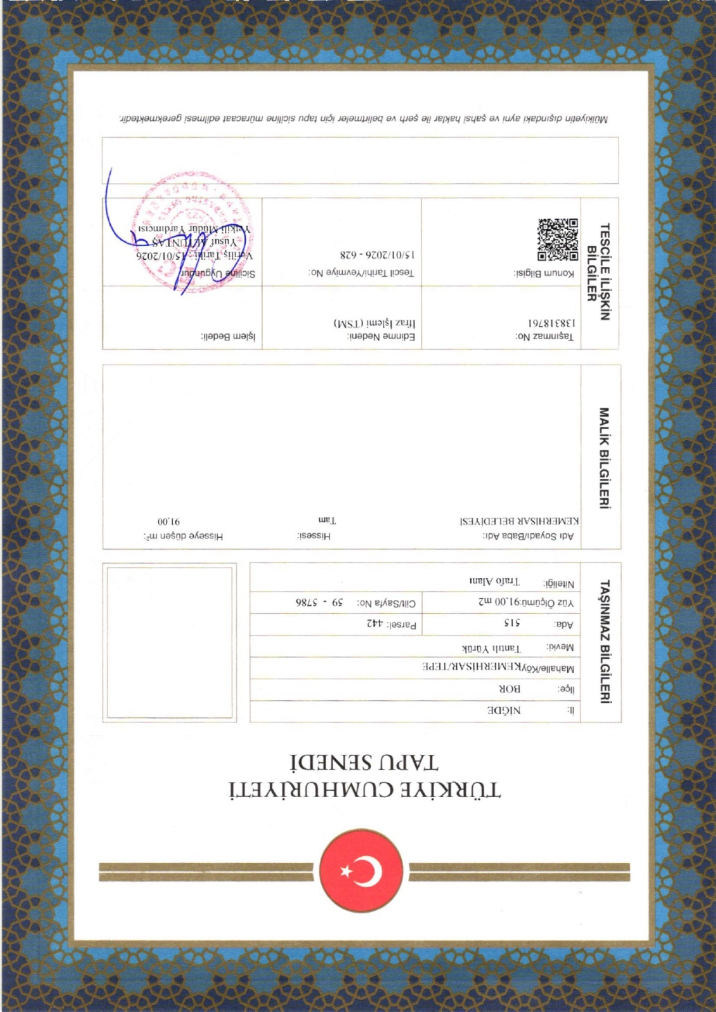
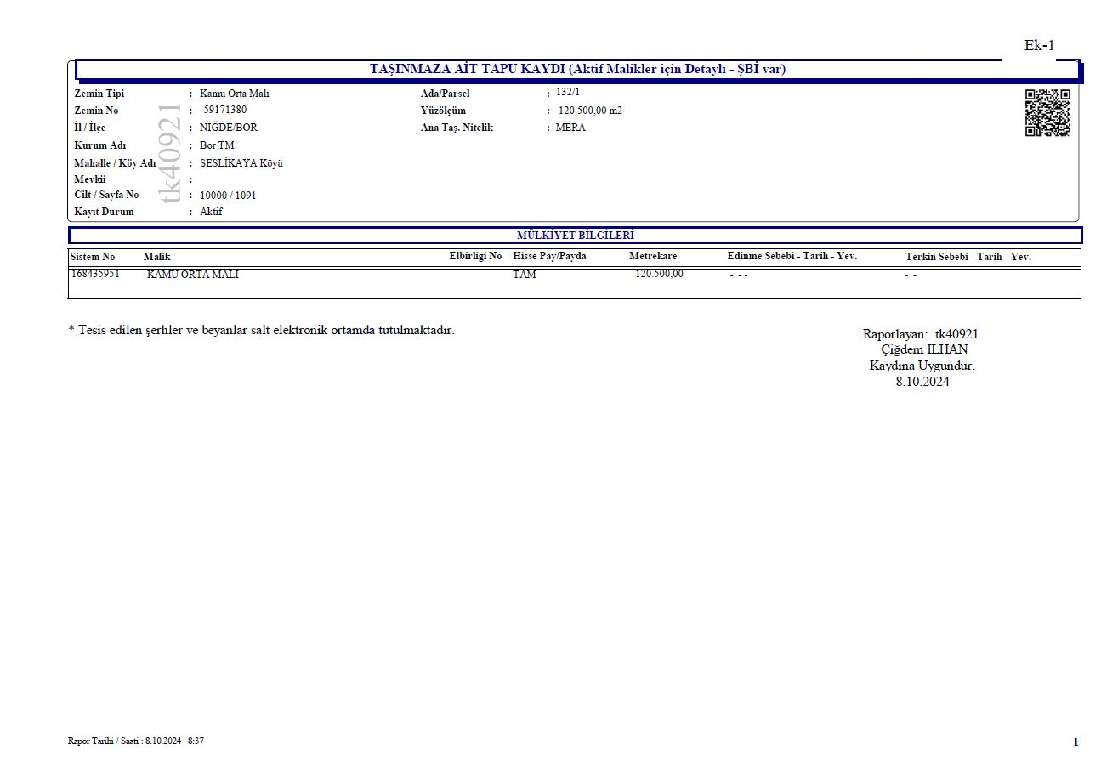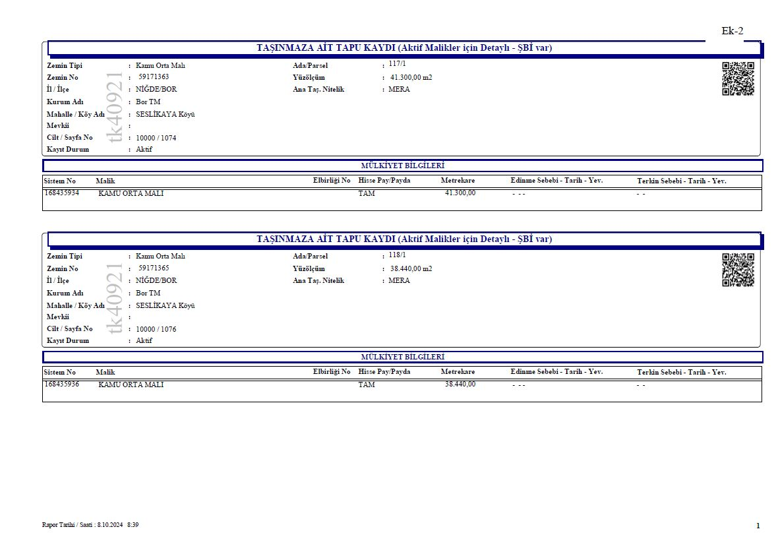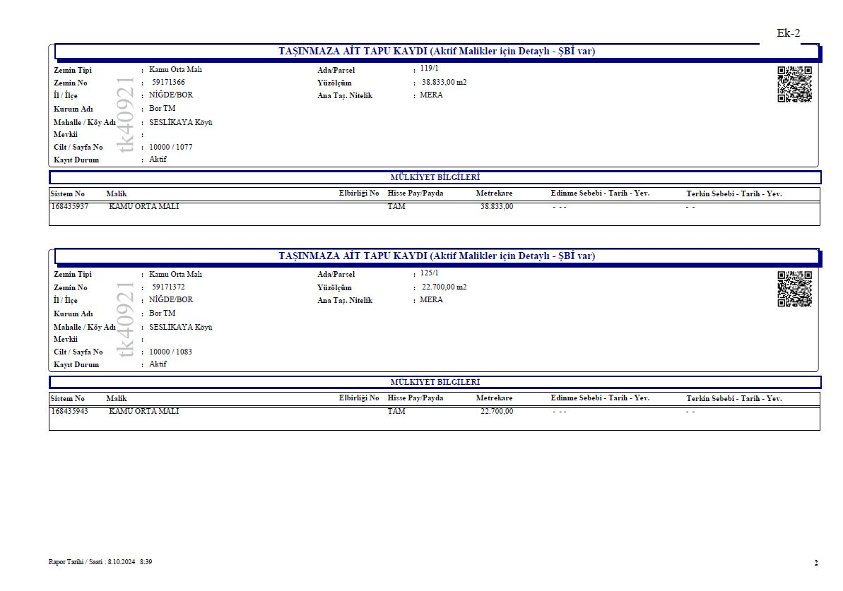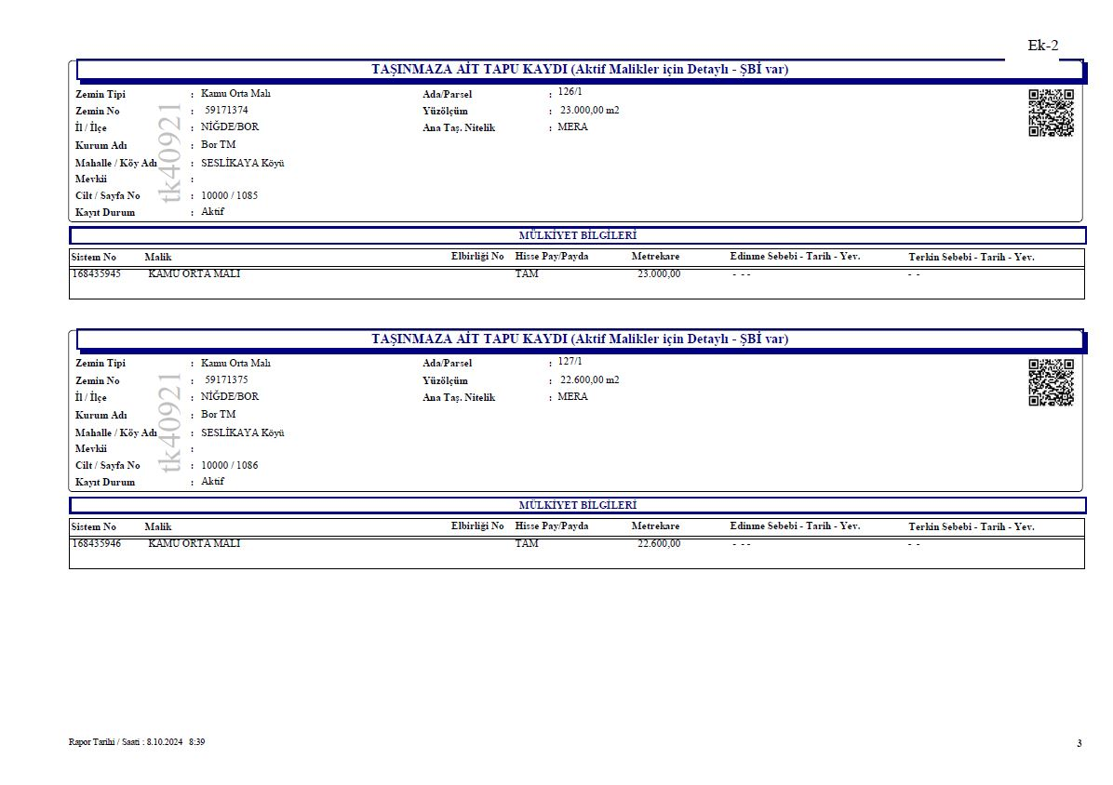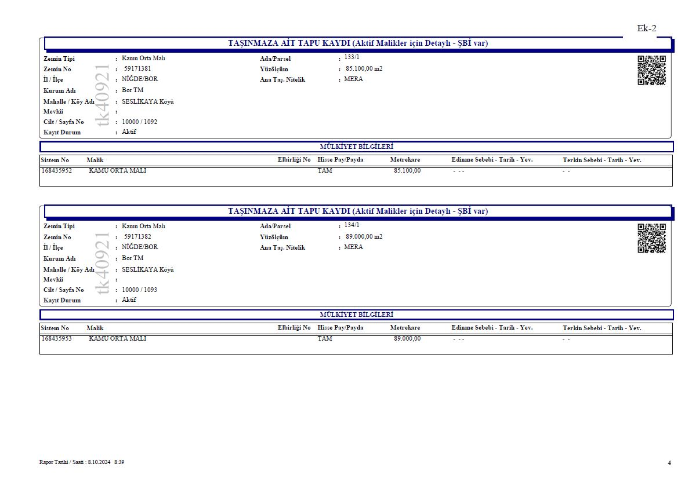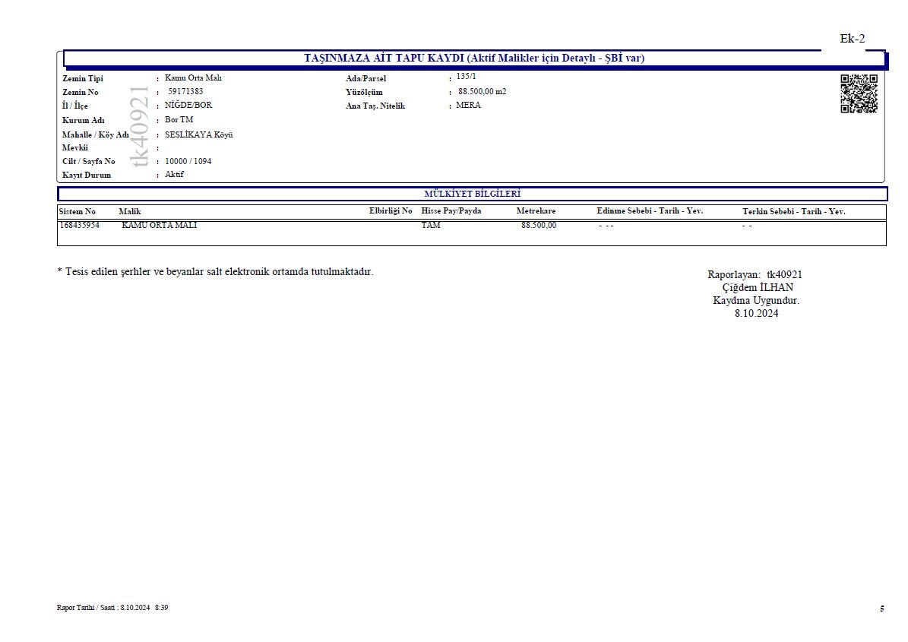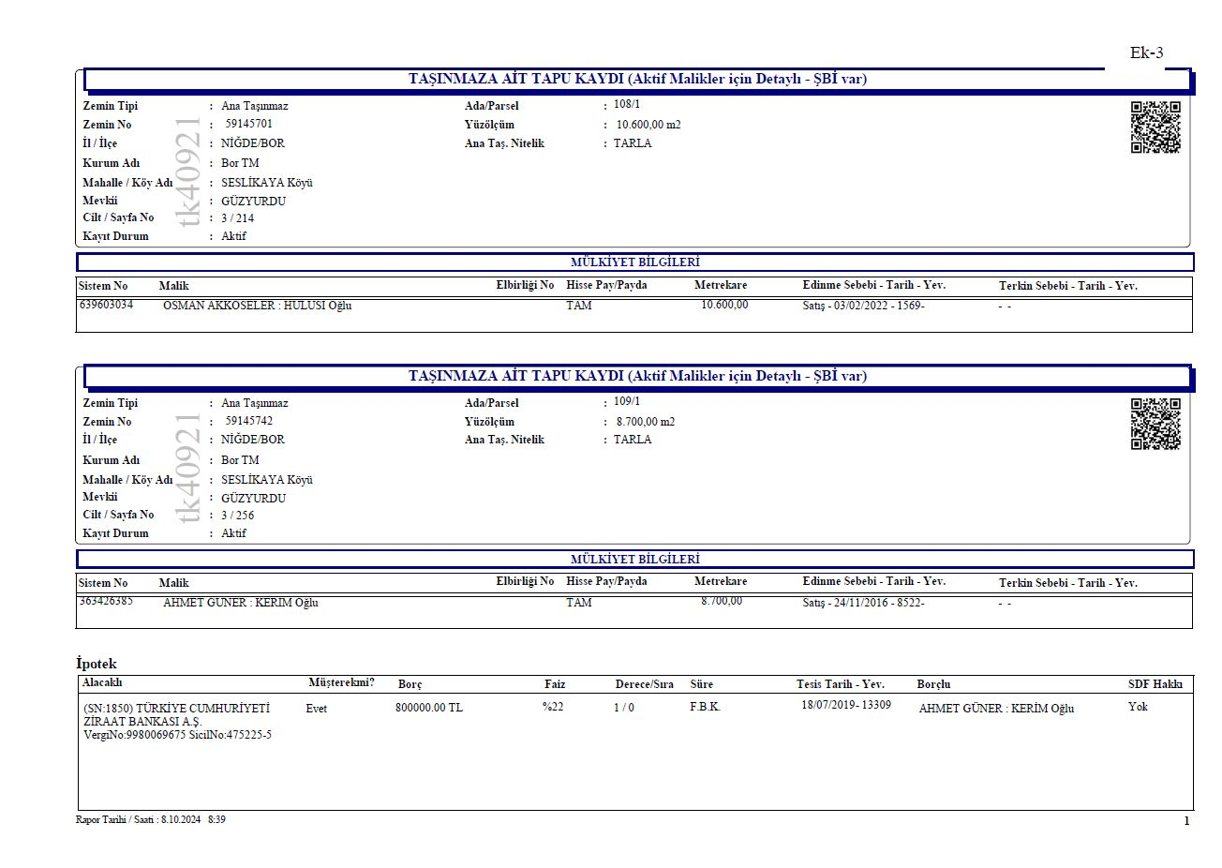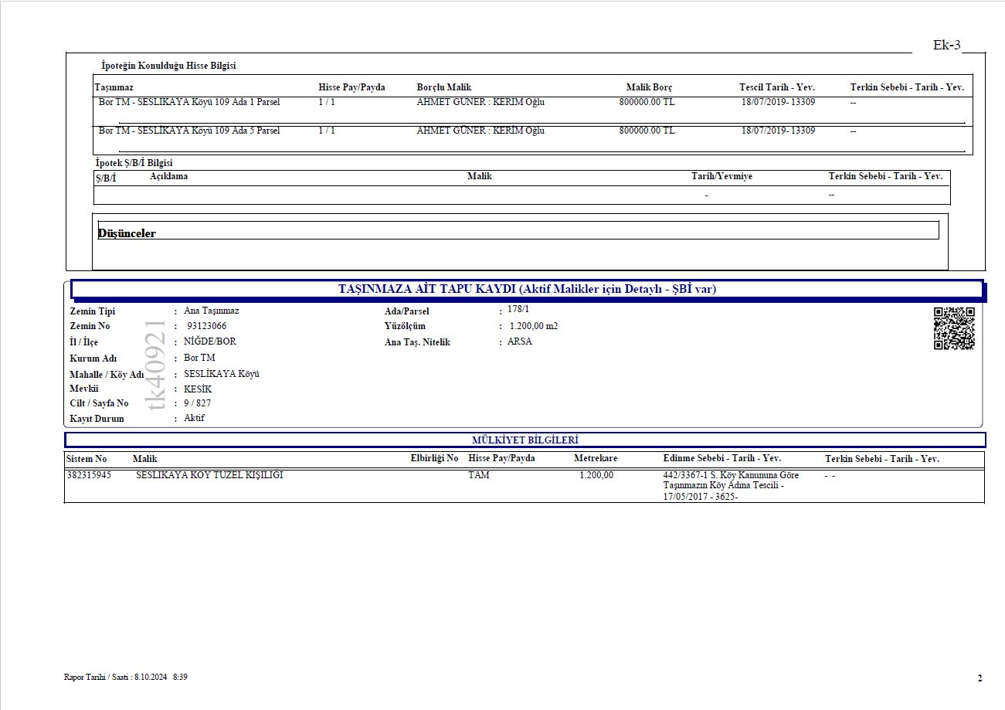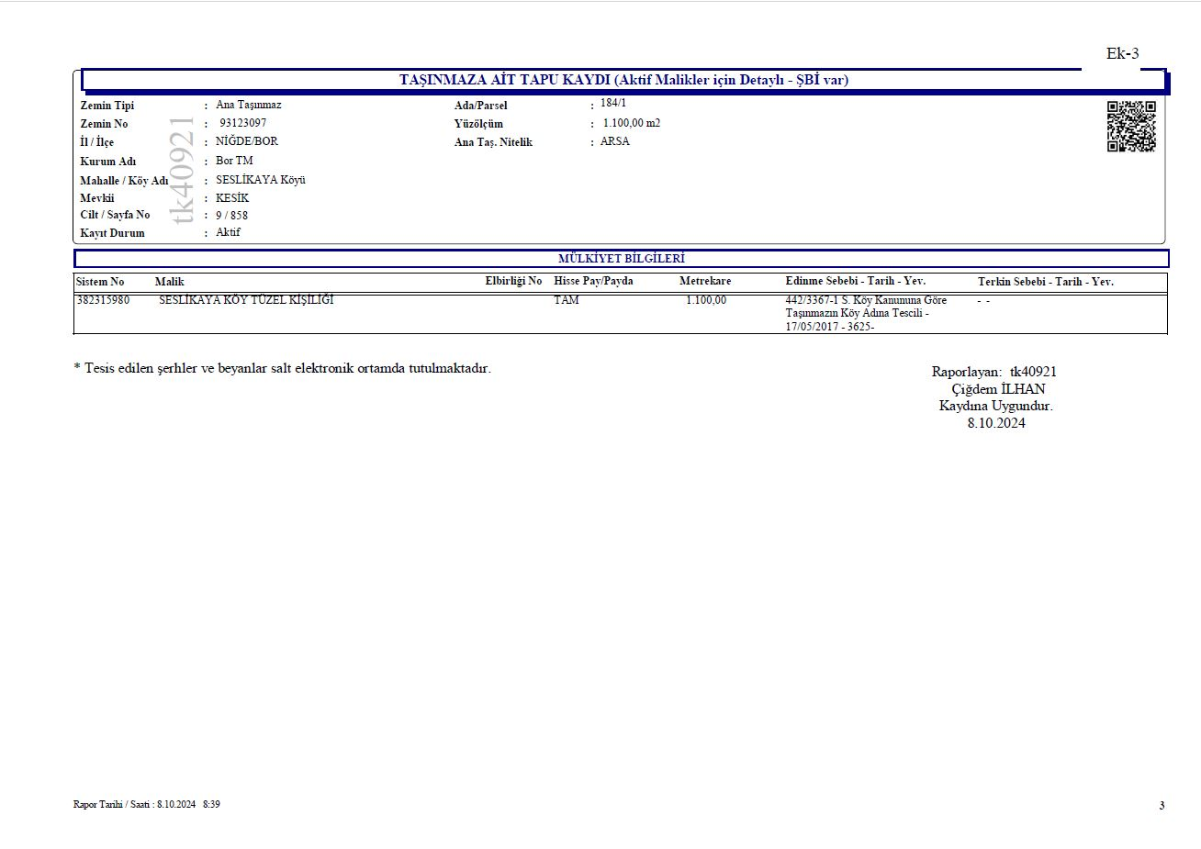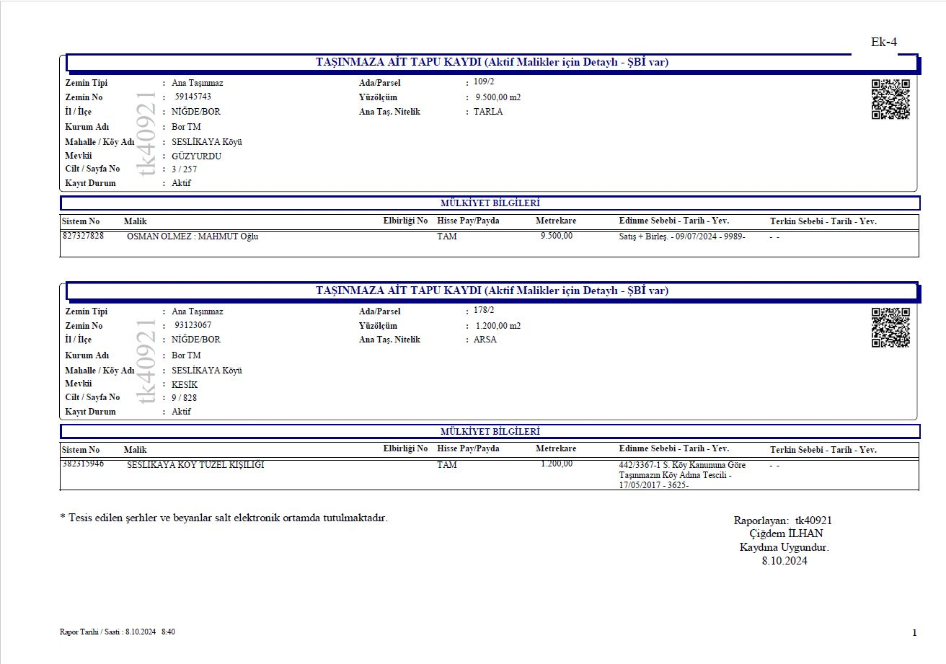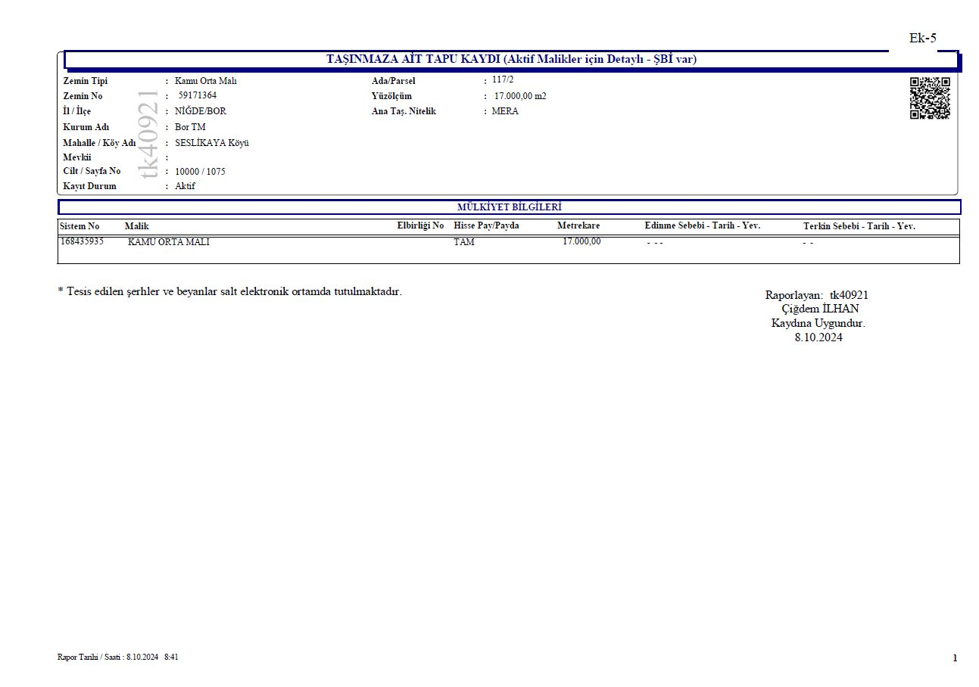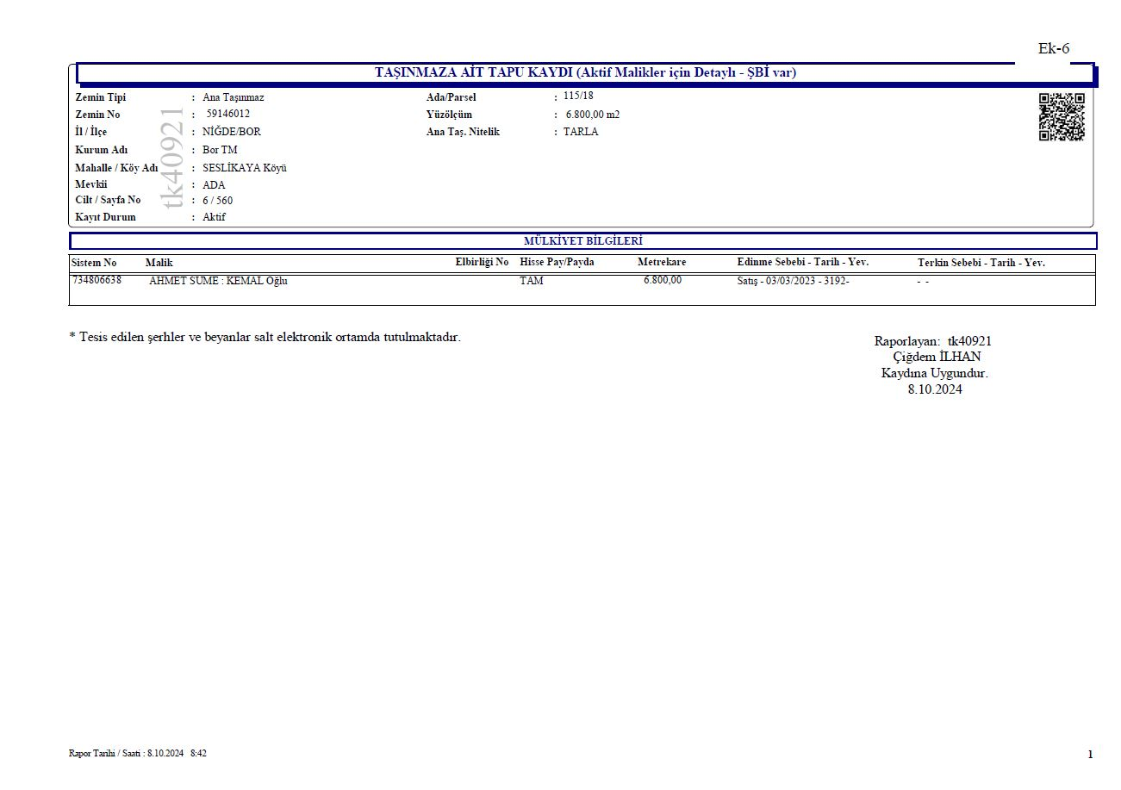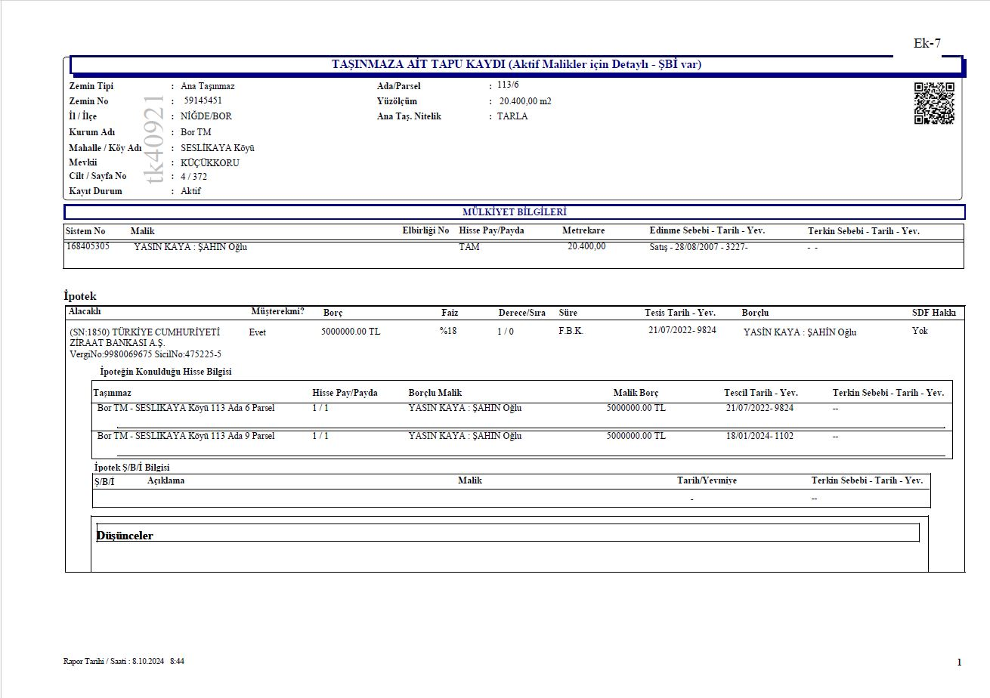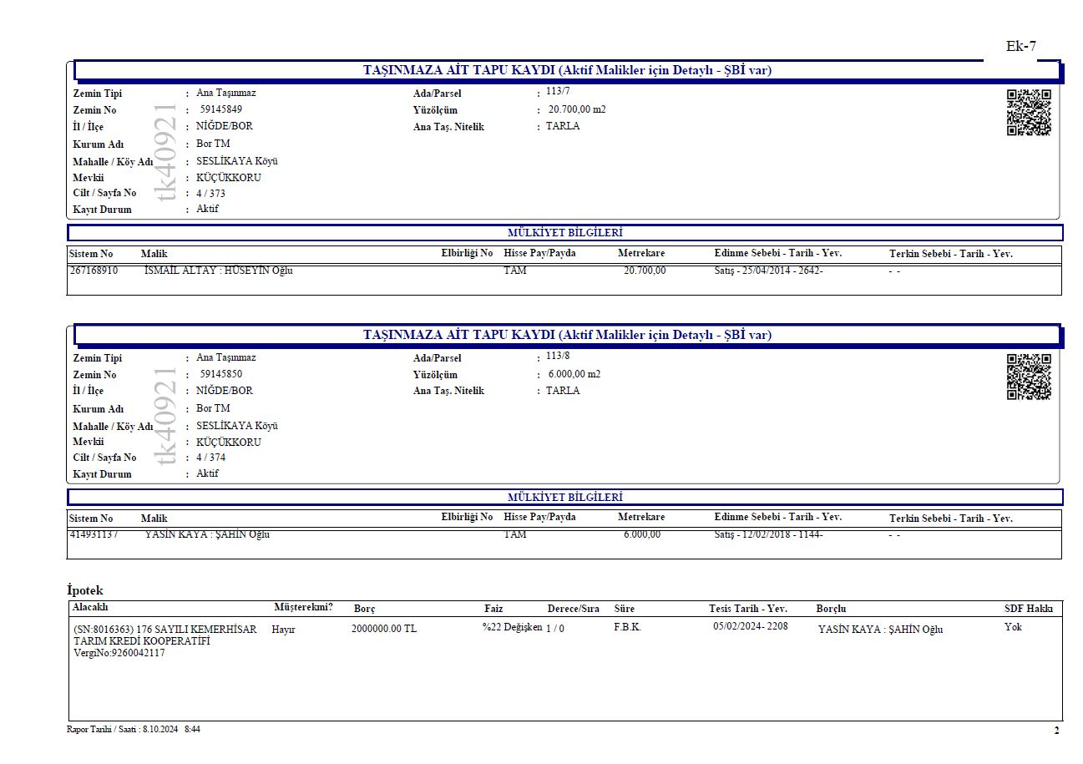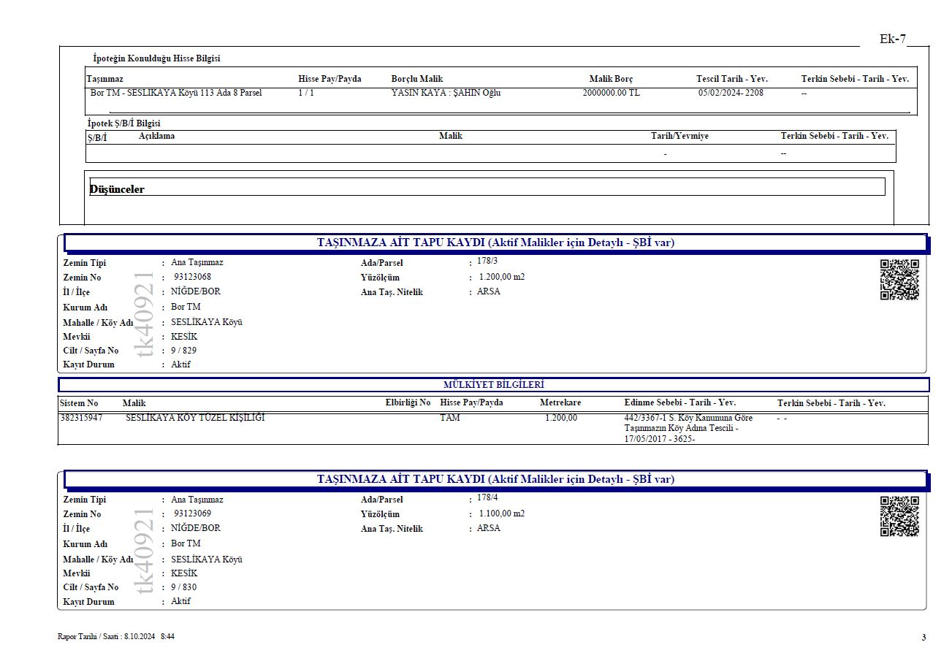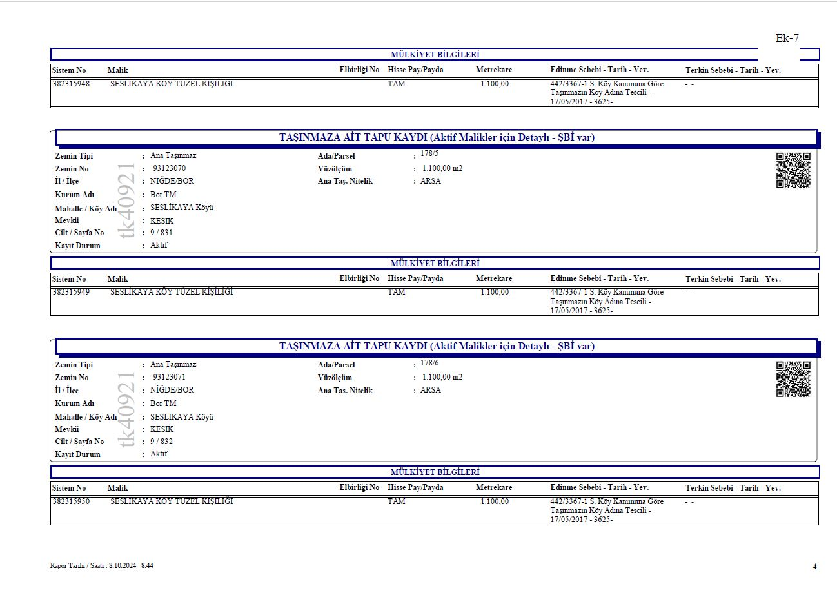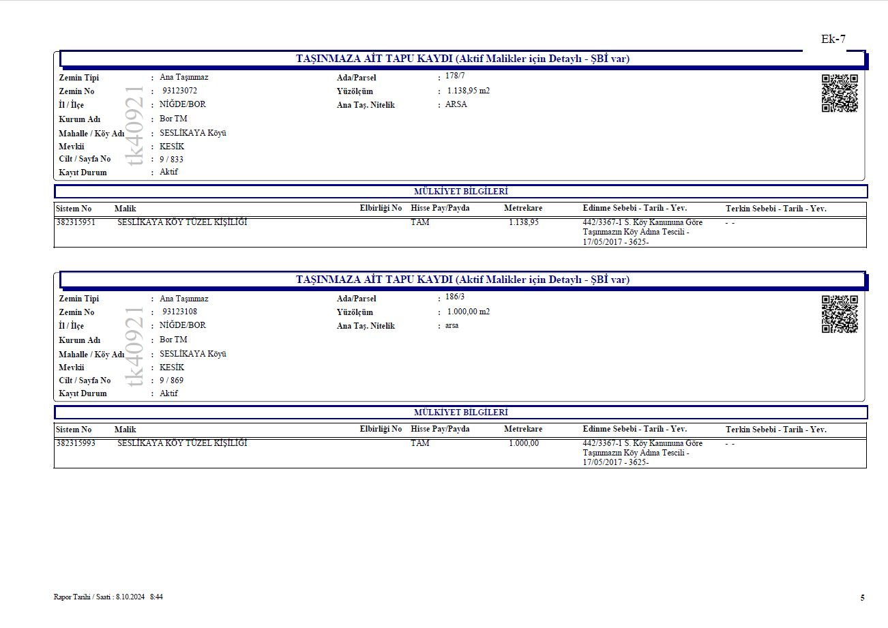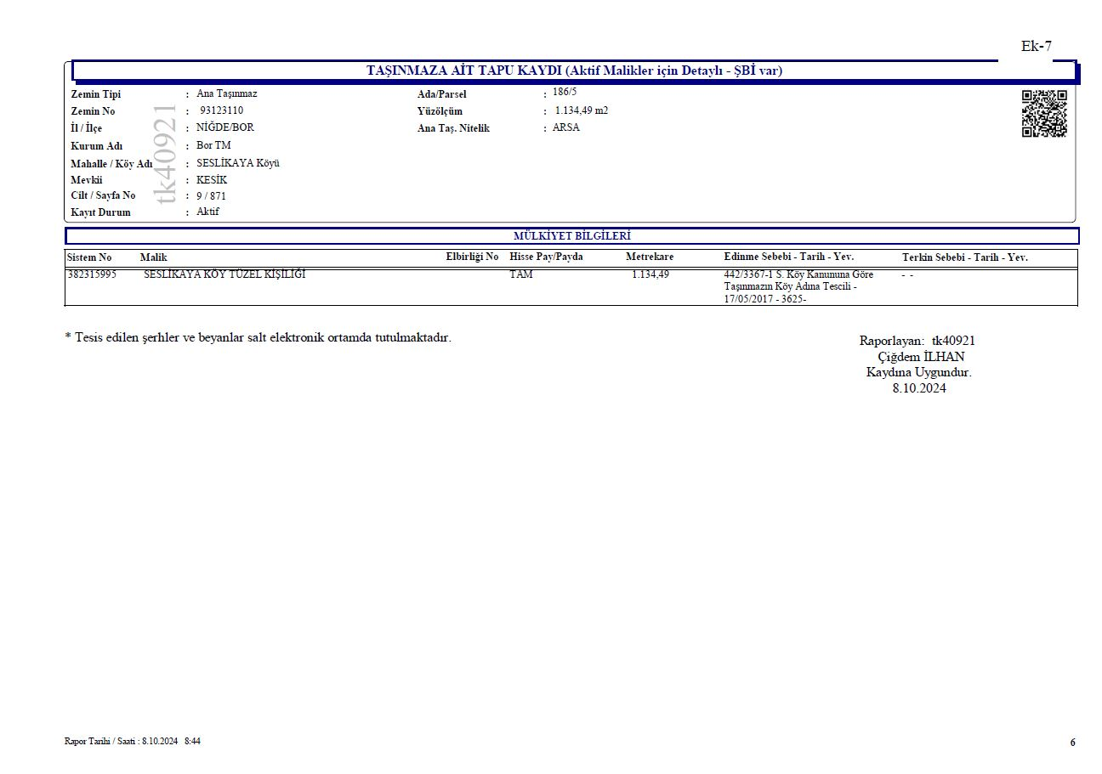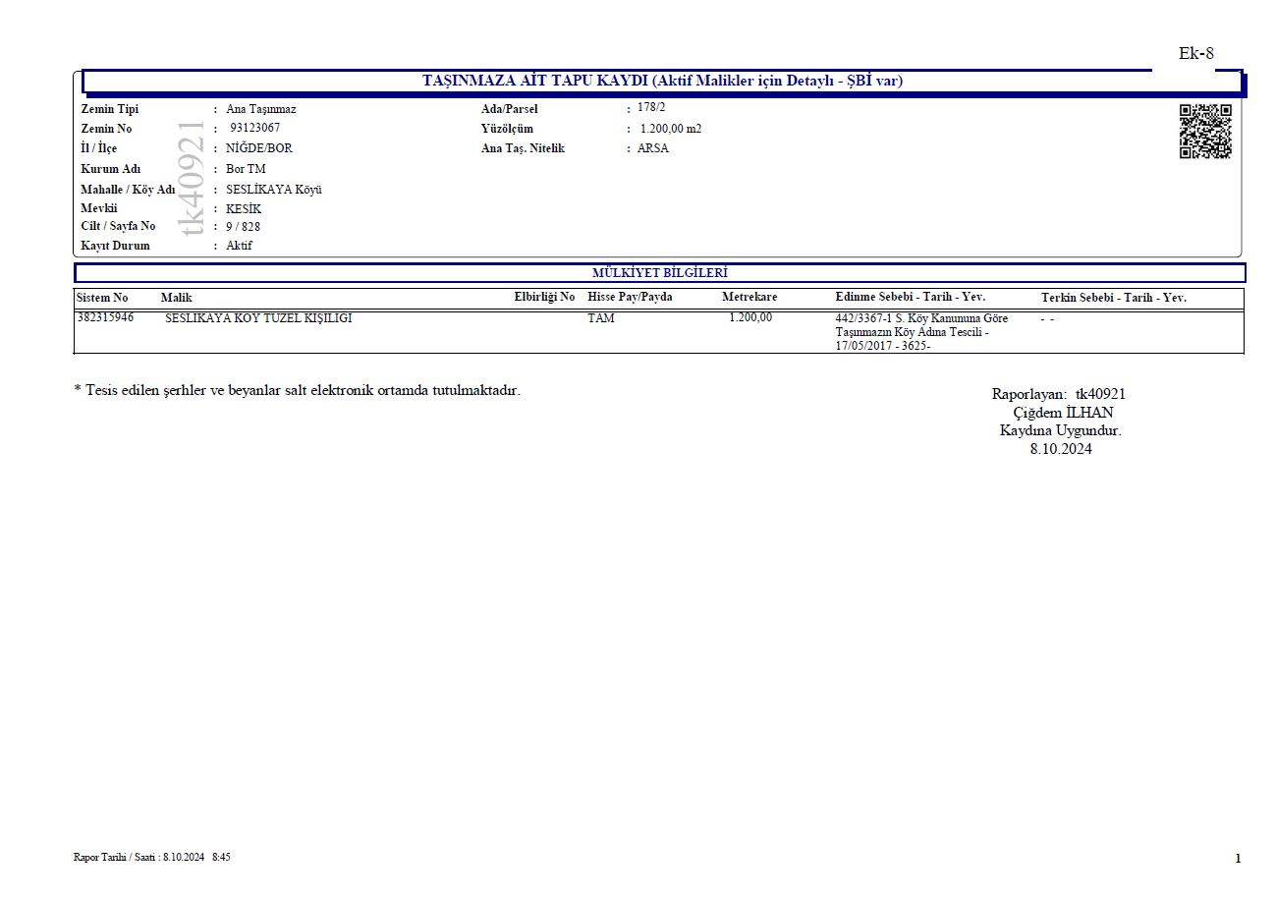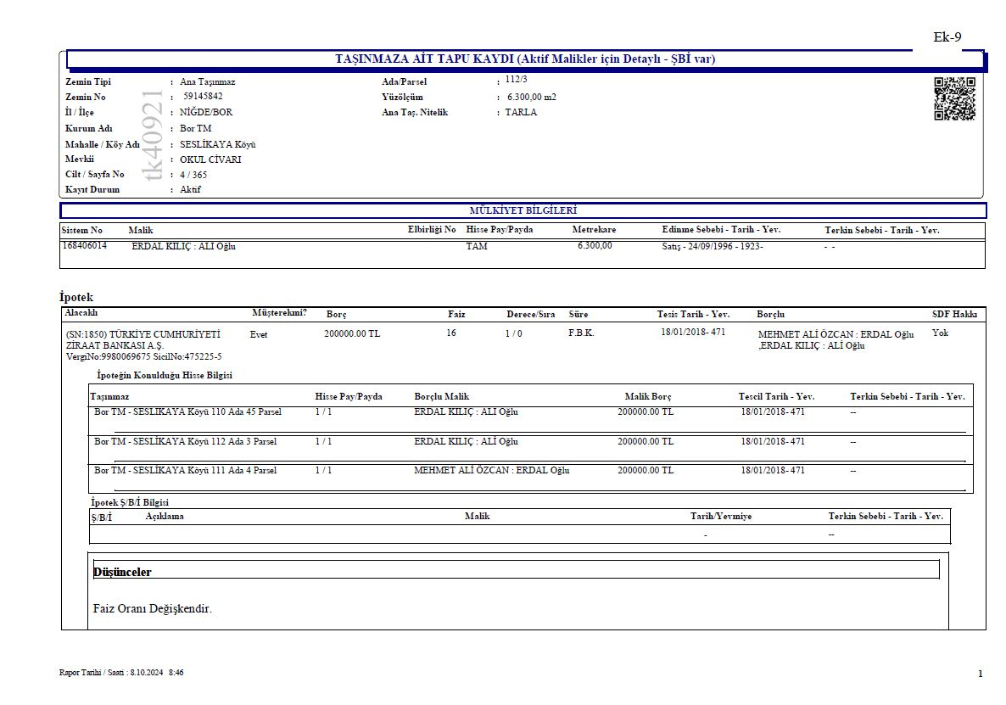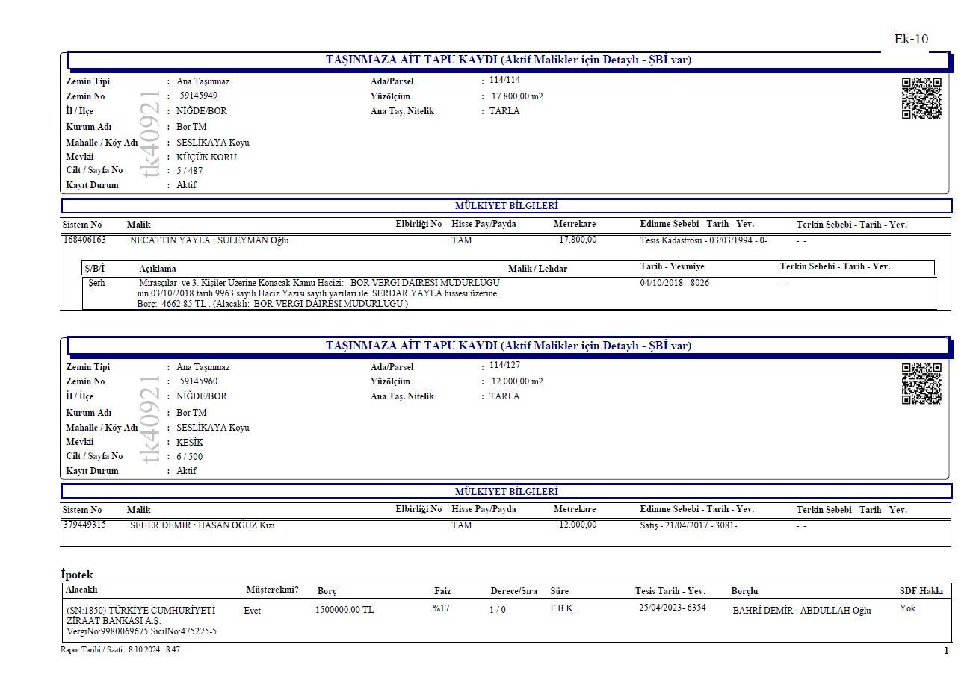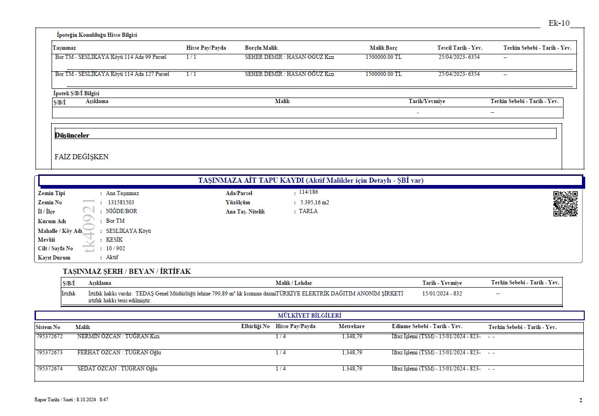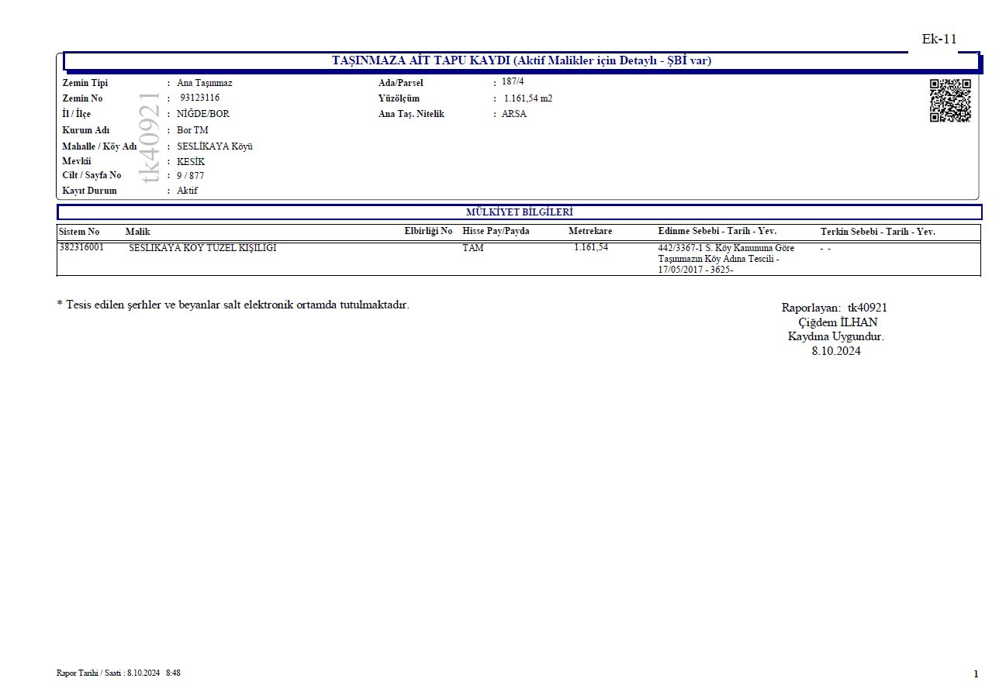
Figure 10-1. Title Deed Information for the Project Area and ETL

Appendix-2 Environmental and Social Screening Checklist for the Project
Sub-project Information
Sub-project title | Kemerhisar SPP
Sub-project beneficiaries | Kemerhisar Municipality
Brief description of sub-project | Kemerhisar Municipality's self-consumption Solar Power Plant Project aims to produce the electricity consumption needed by the town municipality through a solar power-based electricity generation facility.
The planned capacity for Solar Power Plants (MWh/MWe) | It will have a total installed power of 830 +190 kWe.
Site area (ha), location | 21,436.39 m²  Niğde Province, Kemerhisar District, Tepe Neighborhood
Status of national EIA process of sub-project Please attach the official documents for (Annex I - Within the Scope of the Environmental Impact Assessment), (Annex II - Not Requiring Environmental Impact Assessment), and (Excluded from Scope). | The project has been evaluated under Annex II of the Turkish EIA Regulation and has been officially documented as ‘Not Requiring Environmental Impact Assessment.’

Environmental and social impacts related to the proposed sub-project – the existing situation
 | Yes | No | Details
Will the sub-project adversely affect legally protected areas or internationally recognized areas of high biodiversity value? |  | X | The project consists of approximately 7,6 km overhead and 1 km underground transmission line and a 21,436.39 m² solar power plant, and due to its scale and scope, it is not expected to have adverse impacts on nationally or internationally protected areas. Although the project is located within the boundaries of the Ereğli Plain Key Biodiversiy Area (KBA), no direct impact on protected areas is anticipated
Will the sub-project be located in or near the environmentally sensitive or protected area (in accordance with national legislation)? |  | X | There is no nationally protected sensitive area in the immediate vicinity of the project area.
Will the sub-project adversely affect critical habitats such as forest ecosystems, wetlands, marshlands, and aquatic ecosystems or natural habitats? |  | X | The project area and its immediate surroundings consist primarily of agricultural land. No such impact is expected, as there are no wetlands, marshlands, aquatic ecosystems, or natural areas in the surrounding areas.
Will the sub-project adversely affect endangered plant and animal species? |  | X | There are no endangered species in the area where the project takes place, and the area is not located on the migration route.
Will the sub-project affect archaeological sites, historic monuments and settlements? |  | X | There are no archaeological sites or historical monuments found in the past around the project area. For this reason, the probability of finding finds in the area seems low.
Is there woods or forest around the sub-project area? |  | X | There is no forest around the project.
Will the sub-project adversely affect the woods and forest? |  | X
Is there any combustible and flammable subsidence material around the sub-project area? |  | X
Is there underground facilities such as gas pipeline, electrical facilities? |  | X
Are there any overhead lines such as high-voltage lines in or near the sub-project area? |  | X
Will people permanently or temporarily lose access to facilities, services, or natural resources because of the sub-project activities? |  | X
Does this sub-project intervention (for the power plant area, energy transmission line, or transportation route) require the acquisition of privately owned land? If so, please provide details. |  | X | Yes. The sub-project requires acquisition/easement of 7 privately owned agricultural parcels (4 cultivated with seasonal crops, 3 vacant). No perennial crops or structures are present; hydrants and irrigation pipelines will be considered in compensation.
If land parcel acquisition is required (for the Power Plant Area, Energy Transmission Line, or Access Road), what is the actual land size and ownership status? | X |  | The project sites are owned by the Kemerhisar Municipality, with a combined area of approximately 21,436.39 m2  The project sites are located approximately 2,5 kilometers from the city center of Kemerhisar Municipality. Within the scope of the Kemerhisar Solar Power Plant (SPP) Project, a total of 23 land parcels are located along the planned electricity transmission line route, of which 16 are publicly owned and 7 are privately owned.
If new land is needed (for the Power Plant Area, Energy Transmission Line, or Access Road) and the land is privately owned, can this land be purchased through mutual agreement (outside of expropriation) with the consent of the landowner? |  | X | Private lands have been expropriated.
Will the sub-project require the acquisition of public lands? |  | X
If public lands will be acquired, are there any formal/informal users utilizing these lands for income generation purposes? |  | NA
Will there be loss of/damage to productive trees, fruit plants or crops that generate livelihood income for the households? |  | X
Is there any soil contamination observed at the sub-project area? |  | X
Impacts of sub-project (in case of rooftop solar sub-project only):
Will the sub-project affect the daily operation of the building and people? |  | X | No impact expected as long as the dates of active construction are made known to the public
Is the building protected under the law for the protection of cultural heritage? |  | X
Is the building of special significance to any vulnerable group (i.e. disabled people, minorities, youth, etc.)? |  | X | The project area belongs to the municipality, no indirect users have been identified.

Environmental and social/impacts related to sub-project construction/installation
 | Yes | No | Details
Will the sub-project involve the use of forest trees or other natural resources as building materials? |  | X
Will the sub-project emit greenhouse gases (CO₂, NOx, O₃) or ozone-depleting substances (CFC, methyl bromide, etc.)? |  | X | It is envisaged to use a small crane, and a truck during the construction phase of the project. Greenhouse gas generation will be negligible.
Will the sub-project use, produce, or discharge hazardous and toxic materials (e.g., hospital waste, industrial waste, or other?) | X |  | If the equipment is to be filled with fuel near the site, there will be a possibility of minor spills. Apart from this, there is a possibility of small scale medical waste (dressing etc.).
Will the sub-project produce or cause occupational hazards? | X |  | In the exaction material transport and assembling works of panels, PV Panel Power Lines Connecting etc. In all processes, there are hazards such as working at height, electric shock or Hot/Sunstroke.
Will the sub-project cause dust and noise pollution? | X |  | A low amount of dust generation is expected on the access roads during the transportation of the exaction material, panels, and a low amount of noise generation during installation.
Will the sub-project cause water pollution? |  | X | Due to the low number of people to work, there will not be a significant increase in the wastewater load.
Will the sub-project cause soil pollution? | X |  | There is a possibility of pollution due to the storage of hazardous materials and wastes generated during construction and assembly without providing the necessary conditions.
Will the sub-project result in temporary disruption to the livelihoods of any persons/households? |  | X
Will the sub-project cause community safety-related hazards? | X |  | Occupational hazards will arise due to working at height and working with electricity.
Will the sub-project include significant OHS concerns? |  | X
Will the sub-project cause additional traffic load? |  | X | It is envisaged to use a small crane, and a truck during the construction phase of the project. The contribution of the project to traffic will be negligible.
Will the sub-project cause any adverse impact on the closest sensitive receptors (if there is any)? |  | X
Is there a population that can be negatively affected by the sub-project? |  | X | The project sites are located approximately 2,5 kilometers from the city center of Kemerhisar Municipality. However, considering the short construction period and the scope of construction, the impact is not expected.
Other environmental or social impacts (describe the nature and severity of its impact) | Preparation phase:  One of the environmental considerations concerns waste management, as construction activities can generate various types of waste, including exaction material, domestic solid waste, packaging waste, hazardous waste and medical waste. Appropriate waste management practices are essential to prevent negative effects on the environment and human health. There is no expropriation within the project scope.  Construction phase  The effects at the preparatory stage also apply during construction. In addition, maintenance oils and hazardous materials used for vehicles and machinery may pose a risk of soil pollution if not properly managed. In addition, dust emissions may occur due to the movement of machinery. By applying appropriate dust control measures such as water spraying and dust curtains, airborne particles can be reduced and air quality standards can be complied with. Noise from machinery and assembly processes can have potential effects on workers and surrounding local residents. Night work will be avoided and preventive measures will be taken regarding any complaints about noise. Traffic density is not expected to increase significantly due to the restricted movement of heavy equipment on the access roads to the project areas.  Operation phase:  The operation phase of the solar power plant will not involve significant risks in terms of the environment.

Sub-project Categorization and Need for Safeguards Instruments
Sub-project Category | ☒ Low ☐ Moderate ☐ Substantial ☐ High
Key Reasons | The construction phase will be short-term and low-impact. No impact expected during operation.
Environmental and Social Instruments Required | ☒ ESMP  ☒ OHSP  ☐ ESIA  ☐ LMP  ☐ RAP  ☐ Ex-post Social Audit

Appendix-3 Botaş Opinion Letter
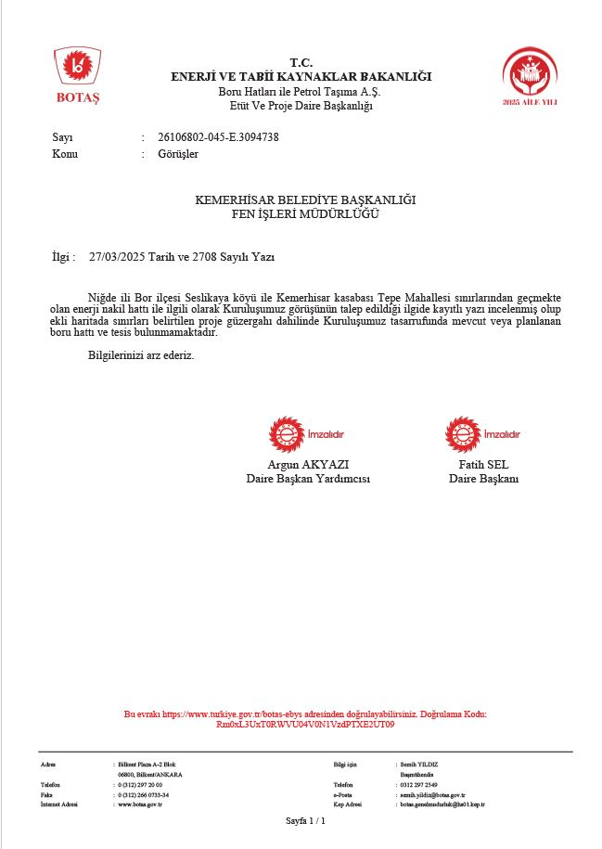

Appendix-4 Call Letter
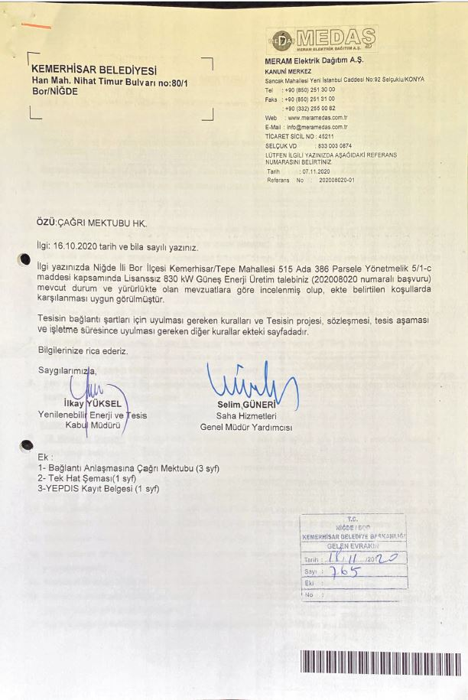

Appendix-5 Photos Taken from the Site Visit
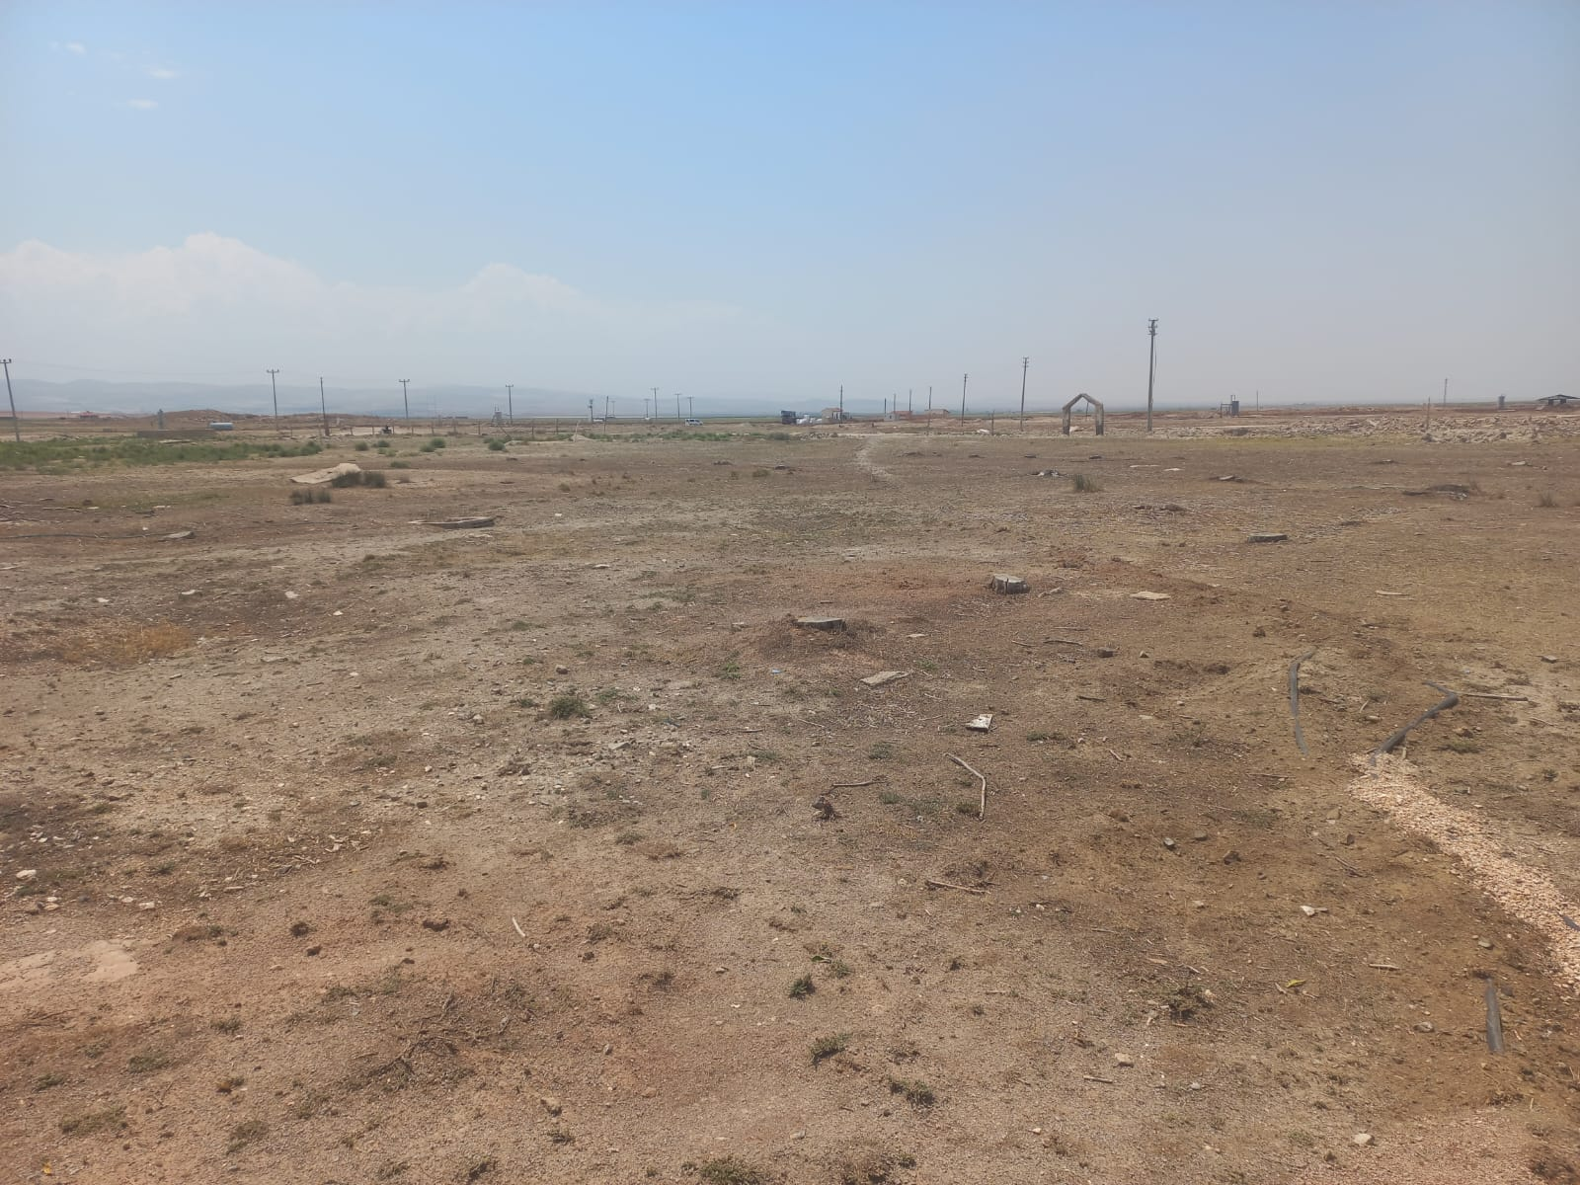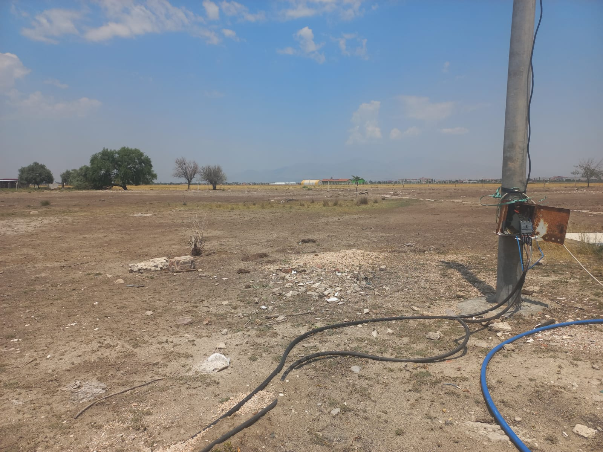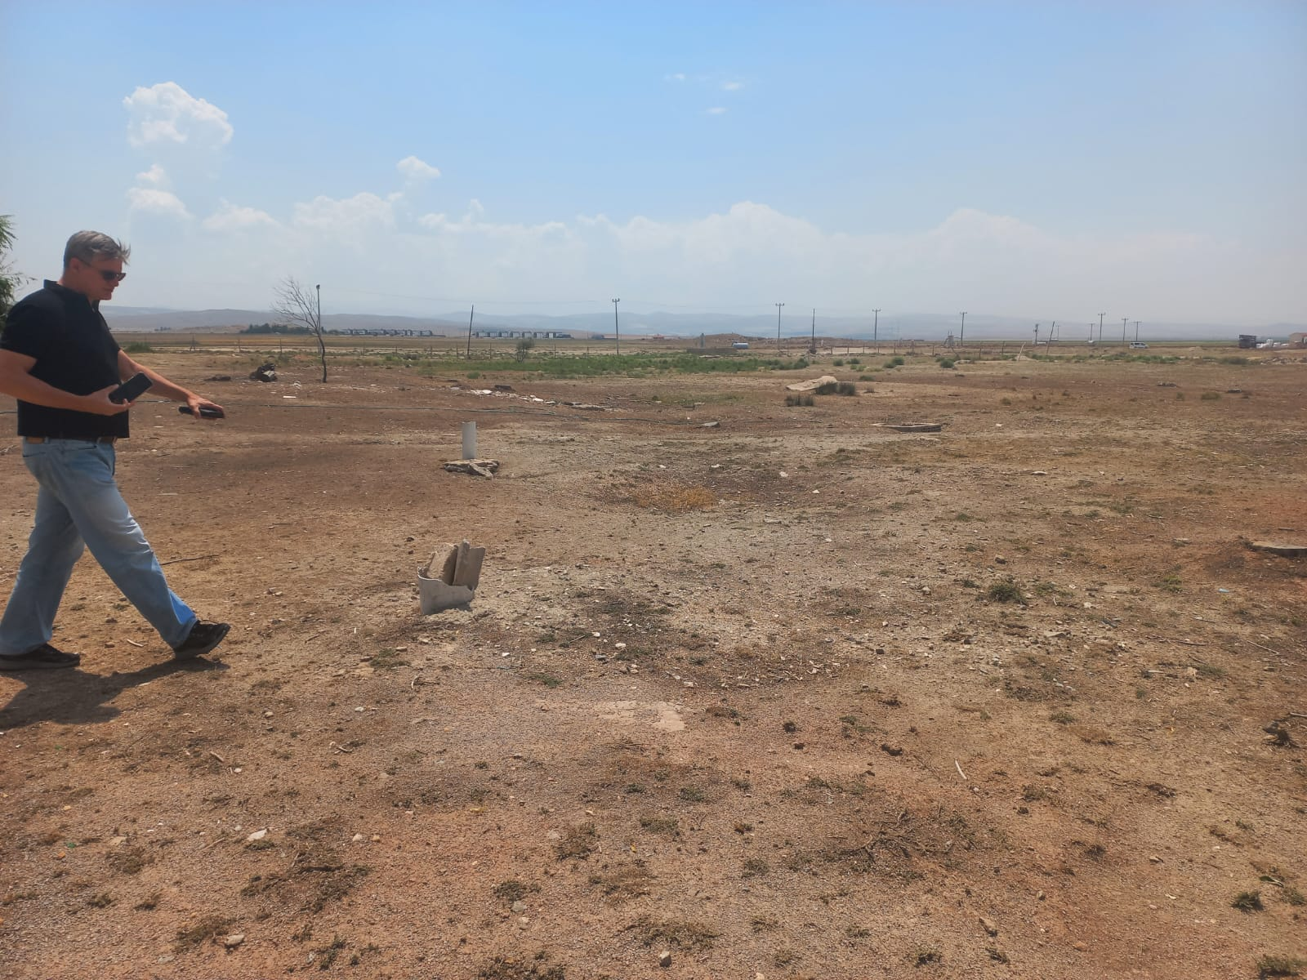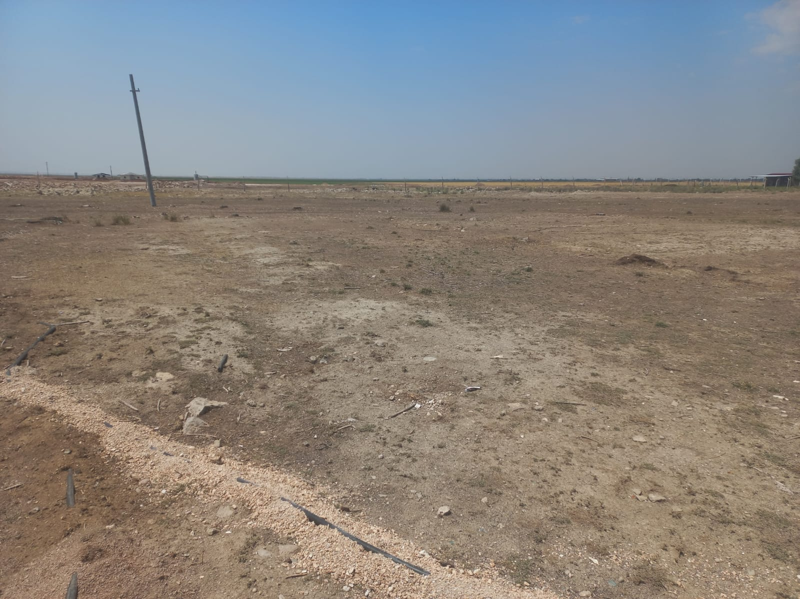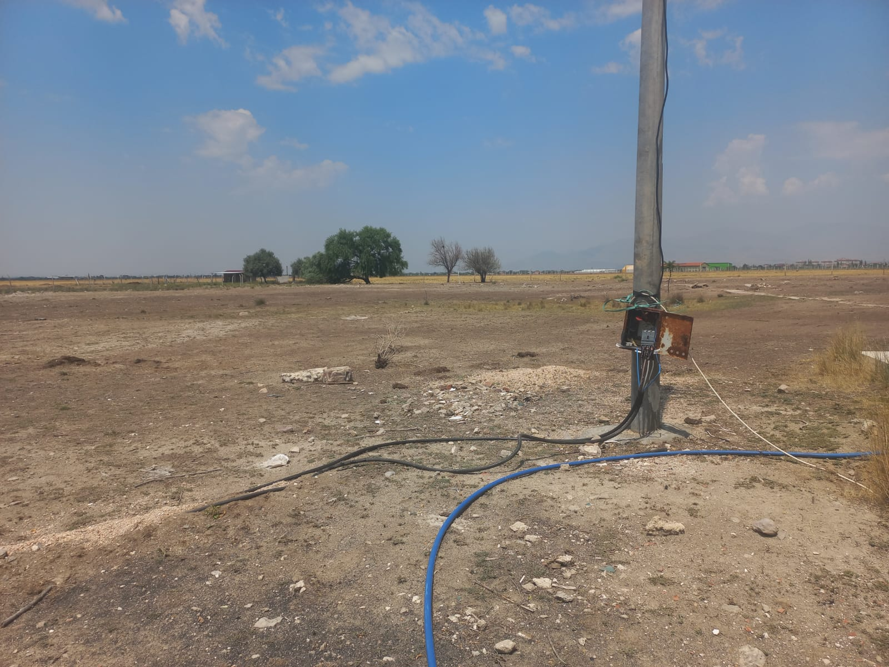

Appendix-6 Chance Find Procedure
INTRODUCTION
This document presents the Chance Find Procedure for Kemerhisar Solar Power Plant Project and is prepared by 2U1K Engineering and Consultancy Inc. for Kemerhisar Municipality (hereinafter referred to as 'Borrower / sub-project owner').
This document is intended to avoid potential impacts of the sub-project on any cultural heritage during land preparation works, including excavation. This Procedure is a part of the general package as an annex to the Environmental and Social Management Plan (ESMP) developed for the sub-project.
SCOPE
Types of Cultural Heritage Covered by This Procedure
Tangible Cultural Heritage
Tangible (physical) cultural heritage refers to movable or immovable objects, sites, structures, groups of structures, and natural features and landscapes that have archaeological, paleontological, historical, architectural, religious, aesthetic, or other cultural significance.
ROLES AND RESPONSIBILITIES
Roles | Responsibilities
Contractors | - Compliance with the Chance Find Procedure provided in contractor agreements,  - Provide appropriate training and information to the worksite personnel who work in the sub-projects and who may disturb the cultural heritage so that they understand their responsibilities for cultural heritage.
Project Owner | - Ensure compliance of the sub-project with the Project Standards and other requirements given in this procedure,  - General responsibility for the scope and implementation of the procedure,  - Development, monitoring and revision of this procedure,  - Fulfilment of cultural heritage evaluation processes,  - Ensure that the operations do not disturb cultural properties and sites without the approval of the relevant authority,  - Investigation, reporting and monitoring of unauthorized damages to the worksite as well as of procedure violations,  - Management of amendments to laws or policies,  - Coordination with the organizations involved in the implementation and other stakeholders.
All Workers | - Learn about the Chance Find Procedure through induction training and any other training provided.
PROJECT STANDARDS
- Law on the Conservation of Cultural and Natural Properties (LCCNP) (No: 2863),
- Convention Concerning the Protection of the World Cultural and Natural Heritage (World Heritage Convention).
CHANCE FIND PROCEDURE
Initial Approach Adopted by the Contractor
- Action 1: Immediately stop all construction works in the vicinity of the chance find, in case of discovery of archaeological finds,
- Action 2: Immediately notify the project manager and/or environmental department,
- Action 3: Take photographs or make technical drawings,
- Action 4: Record the location of the location by keeping all remains in their position (without moving them);
- Action 5: Prevent damage to or loss of movable objects by encircling the area,
- Action 6: Contact an archaeologist from a local university for guidance,
- Action 7: Prepare the Chance Find Form (Annex 1).
Approach Adopted by the Archaeologist
Based on the description of the find, the archaeologist will make recommendations on actions to be taken by phone/e-mail or visit. The sub-project team will take into account the following possible strategies, if the archaeologist(s) confirm(s) the presence of archaeological finds/remains/sites:
Strategy 1: Avoidance by partial or full sub-project redesign or relocation
In case of any archaeological find or discovery, the sub-project owner will provide the relevant information to authorities. This responsibility will apply even if the sub-project is redesigned or relocated. In any case, the relevant governmental body will be informed of the archaeological find or discovery.
Strategy 2: Implementation of worksite protection measures
This option includes the implementation of site protection measures such as fencing or blockage. As per LCCNP No. 2863, any archaeological find is the property of the Republic of Türkiye, and governmental bodies will decide on the geographical scope and implementation of site protection measures.
Strategy 3: Rescue or emergency excavation
If the sub-project owner fails to relocate or redesign the sub-project, this may require rescue or emergency excavation works. If notification is stipulated by LCCNP, an application will be lodged to governmental bodies. If an official application is lodged, the relevant Regional Board will be allowed to make a decision.
After the permit is obtained, archaeological excavations will be performed with the attendance of scientific consultants from the archeological departments of universities. Following the completion of archaeological excavations, the results will be submitted to relevant governmental bodies for the final decision to be taken for the progress of the sub-project.
Procedure for the Discovery of Potential Human Remains
Identification of human remains is very clear in terms of graves or burial sites. If a grave or burial site is found, the procedures to be followed are not different from the procedure applicable to archaeological finds as per Article 6 of LCCNP. Modern burials or forensic human remains will not be addressed within the scope of LCCNP.
KEY PERFORMANCE INDICATORS
The key performance indicators to be used during the implementation of this Procedure are set out below.
Table 10-1. Key Performance Indicators (KPIs)
No | KPIs | Target | Monitoring Measure
1 | Non-conformities reported during the year with respect to key management controls identified in this procedure | Minimization of reported non-conformities, aiming at zero | Database  Reporting  Inspection Reports
2 | Number of complaints lodged by local communities during the year regarding cultural heritages | Investigation of complaints about cultural heritage (disrespect, destruction, removal, sale of artefacts) and fulfilment of relevant actions.  Provision of prompt response to complaints from local communities regarding the misbehaviour of personnel regarding cultural properties. | Database  Grievance Mechanism Records  Reporting
REPORTING
Contractor will comply with reporting requirements including chance finds defined in site-specific ESMP (contractor will develop monthly and quarterly monitoring reports and submit to Kemerhisar Municipality through supervision consultant; Kemerhisar Municipality will examine submit the reports to ILBANK quarterly (and monthly if requested by ILBANK); ILBANK will inform the World Bank by providing regular semi-annual monitoring reports.
ANNEX – 1 Sample Chance Find Form
Place: | Chance Find No: | Date:
Location Data:
Coordination:
Elevation:
Brief Area Description:
Chance Type: | Archaeological Items  Metal Finds  Terracotta Finds  Pottery Shards  Glass Finds | Sculpture etc.  Human / Animal Bone  Unidentified
Temporary Measures
Photograph

Discoverer's Name-Last Name:
Signature:

Appendix-7 Grievance Submission Form
Kemerhisar Municipality |  | Kemerhisar Municipality  Kemerhisar Solar Power Plant Project (TUCSAP)  Adana BSL2 & BSL3 Laboratory  PROJECT NO: 25/12
 |  | GRIEVANCE FORM
Form Completed by: |  |  |  |  | Date and Time:
Subject of Meeting:
- PARTICULARS OF THE COMPLAINANT
Name-Last Name: |  |  |  |  | Grievance Communicated by:
TR ID No: |  |  |  |  | Telephone / Toll Free Number
Telephone: |  |  |  |  | Face-to-Face Meeting
Address: |  |  |  |  | Website / E-mail
E-mail: |  |  |  |  | Other (Describe)
Type of Stakeholder
Governmental  Body | PAP |  | Private  Enterprise | Professional Chamber |  | NGO
Focus Groups | Union of  Industries |  | Labor Union | Media |  | University
- DETAILED INFORMATION ON THE GRIEVANCE
Description of the grievance:
Solution method requested by the complainant
Recorded by  Name-Last Name/Signature |  | Complainant  Name-Last Name/Signature

Appendix-8 Grievance Closure Form

Kemerhisar Municipality |  | Kemerhisar Municipality  Kemerhisar Solar Power Plant Project (TUCSAP)  Adana BSL2 & BSL3 Laboratory  PROJECT NO: 25/12
 |  | GRIEVANCE CLOSURE FORM
Kemerhisar Municipality
PROJECT NO: 25/12
- DETERMINATION OF THE CORRECTIVE ACTION
1
2
3
4
5
Responsible Departments
- GRIEVANCE CLOSURE
This section will be completed and signed by the complainant, if the grievance provided in the Grievance Log Form is remediated.
Grievance Closure Date: | Grievance Closer's Full Name/Signature:  Complainant's Full Name/Signature:

Appendix-9 Sample Key Informant Interview Form (For Single Stakeholder Interviews)

No | İstişare tarihi:  Consultation date: | İstişare yeri:  Consultation location: | İstişare konusu:  Consultation subject: | İstişare saati:  Consultation time: | Toplam katılımcı sayısı:  Total number of participants: | Katılımcı adı soyadı:  Participant name and surname | Kurum / firma:  Institution/company: | Posizyonu/ mesleği:  Position/ profession: | E-mail/ Telefon:  E-mail/ Phone: | İmza  Signature
1
2
3
4
5
6
7
8
9
10
11
12
13
14
15
16
17
18
19

Appendix-10 Sample Consultation Form (For Stakeholder Participation Meeting(s)
Complaint Register  Number | How Complaint is Received (Grievance Form, Community Meeting, Telephone) | Level of Grievance (Municipality/Utility Level, Regional ILBANK Office, ILBANK HQ Level) | Date of Complaint  Received | Location of Complaint  Received | Name of Person Receiving Grievance | Land Parcel #  (If complaint is related to land) | Complainant Information |  |  |  |  | Sub-Project Component Related to Complaint | Grievance Category (expropriation/land acquisition related, environmental issues, damages to structures etc.) | Complaint Summary | Grievance Status (open, closed or pending) | Action Taken |  |  |  | Supporting Documents for Grievance Closeout (bank receipt for compensation, grievance closure protocol)
 |  |  |  |  |  |  | Name/Surname | ID Number | Telephone/  e-mail | Village-District | Gender |  |  |  |  | Responsible Person/Department | Action Planned | Due Date of the Addressing the Grievance | Date of Action Taken

Appendix-11 EIA Scope Out Certificate
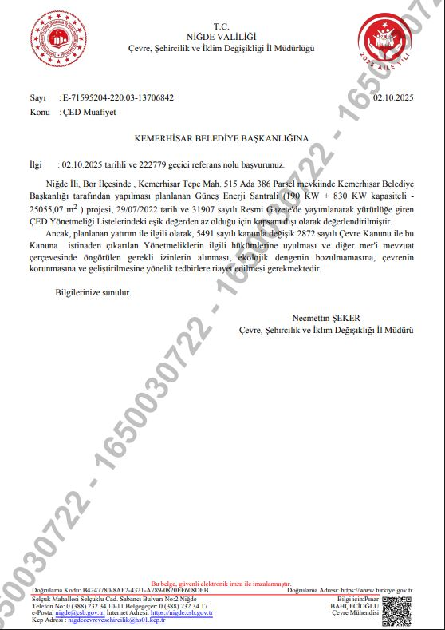

Appendix-12 Project Layout
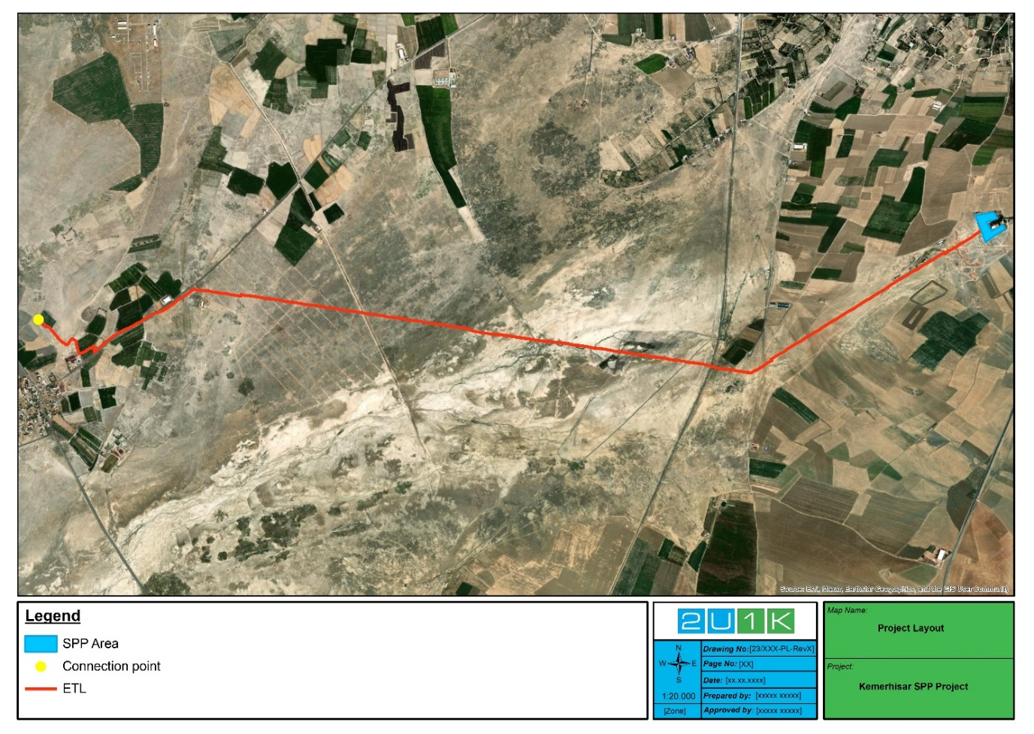

(TUIK-2022)
Extent of occurrence [EOO] is defined as the area contained within the shortest continuous imaginary boundary which can be drawn to encompass all the known, inferred or projected sites of present occurrence of a taxon, excluding cases of vagrancy. This measure may exclude discontinuities or disjunctions within the overall distributions of taxa
As mentioned in the United Nations Development Cooperation Strategy Türkiye 2016-2020 Government of the Republic of Türkiye and The United Nations System in Türkiye, Sustainable, Inclusive Growth and Development Goals.
Chance Find Procedure is presented in Appendix 6.
Sample Key Informant Interview Form (For Single Stakeholder Interviews)and Sample Consultation Form (For Stakeholder Participation Meeting(s) are presented in Appendix 9 and Appendix 10.
Appendix-13 Distributions of Species of Conservation Concern (SCC) Species 