KEMERHİSAR SOLAR POWER PLANT PROJECT
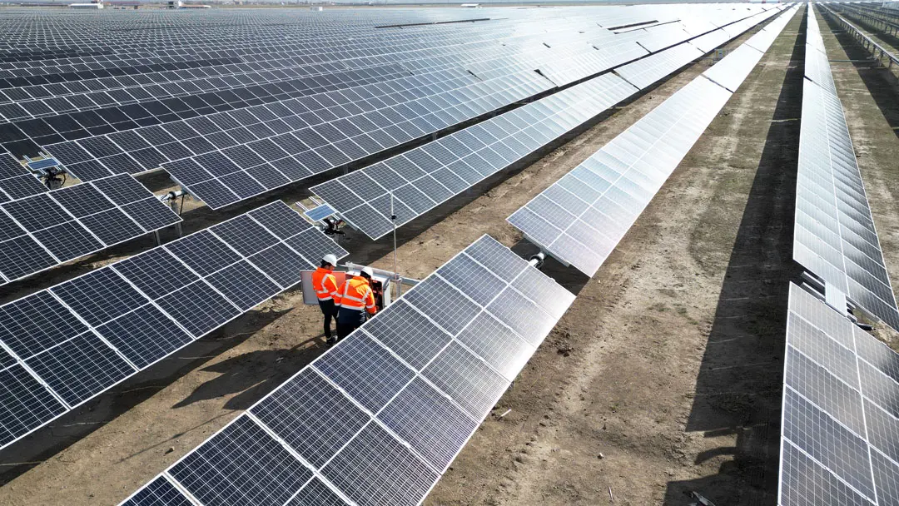
LAND ACQUISITION AND RESETTLEMENT ACTION PLAN
APRIL 2026
ANKARA

KEMERHİSAR SOLAR POWER PLANT PROJECT
LAND ACQUISITION AND RESETTLEMENT ACTION PLAN
Version | Revision | Date | Prepared By |  | Quality Management By | Checked By | Approved By
Draft | A.0 | August 2025 | Deniz Dirier | İrem Yılmaz | Esra Okumuşoğlu | D. Emre Kaya | Günal Özenirler
Draft | A.0 | August 2025 | Sociologist  M.Sc. | Sociologist  B.Sc. | Geological Engineer, B.Sc. | Environmental Engineer, M.Sc. | Environmental Engineer, M.Sc.
Draft | A.1 | October 2025 | Deniz Dirier | İrem Yılmaz | Esra Okumuşoğlu | D. Emre Kaya | Günal Özenirler
Draft | A.1 | October 2025 | Sociologist  M.Sc. | Sociologist  B.Sc. | Geological Engineer, B.Sc. | Environmental Engineer, M.Sc. | Environmental Engineer, M.Sc.
Final | C.0 | Nov. 2025 | Deniz Dirier | İrem Yılmaz | Esra Okumuşoğlu | D. Emre Kaya | Günal Özenirler
Final | C.0 | Nov. 2025 | Sociologist  M.Sc. | Sociologist  B.Sc. | Geological Engineer, B.Sc. | Environmental Engineer, M.Sc. | Environmental Engineer, M.Sc.
Final | C.1 | April 2026 | Deniz Dirier | İrem Yılmaz | Esra Okumuşoğlu | D. Emre Kaya | Günal Özenirler
Final | C.1 | April 2026 | Sociologist  M.Sc. | Sociologist  B.Sc. | Geological Engineer, B.Sc. | Environmental Engineer, M.Sc. | Environmental Engineer, M.Sc.
Revision Codes: A: Draft, B: Final Draft, C: Final
Project No: 25 / 12
APRIL 2026
CLIENT: | CONSULTANT:
 | 
Han Mh, Nihat Timur Blv. No:48, 51730 Kemerhisar/Bor/Niğde  ( +90 388 329 2063  7: +90 388 329 3286 | Tepe Prime İş ve Yaşam Merkezi  Mustafa Kemal Mahallesi Dumlupınar  Bulvarı No: 266 B Blok Kat: 2 Daire: 38  Çankaya - Ankara / Türkiye  : +90 (312) 287 25 07-08  7: +90 (312) 287 25 09

TABLE OF CONTENTS
Page
TABLE OF CONTENTS i
LIST OF TABLES ii
LIST OF FIGURES ii
ABBREVIATIONS iii
1. PROJECT DESCRIPTION 1
1.1. Land Requirements 2
2. OBJECTIVES AND SCOPE OF WORK 4
3. LEGAL FRAMEWORK 5
3.1. National Legislation 5
3.2. International Standards 5
3.3. Gap Analysis between National Legislation and OP 4.12 6
4. SURVEY OF AFFECTED PERSON AND ASSETS 7
4.1. Identification of Affected Landowner and Survey Coverage 7
4.2. Asset Inventory 9
4.3. Socioeconomic Survey 9
5. VALUATION AND COMPENSATION APPROACH 12
6. ELIGIBILITY AND ENTITLEMENT MATRIX 15
7. RESETTLEMENT AND LIVELIHOOD RESTORATION 17
8. STAKEHOLDER ENGAGEMENT 19
8.1. Consultation Activities 19
8.2. Disclosure Activities 19
8.3. Grievance Mechanism 19
9. ROLES AND RESPONSIBILITIES 21
10. MONITORING AND IMPLEMENTATION 22
10.1. Monitoring and Evaluation 22
10.2. Implementation Schedule 23
11. BUDGET 24
12. APPENDICES 25
Appendix A. List of Expropriated Parcels and Survey Status (July, 2025) 25
Appendix B. Survey Questionnaires 26
Appendix C. Photolog 26
Appendix D. Unused Lands (115/8, 109/2, 108/1) 27

LIST OF TABLES
Page
Table 1-1. Parcel-Based Impact Percentages on Private Land 5
Table 3-1. National Legal Framework on Land Acquisition and Expropriation 2
Table 3-2. Gap Analysis 3
Table 4-1. Surveyed Affected Households 5
Table 4-2. Number of Households by Type of Impact on Private Land 6
Table 4-3. Parcel Specific Land Use and Asset Inventory of Affected Private Parcels 7
Table 4-4. Demographic characteristics of affected households 7
Table 4-5. Livelihood sources of the households 8
Table 6-1. Entitlement Matrix 12
Table 9-1 Responsibilities of Key Actors in LARAP Implementation 20
Table 10-1. Monitoring Indicators 21
Table 10-2 Indicative Implementation Schedule 22

LIST OF FIGURES
Page
Figure 1-1 Lands to be Acquired 2

ABBREVIATIONS

CLO | Community Liaison Officer
EHS | Environment, Health and Safety
ETL | Energy Transmission Line
ERO | Energy Regulatory Office
FGD | Focus Group Discussion
GRM | Grievance Mechanism
LARAP | Land Acquisition and Resettlement Action Plan
MEDAŞ | Meram Elektrik Dağıtım Anonim Şirketi
PAP | Project Affected Person
PIU | Project Implementation Unit
RAP | Resettlement Action Plan
SPP | Solar Power Plant
TEİAŞ | Turkish Electricity Transmission Corporation
OIZ | Organized Industrial Zone
OP | Operational Policies
WB | World Bank

PROJECT DESCRIPTION
Kemerhisar Solar Power Project comprises two distinct solar generation units:
- Kemerhisar SPP-1 with a capacity of 190 kWe and
- Kemerhisar SPP-2 with a capacity of 830 kWe.
The Project was initially defined under Parcel 515/386. In line with TEDAŞ requirements, a cadastral subdivision has been carried out to separate the transformer location. Accordingly, the Project remains in the same location; however, the parcel boundaries have been refined, resulting in a slight reduction in the defined project area. SPP units are located on Parcel 515/441, while the associated transformer is situated on the adjacent Parcel 515/442. The project area covers approximately 21,436.39 m2, and the ETL route transverses multiple parcels owned by different private landholders. The transmission line is planned as an above-ground line and will connect to the distribution infrastructure at the Organized Industrial Zone. Connection agreements and permissions, including those from the Turkish Electricity Transmission Corporation (TEİAŞ) and BOTAŞ, have been obtained. The Call Letters issued for both solar units confirm technical feasibility and grid connection compatibility.
The electricity generated by both units will be fed into the local low-voltage grid via a dedicated ETL, which is designed entirely as an above-ground installation. The ETL corridor crosses privately owned parcels and required right-of-way permissions have been obtained through formal easement arrangements.
The power evacuation point is located within the Niğde OIZ and the energy produced by Kemerhisar SPP will be transferred to the OIZ’s internal distribution network. The connection has been approved through a call letter issued by TEİAŞ, and connection agreements have been signed accordingly. Although the OIZ grid is not directly operated by TEİAŞ, it is integrated into the national energy system and complies with TEİAŞ’s technical and regulatory standards.
All energy generation, transmission and connection procedures are being implemented in compliance with Türkiye’s legal framework for unlicensed renewable energy projects, in accordance with Law No. 6446 on Electricity Market and its secondary legislation.
Construction of the solar units and associated infrastructure is expected to be completed within 6 months, contingent on seasonal and logistical factors. Once operational, the project is anticipated to contribute approximately, 1.02 Mwe of clean, renewable electricity to the regional network-supporting local sustainability goals and Türkiye’s commitments under National Energy Efficiency Action Plan and National Climate Strategy.

Land Requirements
The Project requires a total of 21,436.39 m² of land for the installation of the solar generation units. In addition, the ETL corridor traverses 23 parcels in total, of which 16 are publicly owned and 7 are privately owned. All public parcels and private plots affected by the Project are subject to land acquisition or easement rights to enable project use. Among the private parcels, some are subject only to easement for the ETL, while others are subject to permanent land acquisition for tower foundations in addition to easement rights.
The following table presents details for the private land parcels only, including parcel size, ownership, and the proportion of land subject to acquisition or easement.

Table 1-1. Parcel-Based Impact Percentages on Private Land
Parcel no | Purpose | Parcel Area (m²) | Permanenet acquisition (m²) | Permanenet acquisition (%) | Easement (m²) | Easement (%)
114/186 | ETL | 5,395.16 | 0 | 0 | 291.90 | 5.41
113/8 | Tower + ETL | 6,000.00 | 19.24 | 0.32 | 971.10 | 16.18
113/7 | ETL | 20,700.00 | 0 | 0 | 355.01 | 1.72
113/6 | Tower + ETL | 20,400.00 | 16.84 | 0.08 | 1,900.92 | 9.32
115/18 | Tower + ETL | 6,800.00 | 10.89 | 0.16 | 1.011.52 | 14.88
109/2 | Tower + ETL | 9,500.00 | 19.30 | 0.20 | 1,525.15 | 16.05
108/1 | ETL | 10,600.00 | 0 | 0 | 1.359.29 | 12.82

Both public and private land parcels that will be affected by the land acquisition required for the Project are presented in Figure 1-1.
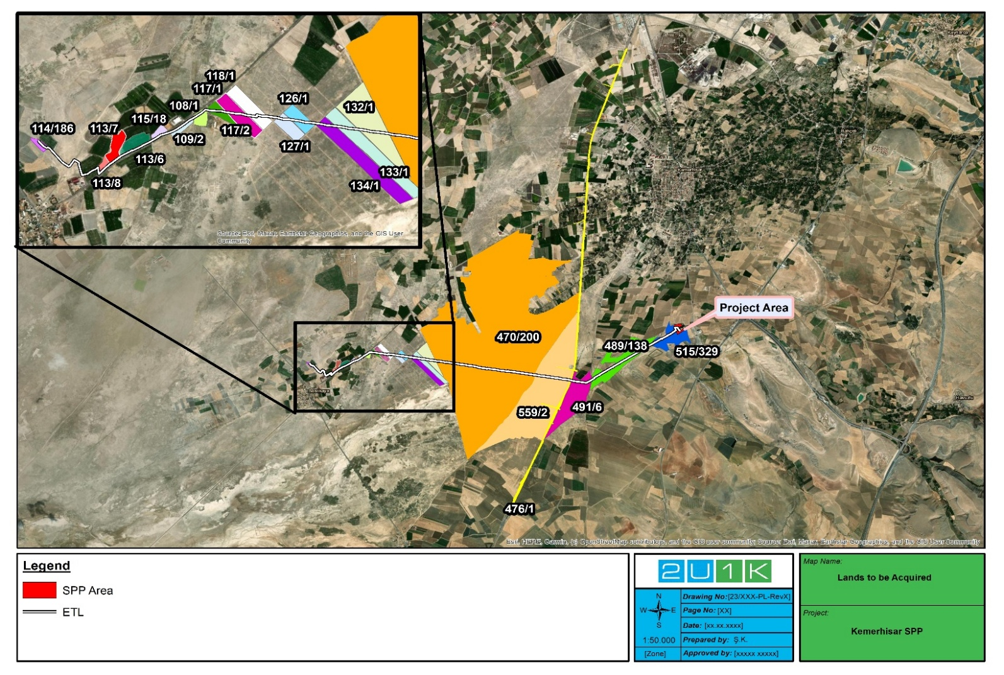
Figure 1-1 Lands to be Acquired

OBJECTIVES AND SCOPE OF WORK
The primary objective of this Land Acquisition and Resettlement Action Plan (LARAP) is to address potential economic impacts on individuals and households whose land and livelihoods are affected by land acquisition and land use restrictions related to the construction and operation of the Kemerhisar Solar Power Plant (SPP) and its associated Energy Transmission Line (ETL). This LARAP has been prepared in line with World Bank Operational Policy (OP) 4.12: Involuntary Resettlement and relevant national legislation to ensure that Project Affected Persons (PAPs) receive fair compensation and assistance measures enabling them to restore, or where possible improve, their pre-Project standard of living.
The scope of this LARAP is limited to land acquisition impacts caused by:
- Permanent land take within the 21,436.39 m² registered project site for the two photovoltaic (PV) units (190 kWe and 830 kWe),
- Establishment of easement rights along the ~8 km-long ETL corridor traversing both privately and publicly owned parcels, and permanent land acquisition for tower foundations.
No additional land acquisition is required for construction-related activities such as access roads or equipment storage, as existing routes and the registered project site will be used.
This document does not cover other ancillary project components such as transformer stations located within the Niğde Organized Industrial Zone (OIZ) or facilities within the OIZ boundaries, as these are not subject to land acquisition or economic displacement. The Project does not involve any physical displacement; therefore, a Resettlement Action Plan (RAP) is not required.
Accordingly, this LARAP focuses exclusively on economic displacement resulting from the solar plant and ETL-related land acquisition process and includes:
- Identification of PAPs affected by permanent or temporary loss of land or access,
- Specification of eligibility criteria and entitlement measures,
- Compensation in line with the principle of full replacement cost,
- Livelihood restoration strategies tailored to the socio-economic context of PAPs,
- Provisions for vulnerable groups and targeted assistance,
- Monitoring, evaluation, consultation, disclosure, and grievance redress procedures.
All measures outlined in this LARAP will be implemented in a transparent and participatory manner, consistent with both national regulations and international good practice.

LEGAL FRAMEWORK

National Legislation
Table 3-1 presents the summary of national laws and regulations directly relevant to land acquisition, expropriation, servitude rights, and compensation processes applicable to the Project.
Table 3-1. National Legal Framework on Land Acquisition and Expropriation
National Legal Framework on Land Acquisition and Expropriation
Expropriation Law | Law No: 2872; Date of Ratification: 1983 Law No. 2942 (as amended by Law No. 4650), Official Gazette No. 17533, dated 08 November 1983
Electricity Market Law | Law No. 6446, Official Gazette No. 28603, dated 14 March 2013
Implementation Regulation on the Expropriation Law | Official Gazette No. 18215, dated 15 August 1983
Land Registry Law | Law No. 4721 (Turkish Civil Code), Official Gazette No. 24607, dated 8 December 2001
Agricultural Lands Protection and Land Use Law | Law No. 5403, Official Gazette No. 25880, dated 03 July 2005
Municipal Law | Law No. 5393, Official Gazette No. 25874, dated 13 July 2005 (provisions on land transfer and public benefit decisions)

International Standards
This Project is subject to the World Bank’s Safeguard Polices, specifically Operational Policy (OP) 4.12: Involuntary Resettlement, which establishes the principles and requirements for land acquisition, restrictions on land use, and resettlement processes. OP 4.12 aims to avoid or minimize involuntary resettlement where feasible, and where it is unavoidable, to ensure that displaced persons are assisted in improving or at least restoring their livelihoods and standards of living.
Accordingly, this LARAP has been prepared in compliance with OP 4.12, ensuring that:
- Project Affected Persons (PAPs) are identified and consulted,
- Compensation is provided at full replacement cost,
- Livelihoods are restored or improved through additional support measures,
- Particular attention is paid to vulnerable groups.

Gap Analysis between National Legislation and OP 4.12
Gap analysis between Turkish legislation and World Bank OP 4.12 is provided below in Table 3-2. The table presents a comparison between the national expropriation and land acquisition framework and the requirements of OP 4.12, identifies issues not fully addressed by the national legislation, and proposes measures to address such gaps. Identified gaps will be covered by this Project-specific Land Acquisition and Resettlement Action Plan (LARAP).
In case of any disparity between Turkish legislation and the requirements of OP 4.12, the principles and policy of OP 4.12 will prevail. This provision is binding for the Project Owner, who will collaborate with relevant government agencies responsible for expropriation and land acquisition to ensure outcomes consistent with OP 4.12.
Table 3-2. Gap Analysis
Aspect | National Legislation | OP 4.12 Requirements | Gap / Action
Eligibility | Compensation limited to owners with formal title. | Includes owners, tenants, informal users, and those without legal rights. | Although OP 4.12 requires inclusion of informal users and tenants, the socio-economic survey and field verification confirmed that there are no informal users or tenants within the Project-affected area. Therefore, no measures are required under this LARAP.
Compensation | Based on market value determined by court/valuation commission. | Compensation must be at full replacement cost, including transaction costs. | Top-up payments may be needed to meet replacement cost.
Livelihood Restoration | Not explicitly required; focus on cash compensation. | Requires livelihood restoration measures to ensure living standards are improved or restored. | Under this LARAP, cash compensation will be provided at full replacement cost, and no additional programs are envisaged at this stage. If deemed necessary, complementary measures will be considered during the monitoring period.
Consultation & Disclosure | Limited, formal notification required by law. | Continuous consultation, disclosure of information, and participation of PAPs are mandatory. | Stakeholder engagement activities must complement legal notifications.
Grievance Mechanism | Formal complaint channels through courts and administrative bodies. | Accessible, project-level grievance redress mechanism required. | A dedicated GRM has been established under the Project.

SURVEY OF AFFECTED PERSON AND ASSETS

Identification of Affected Landowner and Survey Coverage
A baseline study was conducted to identify and record all Project Affected Persons (PAPs) whose land or livelihoods are impacted by the Kemerhisar Solar Power Plant (SPP) Project and the associated 8 km Electricity Transmission Line (ETL). The studyaimed to establish the number of affected households, household members, and key demographic characteristics.
The field survey was carried out on 29 July 2025 and included household-level questionnaires with landowners, a community-level consultation with the village head (Muhtar) of Seslikaya, and a focus group discussion (FGD) with women (Appendix C). The survey results from the interviewed households provided indicative information on the distribution of PAPs according to land ownership status and provided demographic information necessary for the design of compensation and livelihood restoration measures.
Within the scope of the study, it was determined that the 7 private land parcels affected by easement and permanent land acquisition are held by a total of 6 landowners. During the fieldwork, household-level surveys were successfully conducted with 3 landowners covering 4 private parcels. However, for parcels 115/18, 109/2, and 108/1, no interviews could be conducted despite efforts to contact the landowners through local channels. Although cadastral records confirm the presence of 3 registered owners (a list of parcel-based survey implementation status is provided in Appendix A). According to local authorities and community members, these landowners are not known within the settlement, reside outside the project area, and there are no tenants or informal users present on these parcels. The lands are currently vacant and unused. Please refer to Appendix D for the map illustration of vacant and unused lands.
Notwithstanding the lack of direct consultation during the field survey, all affected landowners will be formally notified through the expropriation process in accordance with national legislation. Although no direct consultations were conducted during the field survey, all affected landowners will be formally notified as part of the expropriation process in accordance with national legislation. Landowners will be informed about the expropriation process, property valuation studies, compensation calculations, and the payment process through formal notifications, individual notices, and announcements published on the Kemerhisar Municipality's website. In addition, information regarding the LARAP and the Grievance Mechanism (GM) will be made available through the same communication channels. Land acquisition activities and official communication with rights holders will be coordinated by the Kemerhisar Municipality Project Implementation Unit (PIU). Throughout the process, landowners will have the opportunity to ask questions, request information, and, where applicable, lodge objections in accordance with the procedures set out in national legislation. Compensation payments will be made in accordance with the applicable legislation following the completion of the expropriation procedures, and no construction activities will commence until compensation has been paid.

In cases where landowners cannot be reached despite official notification procedures, compensation amounts will be deposited in a designated bank account in their name or held in escrow, in accordance with national expropriation procedures, ensuring that their rights are fully secured.
Therefore, all landowners will be provided with the opportunity to participate in the process and receive compensation in line with national legislation and OP 4.12 requirements.

Table 4-1. Surveyed Affected Households
Category | # | Percentage (%)
Total affected households | 3 | -
Total household members | 14 | -
Male | 7 | 50%
Female | 7 | 50%
Source: LARAP Field Study, 2025
Of the privately owned parcels, 3 are affected only by the transmission line (ETL), while 4 parcels are affected by both tower foundations and the ETL.
Among the surveyed parcels (4 in total), 2 are affected only by ETL, while 2 are affected by both tower foundations and the ETL. The remaining 3 parcels, for which no surveys could be conducted, include 1 parcel affected only by the ETL and 2 parcels affected by both tower foundations and the ETL. Details on survey coverage by parcel are provided in Appendix A.
Table 4-2. Number of Households by Type of Impact on Private Land
Type of Impact | # of Households
Easement (ETL only) | 3
Permanent acquisition (tower) + easement (ETL) | 4
Total | 7
Source: LARAP Field Study, 2025
In the three households surveyed, a total of 14 household members were identified as Project Affected Persons (PAPs). All parcels are used/owned by the respective households; there are no informal users or tenants on the land affected by the Project. According to the census findings, the primary livelihood source of the households utilizing the land is agriculture. This underscores the importance of providing compensation at full replacement cost and implementing tailored livelihood restoration measures to address their specific needs.

Asset Inventory
The assessment confirmed that all of the 7 privately owned parcels affected by permanent acquisition or easement are classified as agricultural fields.
Among these parcels, 4 are actively cultivated, primarily with seasonal crops such as wheat, alfalfa, and vegetable produce, while 3 parcels are currently vacant and not under agricultural use. No fruit trees or perennial crops were identified within the affected parcels.
The survey also identified two hydrants located on one parcel and irrigation pipelines passing through two parcels. These installations will be taken into account in the valuation and compensation process. No residential or commercial, structures were observed on the affected parcels. Minor auxiliary features such as a water well and irrigation related infrastructure were identified on certain parcels.
Accordingly, the inventory confirms that the impacts are limited to agricultural land, seasonal crops, and minor irrigation infrastructure, with no impact on buildings or perennial plant assets.
The parcel specific distribution of land use and associated assets is presented in Table 4-3 below.
Table 4-3. Parcel Specific Land Use and Asset Inventory of Affected Private Parcels
Parcel No | Impact Type | Land Use Status | Crop Type | Other Assets
114/186 | ETL | Cultivated | Silage maize | None
113/7 | ETL | Cultivated | Wheat | Irrigation hydrant
113/8 | Tower + ETL | Cultivated | Alfalfa | Irrigation pipe
113/6 | Tower + ETL | Cultivated | Melon (bostan) | Water well
115/18 | Tower + ETL | Vacant | None | None
109/2 | Tower + ETL | Vacant | None | None
108/1 | ETL | Vacant | None | None
Source: LARAP Field Study, 2025
Relevant compensation and mitigation measures for affected crops and irrigation infrastructure are detailed in the Entitlement Matrix

Socioeconomic Survey
During the consultations with PAPs, a total of 14 household members were identified across 3 surveyed households. The demographic and socioeconomic characteristics of these household members, including age, gender, education level, marital status, and occupational status, are presented in the table below.
Table 4-4. Demographic characteristics of affected households
Answers | Frequency | Percent
Sex
Man | 7 | 50
Woman | 7 | 50
Total | 14 | 100
Age
0-6 | 0 | 0
7-18 | 2 | 14.3
19-25 | 2 | 14.3
26-39 | 1 | 7.1
40-55 | 4 | 28.6
56-64 | 0 | 0
65+ | 0 | 0
Total | 9 | 64.3
No answer | 5 | 35.7
Grand Total | 14 | 100
Marital status
Single | 8 | 57.1
Married | 6 | 42.9
Widow | 0 | 0
Total | 14 | 100
Educational level
A child who has not yet completed a level of education | 0 | 0
Adult with no formal education | 0 | 0
Primary or secondary school graduate | 4 | 28.6
High school graduate | 3 | 21.4
University graduate | 4 | 28.6
Total | 11 | 78.6
No answer | 3 | 21.4
Grand Total | 14 | 100
Working status (There are individuals who fall under more than one occupational category)
Salaried employee | 4 | 28.6
Self-employed, investor | 1 | 7.1
Farmer | 4 | 28.6
Housewife | 0 | 0
Unemployed | 2 | 14.3
Retired | 1 | 7.1
Student, child | 2 | 14.3
Total | - | 78.6
No answer | 3 | 21.4
Grand Total | - | 100
Soruce: LARAP field study, 2025
The socioeconomic survey revealed that agriculture constitutes a key component of the livelihoods of all three surveyed households. The main crops cultivated include wheat, alfalfa, and melon. In addition to agriculture, households reported supplementary income sources such as salaried employment, livestock breeding, and pensions. All of the interviewed households indicated reliance on more than one income stream, highlighting a degree of livelihood diversification. The primary and supplementary livelihood sources of the households are presented in Table 4-5 below.
Table 4-5. Livelihood sources of the households
Sources | N | Percent
Primary source of income
Agriculture (crop production) | 1 | 33.3
Salaried employment | 2 | 66.7
Total | 3 | 100
Secondary 1 source of income
Agriculture (crop production) | 1 | 33.3
Livestock farming (animal production) | 2 | 66.7
Total | 3 | 100
Secondary 2 source of income
Agriculture (crop production) | 1 | 50.0
Pension income | 1 | 50.0
Total | 2 | 100
Secondary 3 source of income
Salaried employment | 1 | 100
Total | 1 | 100

Household heads emphasized that agriculture remains the primary expenditure item within their annual household budgets, reflecting the central role of crop production in sustaining household welfare and covering recurrent costs.
The survey findings also confirmed that none of the surveyed households include members belonging to identified vulnerable groups.

VALUATION AND COMPENSATION APPROACH
Land acquisition for the Project will be carried out through expropriation, while easement rights for the Electricity Transmission Line (ETL) parcels are expected to be established for a period of approximately 25 years. In total, 23 parcels will be affected, of which 16 are publicly owned and 7 are privately owned. The 7 private parcels are registered under 6 owners; consultations were successfully conducted with 3 landowners representing 4 parcels, while the remaining 3 owners could not be reached since they reside outside the settlement, are not known by local residents, and their parcels remain unused. Consultations with landowners served to disclose Project information and confirm parcel ownership details. Land acquisition for tower foundations will be implemented through expropriation, while easement rights for the ETL corridor will be established for 25 years. Voluntary sale or leasing of land is not foreseen under the Project.
The valuation and compensation approach is designed to ensure compliance with OP 4.12: Involuntary Resettlement and national legislation. Although the current cadastral valuations in the area are significantly lower (12.75 TL/m²), compensation to be paid for permanent expropriation and easement rights will be calculated based on market value (approximately 400 TL/m²) for expropriation and 350 TL/m² for easement) in order to reflect the principle of full replacement cost.
The indicative unit rates have been determined through a market comparison approach, reflecting the average market prices of similar agricultural lands within and around the Project area (Niğde–Bor–Kemerhisar). The estimate is based on local market information and informal consultations with landowners and real estate agents, representing the prevailing transaction values observed during the second and third quarters of 2025. This approach has been adopted to ensure consistency with the OP 4.12 principle of full replacement cost, which requires that compensation reflects the market value of affected assets, independent of administrative or cadastral valuations.
For permanently acquired land (tower foundations), and land affected by easement rights (ETL), compensation under national legislation is limited to land value only, with no provision for crop compensation. However, in line with OP 4.12 requirements and the principle of full replacement cost, the Project will provide additional compensation for crop losses, where applicable. Landowners of both permanently acquired and easement-affected areas will be given sufficient time before the construction period to harvest their crops and will be allowed to collect their produce. In case of any damage to the crops, additional compensation will be provided to cover the losses.
Given the alignment of the ETL corridor along parcel boundaries and the limited footprint of tower foundations, no significant impacts on livelihoods are anticipated. However, owners of irrigated land have expressed concerns regarding potential damage to irrigation pipelines and crop yields during the construction phase. These issues will be monitored and addressed through appropriate mitigation and compensation measures during implementation. Meram Elektrik Dağıtım Anonim Şirketi (MEDAŞ), as the responsible authority, will oversee the land acquisition process and ensure that all compensation payments are made in accordance with applicable standards.
During the field survey, the inability to reach 3 owners of 3 affected parcels created gaps in the consultation process.
All affected landowners have been identified through official Land Registry records, and their ownership status has been verified. As the land acquisition and expropriation process has not yet commenced, disclosure of the LARAP and formal communication regarding the land acquisition process will be carried out during the implementation phase.
Kemerhisar Municipality Project Implementation Unit (PIU) will disclose the LARAP to all affected landowners in accordance with the OP 4.12 prior to the commencement of land acquisition activities. The disclosure process will provide information on the Project, the land acquisition process, eligibility and entitlements, compensation principles, payment procedures, the Grievance Mechanism. In addition, all formal notifications related to the expropriation process will be issued by Kemerhisar Municipality in accordance with the applicable national legislation. Throughout the process, affected landowners will have the opportunity to request information, ask questions, and submit grievances through the Grievance Mechanism. All disclosure and formal notification activities will be documented by the PIU.
During the field survey, the inability to reach 3 owners of 3 affected parcels created gaps in the consultation process. Nevertheless, the expropriation compensation determined for the relevant right holders will be deposited into bank accounts linked to their national identification numbers, and the right holders will be able to access these funds at any time. In addition, information on the LARAP and the Grievance Mechanism (GM), as well as announcements regarding the expropriation process, will be published on the Kemerhisar Municipality's website to ensure that the relevant persons have access to the necessary information. Accordingly, the fact that these right holders could not be reached during the field survey will not restrict their right to access the expropriation compensation or to benefit from the grievance mechanisms.

Current information on landowner identification and survey status is presented in Appendix A.

ELIGIBILITY AND ENTITLEMENT MATRIX
This LARAP establishes eligibility for compensation and assistance in line with national legislation and OP 4.12. The cut-off date will be formally announced prior to the commencement of the expropriation process and will be publicly disclosed to all persons potentially affected by the Project.
Eligible persons and entities include:
- Legally registered private landowners,
- Co-owners of affected parcels (compensated proportionally to their shares),
- Registered farmers with officially recorded crop production,
- Owners and users (formal or informal) of affected land,
- Formal tenants and informal users of land,
- Owners of irrigation infrastructure (hydrants, pipelines),
- Vulnerable groups, if identified during implementation, who may require additional support.
Non-eligible persons include:
- Individuals who plant crops or make new investments on the land after the cut-off date,
- Persons who settle in the Project area after the cut-off date, solely in anticipation of compensation or assistance,
- Individuals without legal or recognizable claims to the affected parcels as of the cut-off date.
The following Entitlement Matrix outlines the categories of impacts, eligibility criteria, and corresponding compensation and assistance measures, developed in line with World Bank OP 4.12 and national legislation.
Table 6-1. Entitlement Matrix
Type of Impact | Eligible Persons | Entitlement (World Bank OP 4.12 Compliant) | Implementation Arrangements
Permanent land acquisition (tower foundations) | Legal landowners | Cash compensation at full replacement cost, based on market value (~350 TL/m²); transactional costs (fees, taxes, registration) included | Crops may be present on tower footprints depending on the cultivation season. In case unharvested crops are affected at the time of land entry, compensation at full replacement cost or salvage rights will be provided in accordance with World Bank OP 4.12. Overall, the impact is expected to remain limited due to the small footprint size.
Easement over land (ETL corridor) | Legal landowners | Cash compensation for easement rights, calculated at full replacement cost based on market value (~400 TL/m²), reflecting the 25-year easement period; land ownership retained. | Landowners will be allowed sufficient time before construction to harvest their crops. In case of any crop damage, additional compensation will be provided. Valuation will be based on market comparison and official farmer registry records.
Seasonal crop losses (wheat, alfalfa, etc.) | Registered farmers | Cash compensation at full replacement cost for one harvest cycle, including input costs and labour; applicable for unharvested or damaged crops on both expropriated and easement-affected lands. | Compensation amounts will be determined based on official farmer registry data, annual yields, and market prices, and recalculated in case of changes in cropping before construction.
Irrigation infrastructure (hydrants, pipelines and water well) | Owners of affected parcels | Cash compensation at replacement cost, including labour and materials for reinstallation | Verification required during construction; reinstatement option may be offered.
Vacant / uncultivated parcels | Legal landowners | Land compensation (if permanently acquired) | Applies to 3 uncultivated parcels.
Vulnerable households | Identified vulnerable PAPs (elderly-headed, women-headed, etc.) | Additional assistance: facilitation in accessing payments, administrative support, livelihood restoration measures if needed | No vulnerable PAPs were identified during the socio-economic survey. However, provisions are included to ensure that if vulnerable persons are identified during implementation, they will be provided with additional assistance as required.
Unreachable landowners (3 owners, 3 parcels) | Legal owners once identified | Entitlements reserved; outreach & disclosure to continue; payments deposited in escrow if legally required | To be addressed in implementation phase

In the implementation of the Entitlement Matrix, the following key principles, in line with World Bank OP 4.12, will be applied:
- Compensation will be provided prior to land entry.
- All payments will reflect full replacement cost, not cadastral values.
- Livelihood restoration measures will be considered if crop or irrigation impacts prove significant.
- Transparency and proper documentation (agreements, receipts, records) will be ensured.
- The grievance mechanism will remain accessible to all PAPs.

RESETTLEMENT AND LIVELIHOOD RESTORATION
Livelihood restoration measures will be defined as precautionary measures for Project Affected Persons (PAPs) economically displaced due to land acquisition and the establishment of easement rights for the Electricity Transmission Line (ETL). These measures are designed to complement the compensation provisions defined in the Entitlement Matrix and ensure compliance with World Bank Operational Policy (OP) 4.12: Involuntary Resettlement.
Given that the affected parcels are used mainly for crop cultivation (wheat, alfalfa, and vegetables), and no perennial crops or structures are present, the Project does not anticipate severe long-term impacts on livelihoods. However, temporary restrictions during construction and possible damage to irrigation infrastructure (hydrants and pipelines) may create short-term losses that will require mitigation.
The field survey conducted in July 2025 indicated that agriculture is a common livelihood activity among affected households, complemented by wage employment, livestock breeding, and retirement pensions in some cases. All the households interviewed reported having more than one source of income, which provides a level of resilience against economic displacement.
The following measures are defined as precautionary livelihood support actions in line with the socio-economic profile of affected households and will be implemented only if temporary impact occur:
Land-based livelihoods (contingency measures):
- Compensation for any temporary crop losses, calculated according to official registry data and market yields.
- Repair or replacement of damaged irrigation infrastructure (hydrants, water pipelines, water well) caused by construction activities.
- Access restoration if construction temporarily restricts entry to cultivated parcels.
As described in the preceding sections, based on the asset inventory and survey findings, no significant or permanent livelihood impacts are anticipated. This is supported by the limited scale of permanent land acquisition (restricted to 4 parcels for tower foundations), as well as the fact that the expropriated areas represent only a very small proportion of the total parcel sizes (generally below 1%, and approximately 0.3% for the largest parcel), and the fact that the majority of affected areas are subject to easement rights, under which agricultural activities can largely continue without restriction.
Based on the asset inventory and survey findings, a total of 3 households (14 PAPs) have been identified as economically active on the affected parcels; however, these households have multiple income sources and are not solely dependent on the affected land.
For the 3 landowners (corresponding to 3 parcels) who could not be reached during the field survey, no active land use or livelihood activity was identified, and the parcels are currently vacant. Accordingly, no livelihood impacts are anticipated for these landowners. Nevertheless, this assessment will be verified during the implementation phase, and any unforeseen impacts will be addressed in line with the provisions set out in the Entitlement Matrix (Table 6-1).
Therefore, livelihood restoration support is not expected to be required under normal conditions. The above measures are included as a precautionary approach to address potential temporary impacts that may arise during construction or due to unforeseen circumstances (e.g., crop damage or damage to irrigation infrastructure), as reflected in the asset inventory and the Entitlement Matrix.
Wage-based livelihoods (if applicable):
- Priority consideration for local employment opportunities generated during construction, particularly for unskilled and semi-skilled work.
Based on the socio-economic survey findings, no household members were identified as unemployed or in need of employment support at the time of the survey. However, household conditions may change over time, and such needs may arise during the implementation phase, including among landowners who could not be reached during the survey. For this reason, local employment opportunities will be made available to PAPs where possible, although this is not considered a required livelihood restoration measure under current conditions.
Vulnerable households:
Based on socio-economic survey conducted with 3 affected households, o vulnerable PAPs (e.g., elderly-headed households, women-headed households, or persons with disabilities) were identified. However, considering that the survey covered a limited number of households and that 3 landowners could not be reached during the field study, the presence of vulnerable individuals cannot be fully excluded. Given the absence of identified vulnerable groups in the baseline, the measures are defined as precautionary and targeted support actions rather than a full livelihood restoration program. In this context, the following measures will be applied if vulnerable people are identified during LARAP implementation:
- Screening during implementation to identify any vulnerable individuals among PAPs.
- Facilitated access to compensation payments and administrative procedures
- Additional support in accessing grievance mechanism
- Provision of additional support measures, including compensation for crop losses, restoration of affected irrigation infrastructure, and facilitation in accessing entitlements, in line with the Entitlement Matrix.
Monitoring will continue throughout implementation to identify unforeseen livelihood impacts, and additional measures may be developed as necessary to ensure compliance with OP 4.12.

STAKEHOLDER ENGAGEMENT

Consultation Activities
During the preparation of this LARAP, initial consultations were conducted with relevant stakeholders to identify potential social impacts and expectations. In this context, meetings were held with the Kemerhisar Municipality, the mukhtar of Seslikaya Village, and several landowners from the affected parcels. In addition, focus group discussions with women in the village provided insights on livelihood concerns and community needs.
Key issues raised during consultations included:
- Concerns over the loss of grazing lands due to multiple solar energy projects in the area,
- The need for reliable drinking water sources,
- The lack of trust in external project developers due to unfulfilled promises in previous projects,
- Village-level infrastructure problems, such as malfunctioning sewage systems.
These concerns have been taken into account in the LARAP design. Additional consultations will be carried out during the implementation phase to confirm entitlements, explain compensation and livelihood restoration measures, and ensure that vulnerable groups are adequately informed and supported.

Disclosure Activities
Disclosure of the LARAP and project-related information will be carried out in line with national legislation and World Bank Operational Policy (OP) 4.12requirements. Key principles of disclosure include accessibility, transparency, and cultural appropriateness.
Planned disclosure activities:
- The non-technical summary (NTS) of the LARAP and project information will be made available at Kemerhisar Municipality and Seslikaya Village mukhtar’s office.
- Information will also be shared via public announcement boards and, where needed, through mosque loudspeakers or local meetings to reach residents who may have limited access to written materials.
- Individual disclosure meetings will be held with affected landowners/users, especially those directly subject to land acquisition or easement.
All disclosed information will be recorded, and feedback will be integrated into the LARAP implementation process.

Grievance Mechanism
A project-specific Grievance Mechanism (GRM) will be established to ensure that all Project Affected Persons (PAPs) and stakeholders have the opportunity to raise concerns or complaints regarding land acquisition, compensation, or any other project-related issue. The GRM is designed in line with national legislation and World Bank Operational Policy (OP) 4.12 requirements.
Objectives and Principles
The GRM aims to provide a transparent, accessible, and timely process for the submission, review, and resolution of grievances. Key principles include:
- Accessibility for all affected persons and stakeholders, including vulnerable groups,
- Transparency in handling and resolving complaints,
- Confidentiality and protection from retaliation,
- Timely acknowledgment and response to grievances.
Scope
The GRM will be available throughout the land acquisition and implementation phases of the Project. It will be open to all affected persons, local communities, and stakeholders.
Process
- Submission: Grievances may be submitted verbally or in writing through multiple channels, including the mukhtar, municipality office, Community Liaison Officer (CLO), grievance boxes, phone, or email.
- Registration: All grievances will be recorded in a grievance log. Complainants will receive confirmation of receipt within 2–5 working days.
- Assessment and Resolution: Grievances will be reviewed within 10 working days and corrective measures proposed.
- Communication of Outcome: Complainants will be informed of the resolution. If not accepted, further dialogue will be organized.
- Escalation: Unresolved grievances may be escalated to ILBANK or competent courts.
Access Points
- Municipality and village offices,
- Community Liaison Officer (CLO),
- Grievance boxes at accessible public locations,
- Telephone and email channels.
Special Measures for Vulnerable Groups
The Project will ensure that vulnerable persons (e.g., elderly, women-headed households, or persons with limited literacy) can easily access the GRM. Support will be provided to assist them in filing and following up on grievances. Confidentiality and non-retaliation assurances will be strictly upheld.
Monitoring and Reporting
All grievances will be logged, tracked, and regularly reported by the Project Implementation Unit (PIU) in coordination with the Community Liaison Officer (CLO), including the nature of complaints, actions taken, and resolution status. Summaries of grievances and responses will be integrated into LARAP monitoring reports.

ROLES AND RESPONSIBILITIES
The successful implementation of the LARAP requires clear assignment of roles and responsibilities among the key institutions involved. Table 9-1 summarizes the responsibilities of the Municipality, ILBANK, contractors, supervision consultant, and financiers to ensure effective coordination, compliance with national legislation, and alignment with WB OP 4.12.
Table 9-1 Responsibilities of Key Actors in LARAP Implementation
Responsible Institutions and Parties | Roles and Responsibility
Kemerhisar Municipality (PIU) | - Lead institution for LARAP implementation  - Manage land acquisition and compensation process  - Establish and operate the Grievance Redress Mechanism (GRM)  - Ensure disclosure and consultations with Project Affected Persons (PAPs)  - Keep records of payments and agreements  - Report implementation progress to ILBANK
MEDAŞ (Meram Elektrik Dağıtım A.Ş.) | - Implementation of land acquisition and expropriation in line with national legislation  - Establishment of easement rights and transfer of ownership where required  - Coordination with ILBANK and Kemerhisar Municipality during LARAP implementation  - Ensuring compensation payments are completed before land entry  - Disclosure to affected landowners regarding expropriation procedures
ILBANK | - Supervise and monitor the overall LARAP implementation  - Provide guidance to Municipality on compliance with national law and WB standards  - Review monitoring reports  - Escalate unresolved grievances if necessary
Contractor / Subcontractors | - Mitigate construction-related impacts (temporary land access restrictions, crop damages, infrastructure disturbances)  - Provide timely information on construction activities to Municipality and PAPs  - Support local employment opportunities  - Record and forward grievances related to construction impacts to the Municipality
Supervision Consultant | - Provide technical support and quality assurance for LARAP implementation  - Monitor land acquisition and livelihood restoration measures  - Verify grievance management and compensation delivery  - Report findings to ILBANK and Municipality
World Bank (if applicable) | - Conduct oversight of LARAP implementation in line with financing requirements  - Review regular progress reports  - Undertake site visits as needed  - Ensure compliance with WB OP 4.12

MONITORING AND IMPLEMENTATION

Monitoring and Evaluation
The implementation of the LARAP aims to ensure compliance with national legislation and WB OP 4.12, to guarantee that Project Affected Persons (PAPs) receive timely information and compensation, and to specifically address impacts related to the four cultivated private parcels, two hydrants, and two parcels with irrigation pipelines.
Internal monitoring will be carried out by the Kemerhisar Municipality PIU with the support of the Contractor and the Community Liaison Officer (CLO). Verification and quality assurance will be provided by the Supervision Consultant, while ILBANK will oversee overall compliance. Data sources will include the census/asset inventory, disclosure and consultation records, signed compensation agreements, payment receipts, GRM records, and field verification (including photographs).
In addition, external monitoring will be undertaken by an independent expert to assess the overall effectiveness of compensation delivery, livelihood restoration, support to vulnerable groups, and the functionality of the grievance mechanism. A Completion Audit will be conducted at the end of LARAP implementation to confirm that all entitlements have been delivered and livelihoods restored.
Monitoring indicators for both internal and external monitoring are presented in Table 10-1 below.
Table 10-1. Monitoring Indicators
# | Indicators | Monitoring Frequency | Data Collection Method
Output Indicators
1 | Number of absentee landowners contacted and reached (out of 3) | Monthly (Months 1–3 and ongoing) | Outreach records
2 |  | Monthly | Meeting minutes, attendance sheets
  Number of disclosure & consultation meetings held; participants disaggregated by gender/age
3 | Number of compensation agreements signed; % of payments made prior to land entry | Monthly | Agreements, payment records
4 |  | Upon confirmation of impact | Claim forms, farmer records
  Number of crop loss compensation claims processed (limited to 4 cultivated parcels)
5 | Number of irrigation infrastructure damages (hydrants, pipes) verified and reinstated/compensated | During/after construction | Site records
6 | Number of grievances received in total; % acknowledged within 2–5 days; % resolved within 15 days | Monthly | Grievance register
7 | Categories and trends of grievances (e.g., compensation, access, construction disturbance) | Quarterly | Grievance register
8 |  |  | GRM/disclosure records
  Number of vulnerable PAPs supported (if identified)
  Continuous
Outcome Indicators
9 | PAP satisfaction with compensation process (target: >80% satisfied) | 6–12 months after compensation | Follow-up survey, interviews
10 | Livelihood restoration outcomes: comparison of agricultural production/income before vs. after compensation | Annual (until restoration confirmed) | Baseline census, follow-up monitoring
11 | % of PAPs reporting improved or restored livelihood standards after livelihood restoration assistance | Annual | Monitoring surveys, external evaluation
12 |  | Semi-annual | Grievance register analysis
  Effectiveness of grievance mechanism: reduction in repeated/unresolved grievances over time
13 | Completion Audit: confirmation that all entitlements delivered and livelihoods restored | End of LARAP implementation | Independent audit report

Monitoring results will be consolidated in regular LARAP monitoring reports.

Implementation Schedule
The following implementation schedule has been prepared as an indicative plan, based on the assumption that land acquisition will commence in 2026. The schedule outlines the main activities under the LARAP and the stage at which they are expected to be implemented. However, the detailed dates and implementation steps will be updated and finalized once the land acquisition process officially begins and affected persons and assets are confirmed.
Table 10-2 Indicative Implementation Schedule
Activity / Step | Indicative Timing | Responsible Party
Disclosure of Short LARAP to affected communities | Before start of land acquisition (2026) | Project Company / CLO
Census and asset inventory (if not already completed) | Early 2026 | Project Company / Consultant
Negotiations with landowners | Prior to land entry | Project Company
Compensation agreements and payments | Before construction commencement | Project Company
Livelihood restoration measures (if applicable) | Following compensation | Project Company / Consultant
Internal monitoring | Throughout implementation | Project Company
External completion audit | After completion of compensation and restoration activities | Independent Monitor / IFI

BUDGET
No | Purpose of Expropriation | Parcel no | # of Shareholders | Type of Land | Landowner | User | Total Area of Land (m²) | Expropriated Area (m²) | Easement Area (m²) | Unit Price for Expropriation (₺/m²)) | Compensation for Expropriated Area (₺) (applicable to land subject to expropriation) | Unit Price for Easement (₺/m²) | Compensation for Easement Right (₺/m²) | Overall Payment (₺)
1 | ETL | 114/186 | 1 | Field | Candan Yanık | Candan Yanık | 5395,16 | 0 | 291,9 | 400 | - | 350 | 102.165 | 102.165
2 | Tower + ETL | 113/8 | 1 | Field | Yasin Kaya | Yasin Kaya | 6000,00 | 19,24 | 971,10 | 400 | 7.696 | 350 | 339.885 | 347.581
3 | Tower + ETL | 113/6 | 1 | Field | Yasin Kaya | Yasin Kaya | 20400,00 | 16,84 | 1.900,92 | 400 | 6.736 | 350 | 665.322 | 672.058
4 | ETL | 113/7 | 1 | Field | İsmail Altay | İsmail Altay | 20700,00 | 0 | 355,01 | 400 | - | 350 | 124.253,5 | 124.253,5
5 | Tower + ETL | 115/18 | 1 | Field | Ahmet Sume | Land Vacant / Not in Use | 6800,00 | 10,89 | 1.011,52 | 400 | 4.344 | 350 | 354.032 | 358.376
6 | Tower + ETL | 109/2 | 1 | Field | Osman Ölmez | Land Vacant / Not in Use | 9500,00 | 19,30 | 1.525,15 | 400 | 7.720 | 350 | 533.802,5 | 541.522,5
7 | ETL | 108/1 | 1 | Field | Osman Akköseler | Land Vacant / Not in Use | 10600,00 | 0 | 1.359,29 | 400 | - | 350 | 475.751,5 | 475.751,5
GRAND TOTAL |  |  |  |  |  |  |  |  |  |  |  |  |  | 2.621.707,50

APPENDICES

List of Expropriated Parcels and Survey Status (July, 2025)

MERAM ELECTRICITY DISTRIBUTION COMPANY
KEMERHİSAR MUNICIPALITY 1–2 SPP 3/0 AWG POWER TRANSMISSION LINE
LIST OF IMMOVABLE PROPERTIES TO BE EXPROPRIATED
SERIAL NO | INSTITUTION FILE NO | PROVINCE | DISTRICT | NEIGHBORHOOD / VILLAGE | BLOCK NO | PARCEL NO | OWNERS |  |  | TYPE OF PROPERTY | TOTAL AREA OF PROPERTY (m²) | EXPROPRIATED AREA (m²) |  | PURPOSE OF EXPROPRIATION | CONTACTED PERSON – PHONE NO |  | SURVEY STATUS AND NOTES
 |  |  |  |  |  |  | FULL NAME | FATHER'S NAME | SHARE RATIO | TYPE OF PROPERTY | TOTAL AREA OF PROPERTY (m²) | OWNERSHIP (m²) | EASEMENT(m²) | PURPOSE OF EXPROPRIATION
1 | 1 | NİĞDE | BOR | SESLİKAYA | 114 | 186 | CANDAN YANIK | CELAL | 1/1 | FIELD | 5395,16 | 0,00 | 291,90 | ETL | Candan Yanık |  | survey was conducted
2 | 2 | NİĞDE | BOR | SESLİKAYA | 113 | 8 | YASİN KAYA | ŞAHİN | 1/1 | FIELD | 6.000,00 | 19,24 | 971,10 | TOWER + ETL | Yasin Kaya - 5315670244 |  | survey was conducted
3 | 3 | NİĞDE | BOR | SESLİKAYA | 113 | 7 | İSMAİL ALTAY | HÜSEYİN | 1/1 | FIELD | 20.700,00 | 0,00 | 355,01 | ETL | İsmail Atay - 5366666083 |  | survey was conducted
4 | 4 | NİĞDE | BOR | SESLİKAYA | 113 | 6 | YASİN KAYA | ŞAHİN | 1/1 | FIELD | 20.400,00 | 16,84 | 1.900,92 | TOWER + ETL | Yasin Kaya - 5315670244 |  | survey was conducted
5 | 5 | NİĞDE | BOR | SESLİKAYA | 115 | 18 | AHMET SUME | KEMAL | 1/1 | FIELD | 6.800,00 | 10,89 | 1.011,52 | TOWER + ETL | Contact information is not available. |  | These persons are not known in the area, and their lands are unused and vacant. There are no tenants or informal users on the land.
6 | 6 | NİĞDE | BOR | SESLİKAYA | 109 | 2 | OSMAN ÖLMEZ | MAHMUT | 1/1 | FIELD | 9.500,00 | 19,30 | 1.525,15 | TOWER + ETL
7 | 7 | NİĞDE | BOR | SESLİKAYA | 108 | 1 | OSMAN AKKÖSELER | HULUSİ | 1/1 | FIELD | 10.600,00 | 0,00 | 1.359,29 | ETL

Survey Questionnaires
The household-level survey, community-level survey, and focus group discussion (FGD) form will be submitted as a separate file.

Photolog
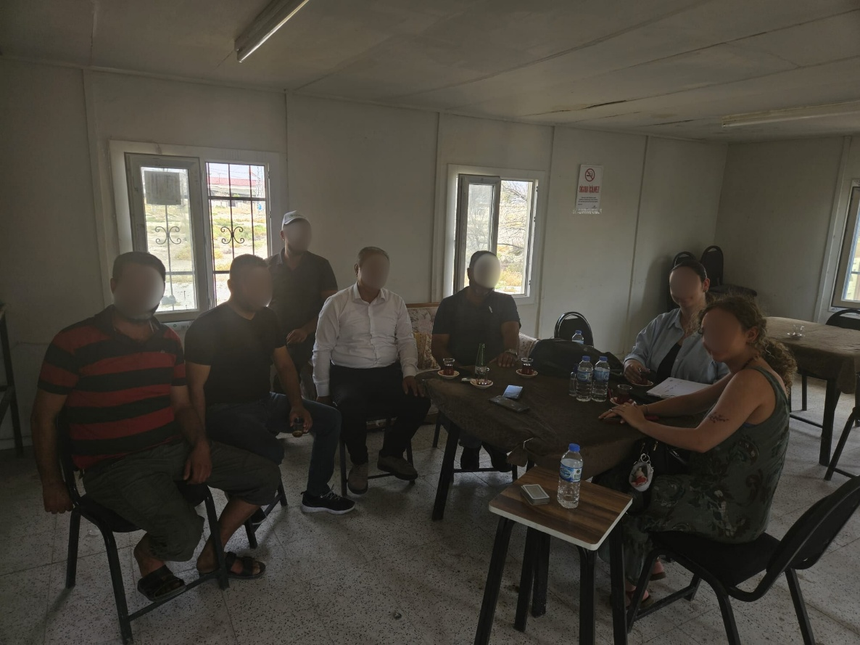
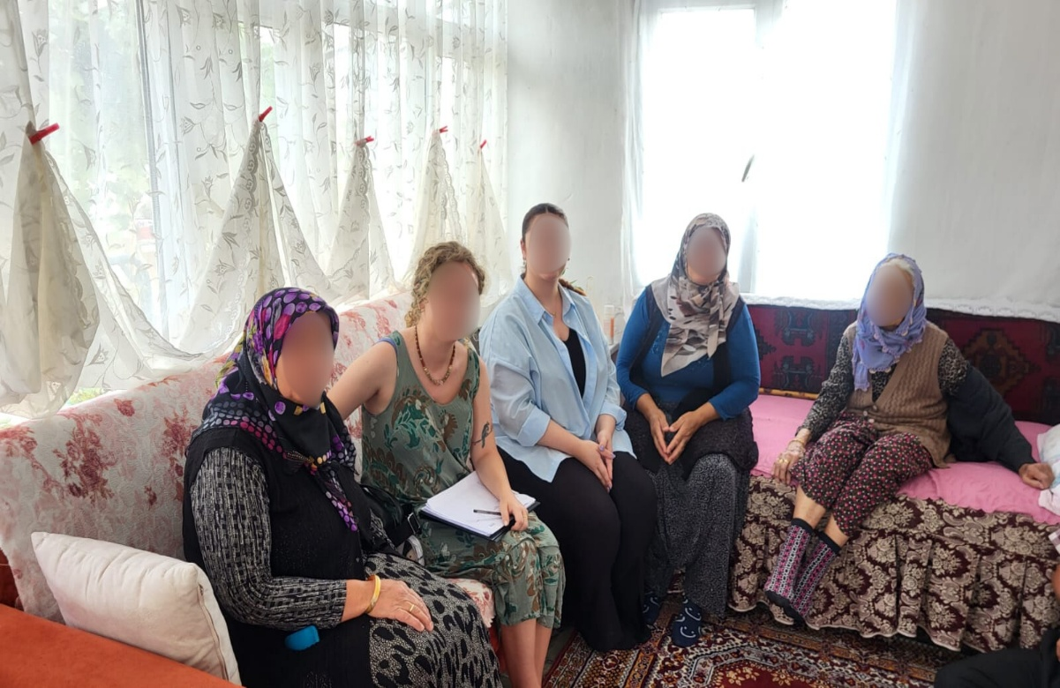

Unused Lands (115/8, 109/2, 108/1)
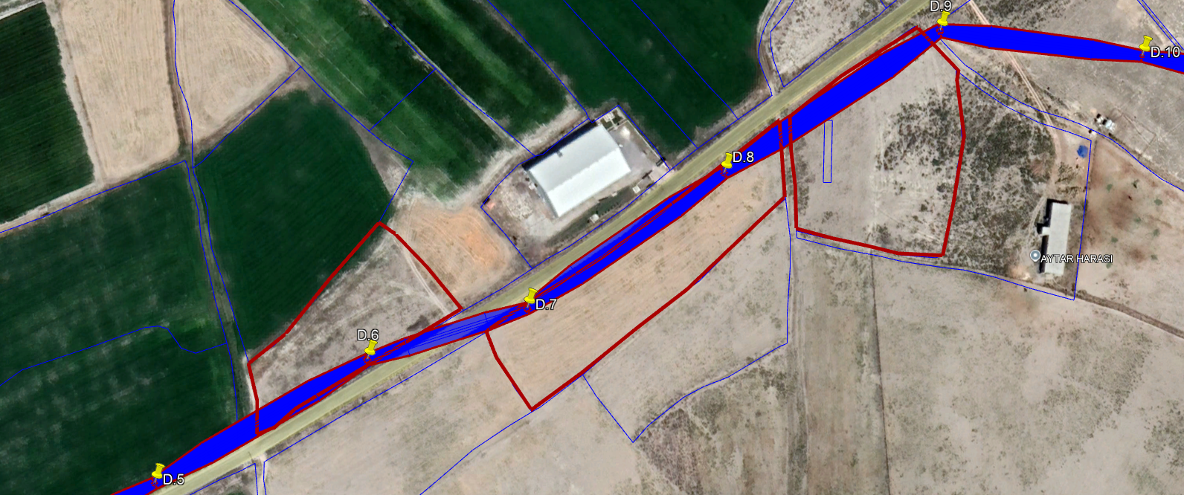
108/1
115/18
109/2

